Computer science coursework

Aaron Luckett

Contents

**Analysis** 4

Client 4

Background information/identification of the problem 4

Description of current system 4

Users of the system 5

Manager 5

Players 5

Scouts 5

Ways of gathering data 5

Player questionnaire 5

Interview with a manager 5

Football questionnaire 6

Questionnaire analysis 9

Interview with client 14

Analysis diary 16

Proposed hardware/software 17

Data volumes 17

DFD Diagrams 18

Current system 18

Proposed system 19

Data dictionary 20

SMART Objectives 21

**Design** 22

Data dictionary 22

Data flow diagrams 23

Add player 23

Delete player 23

Edit player 24

Drawing a one player graph 24

Drawing a graph to compare players 25

Entity relationship diagrams 26

Table structure 26

Playerdetails table 26

gamestats table 27

Flowcharts 28

Login flowchart 28

System flowchart 29

Edit player 30

Delete player 30

Add player 31

Delete all and exit program 31

View team and creating graphs 32

Hierarchy chart 33

Input, process, output (IPSO) 35

Adding a player 35

Edit a player 35

Delete a player 36

Delete all from database 36

Logging into the program 37

Drawing a graph for one player 37

Drawing a graph for all players 38

Exit the program 38

Page Layout 39

Pseudo code 49

Login menu 49

Drawing a graph for one player 50

Drawing a graph for all players and one stat 51

Deleting a player 52

Adding a player to the database 53

Edit player function 54

Delete all function 56

Validation 57

Sql statements/queries 58

Creating the database with tables 58

Plotting graph for all the players comparing one stat 58

Plotting graph for one player and all statistics 59

Error checking sql query 59

Selecting data from both tables at the same time 60

Deleting from the database 60

Deleting all from the database 61

Adding data to the database 61

The code 62

**Testing** 75

Testing table 75

Testing screenshots 79

**Evaluation** 91

Smart objectives 91

Email from client 93

Conclusion 94

# Analysis

## Client

The client is called Brian Lasham and is a manager of a semi professional football team. He wants to be able to track his players and view how his players a performing during the course of the full season. He wants a quick and simple way to view all of the necessary statistics (such as goals and assists) and compare with all of the other players in the team from the current season and past seasons.

## Background information/identification of the problem

The problem that my system is aiming to solve is that semi pro/Sunday league teams do not really have any means of tracking their performances, apart from results and the league table. They also so not have any way of looking at the individual players in the team and how they are performing; seeing their key stats such as goals, assists etc. This could really help these teams as it could give managers a helping out in finding out which of their players are performing well and which players are consistently playing well.

## Description of current system

The current system for this is on the website for the teams. This brings up the league table the team is in. It can also bring up recent results and upcoming fixtures. However this does not bring up in depth stats about each player in each team, making it hard for players/ managers to see how they compare to other players in the league. This system is updated a few days after the games have been played, sometimes even a week. This can be frustrating at times as managers want to see all of the results as soon as possible. However some teams do not have access to the website and have no means of tracking their players’ stats meaning they have to do it themselves.

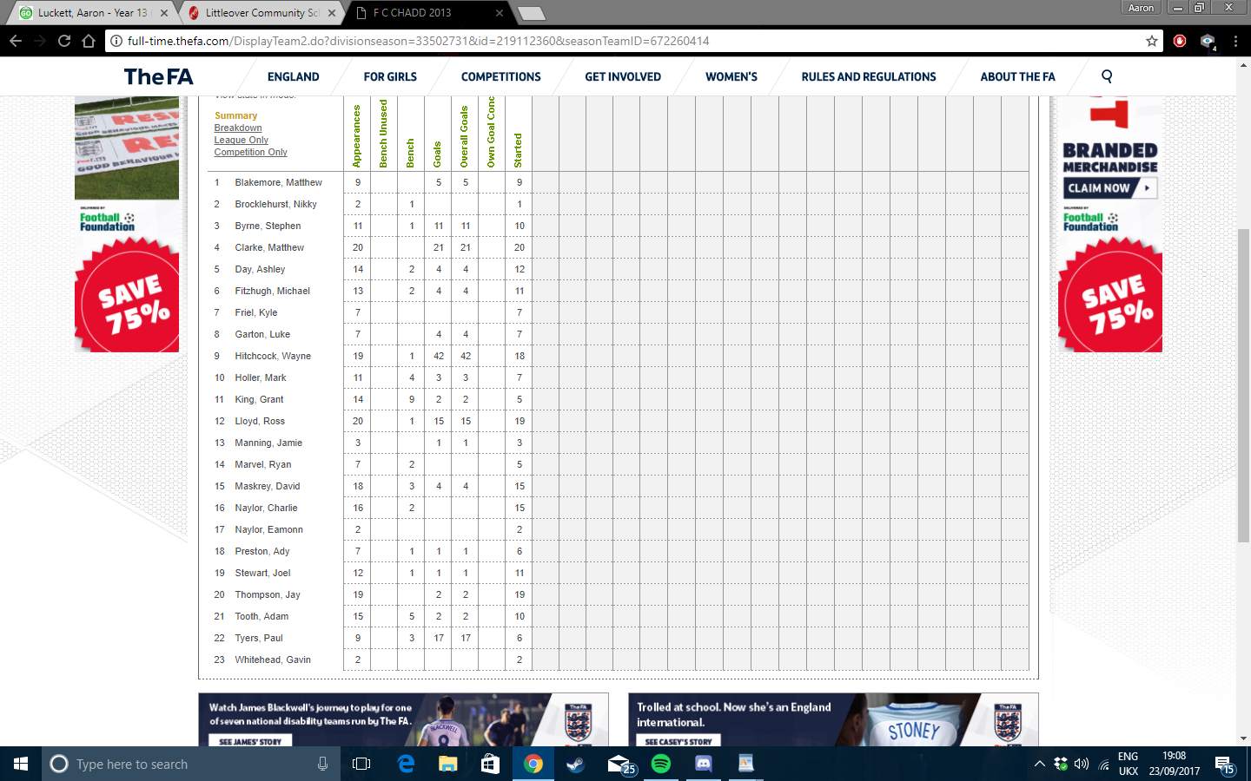

Current system, only tracks goals and is not updated very quickly.

## Users of the system

### Manager

A manger’s of a semi pro/Sunday league team could use the system to track all of their players’ stats to see who is playing well and which players may need to improve. The manager is also the supervisor and end-user.

### Players

Players in the team could use the system to track their individual performance and to see how they are doing this season. It could also help them improve if they see that they can see on the system that they are struggling with certain things.

### Scouts

Scouts could possibly use this system to see which players are playing well. This could then help them decide which player they want to go a watch play.

## Ways of gathering data

## Player questionnaire

I am going to produce a questionnaire for players to see if they would use the system and would find it helpful/useful to keep track of their own individual performances.

## Interview with a manager

I will conduct an interview with a manager to see what features they would like to be included in the system. I will ask them to see if the system will be beneficial to them and would help them keep track of all of their players’ progress and statistics.

## Football questionnaire

I decided to send out my surveys on a website called survey monkey, where the results would be sent back to me a few days later. This means I could then analyse them and put the results in graphs and tables to help sort and view the results. The questions I used in this questionnaire were:

How often do you play football?

* Never
* A few times a month
* Once or twice a week
* Three or four times a week
* Everyday

On a scale of 1-5 with 5 being love it, how much do you enjoy playing football?

* 1
* 2
* 3
* 4
* 5

On a scale of 1-5 with 5 being a lot, how much do you care about personal statistics?

* 1
* 2
* 3
* 4
* 5

How do you currently keep track of your personal stats? (Goals, assists etc.)

* I don’t
* I ask the manager
* Tally it on a piece of paper
* Look at a website
* Have a team database

Would you use a system that tracks these stats regularly?

* No
* Yes

What would be the reason you use a system to track your stats throughout the season?

* Just for fun
* Compare with other people
* To help improve your performance
* Other

If a system tracked your stats throughout the season, do you think it would help you improve certain aspects of your game?

* Yes
* No

What would be the most important feature of a system that tracks your stats?

* Looks good
* Simple to use
* Speed when using the system
* Reliability
* Accessibility
* Other

## Questionnaire analysis

How often do you play football?

From this we can see that most of the people who took the questionnaire play football at least once or twice a week. This shows that they play football regularly, most likely for a team which means that their stats can be tracked on a weekly basis.

On a scale of 1-5 with 5 being love it, how much do you enjoy playing football?

This shows that the players really enjoy playing football therefore would take the game seriously enough to care about their stats.

On a scale of 1-5 with 5 being a lot, how much do you care about personal statistics?

This shows that they majority of players care about their personal performances and would benefit from a system to track their stats and performances.

How do you currently keep track of your personal stats? (Goals, assists etc.)

This result shows that many players do not a have a reliable way of keeping track of their performances, which shows there is a space for a system that does this.

Would you use a system that tracks these stats regularly?

This is very positive as it shows that the high majority of player would use a system that allows them to track their stats.

What would be the reason you use a system to track your stats throughout the season?

This shows that a few player would use the system to improve their performance. However a lot of player would use it to compare with other players are just for fun to look at how they are doing.

If a system tracked your stats throughout the season, do you think it would help you improve certain aspects of your game?

This is a positive result as it shows that the players would see themselves improving their game if they used this system to track their stats. This makes making the program worthwhile.

What would be the most important feature of a system that tracks your stats?

This result is very varied but the top result is that the system must be simple to use. As well as this the speed and looks of the system are also important. Ideally all of the features will be included.

Overall the questionnaire went really well and produced some good results. They proved that the system is worth making as it will help players improve their games, as well as simply provide them with a way of viewing their stats throughout the season.

## Interview with client

I decided to conduct an interview with a manager of a Sunday league team to get his views on the system and whether or not it would be useful for him and the club. This would give me a good understanding on how to make the system, as the manager will be the prospective user.

1. **Do you currently have a system in which you can track you’re players’ statistics?**

No, I just let the players keep track of their goals and things on their own as i don’t have time to keep track of it all.

1. **Would you find a new system beneficial to be able to look at these statistics?**

Yes as it will allow me to keep track of all the goals and assists of my players so I can see who is playing well at that current time. This means I’ll be able to choose the players that are playing the best at that time.

1. **Are there any specific features you would like the system to include?**

I would like it to include the goals and assists scored by my players. I also would prefer it if it could bring up stats week by week, as well as the entire season.

1. **Would you like the system to be used by multiple people or just by you?**

I would like the system to be able to be used by my coaches as well as myself.

1. **How often would the system be used and the data be changed?**

I would update it after every time we have a game, so near enough every week.

1. **Do you think the players will find it useful to view the system?**

Certainly, I think that if a player knows that they are playing well and scoring a lot of goals then it will give them confidence to score more. On the other hand it can also help players try harder if they see they are falling behind in some areas.

1. **Would the system effect or change the way you manage the team or will it be purely for viewing purposes?**

Personally the system would change the way I choose the team. For example if I see my striker isn’t scoring I will have a word with him or even drop him.

1. **Are there any other comments you would like to make regarding the system?**

Just make it as simple and easy to use as possible.

The interview went well and I gathered enough information to be able to go ahead and create the solution to the managers needs. From the interview I can take away some key points, such as how the system will change and help how he picks the team every week and how he feels it will help the players improve the game. The most important feature for him is that the system is simple to use for him and his coaches.

## Analysis diary

Here is a log of my analysis and when I started and completed the different sections.

22/09/17 – Questionnaire was designed

23/09/17 – Interview questions were planned and interview was prepared to take place on the 28th September

25/09/17 – Questionnaire was sent off on the website for people to fill out, I also asked a few football players I know to fill out the questionnaire

26/09/17 – Results for questionnaire’s were analysed and typed up by me

27/09/17 – Short evaluation about the results from the questionnaire was written up.

28/09/17 – Interview was carried out with manager of football team. The transcript and overview of the internet was written up along with a brief evaluation of the interview and what to take away from it (e.g. Features of the system.)

## Proposed hardware/software

The only thing I really need to complete this project is python. This is because I can use the sqlite3 to make the database and manipulate data inside of it. The computer does not need to be powerful to run it as the file size will only be a few megabytes. However a module that I may need to install to python is matplotlib, as this would allow me to draw graphs from the data in the database.

## Data volumes

The data in this database will be small, meaning the file itself will only be a few megabytes in size. The data will be updated at least once, maybe twice a week with all of the stats being updated. A graph would be produced maybe once every two weeks to once very month just to keep track of progress. The data itself will be view once or twice a week as well, as most likely all of the players will want to view how they are doing throughout the course of the season. The system will only be dealing with at most 30 records. This is because there will not be more than 30 players playing for the team. Each of these records only has 9 fields of data in them and will only be text based. Overall this means that the programme will only deal with at most 270 pieces of data each being less than a kilobyte in size. Adding this up it means the data will only be about 5 kilobytes in size.

## DFD Diagrams

### Current system

Level 0

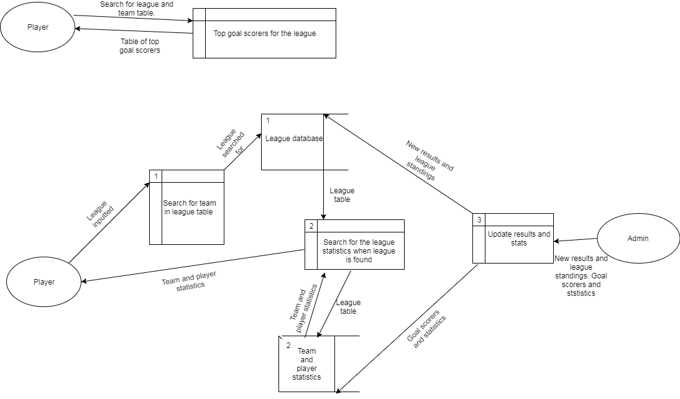

1

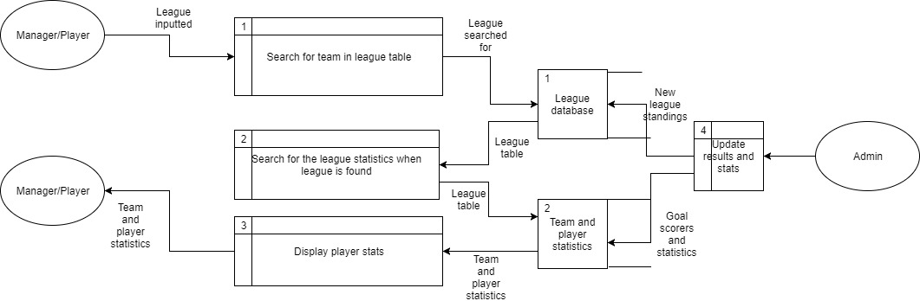

Level 1

This DFD is for the current system. The way it works is the player searches firstly for the league that the team they are in. The system then loads that league. The player then loads up the page with all of the player statistics for that league. They do this by clicking on player statistics underneath the league standings. The page is then loaded with all of the players in that league’s statics like goals and appearances; however this only shows the top ten or so players. After every week or two of games the admin can update the two databases with the latest results. This is the data that then shown when the player wants to see the results the next week.

### Proposed system

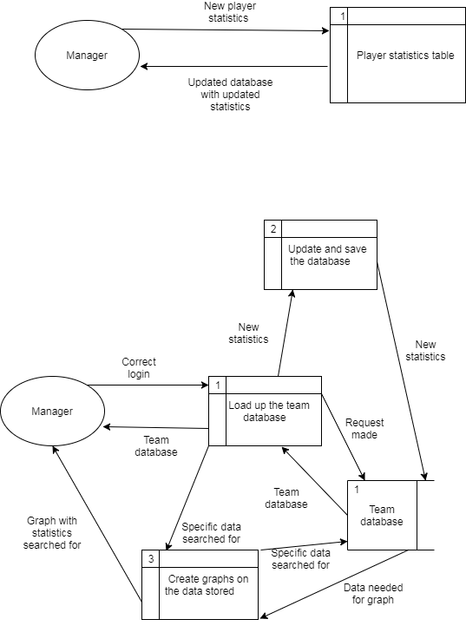

Level 0

Level 1

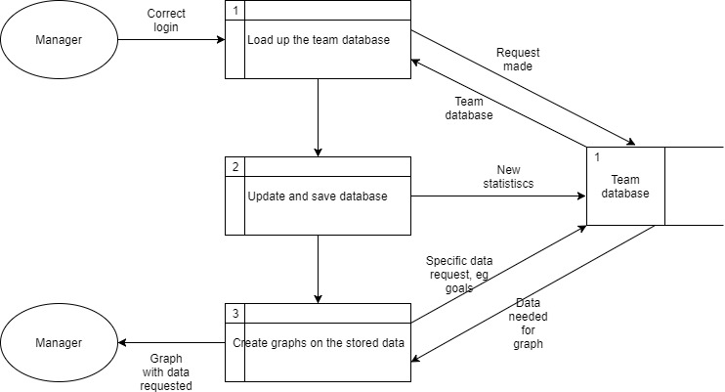

This DFD is for the proposed system and shows that the manager can load up the database and do a number of things. If the correct login is entered he can do numerous things. The first would be that he can view the team and all of their stats in one table. When the ‘View team’ button is pressed in the main menu the programme loads up a table with all of the stats. The manager can also choose to update and delete certain stats. This is updated in the database whenever he chooses to do this. He can finally create graphs on certain stats and to do this the programme gets the stats required and produce a graph on that statistic.

## Data dictionary

|  |  |  |  |  |  |
| --- | --- | --- | --- | --- | --- |
| Field name | Data type | Data format | Field size | Description | Example |
| First name | Text | TTTTTTTTTTTTTTTTTTTT | 20 | First name of player | Sam |
| Surname | Text | TTTTTTTTTTTTTTTTTTTT | 20 | Surname of player | Smith |
| Appearances | Integer | NNN | 3 | Amount of appearances by the player | 30 |
| Goals | Integer | NNN | 3 | Number of goals by the player | 26 |
| Assists | Integer | NNN | 3 | Number of assists by the player | 8 |
| Position | Text | TTT | 3 | The position of the player (Where they usually play) | ST |
| Yellow cards | Integer | NNN | 3 | Number of yellow cards the player has received | 6 |
| Red cards | Integer | NNN | 3 | Number of red cards the player has received | 1 |
| Average rating | Float | NN.NN | 4 | The average rating of the player over the season | 8.80 |

## SMART Objectives

1. The program must store all of the statistics for each player in the squad.
2. The program must allow the user to delete, update and add specific pieces of data in the database.
3. The program must be able to create graphs on specific pieces of data in the database.
4. The program must have a login window that will only allow specific people with logins to change the data
5. The program must display a message saying “Incorrect login details” when the incorrect login is inputted, therefore only allowing certain people to access the data.
6. The program must display the data stored in the database in a GUI window that is quick to view and find specific data.
7. The program must get rid of any GUI windows that are not being used to make it as simple as possible for the user to use the program.
8. The system must be easy to navigate around and easy to view and read.
9. The program must save all changes to the data in the database if it is changed or deleted.
10. There should be an option to clear all of the data. This could be used if a new season has begun.
11. The system must allow the user to view the data both in a table format as well as in a graph.
12. The graphs produced must be able to be printed in colour.
13. The colours used must stick to the colour scheme of the club, red and black.

# Design

## Data dictionary

The database will be split into two tables. The player details table will contain the basic details about the player such as name, position and squad number, the primary key.

The game stats table will store all of the statistics about the player such as gaols and assists. It also stores the squad number in order to link with the other table.

Player details table

|  |  |  |  |  |  |
| --- | --- | --- | --- | --- | --- |
| Field name | Data type | Data format | Field size | Description | Example |
| First name | Text | TTTTTTTTTTTTTTT | 15 | Players first name | Aaron |
| Last name | Text | TTTTTTTTTTTTTTT | 15 | Players last name | Phillips |
| Squad number | Integer | NN | 2 | Players unique squad number (Primary key) | 43 |
| Age | Integer | NN | 2 | Age of player | 25 |
| Position | Text | TTT | 3 | Players position | CM |

Game stats table

|  |  |  |  |  |  |
| --- | --- | --- | --- | --- | --- |
| Field name | Data type | Data format | Field size | Description | Example |
| Squad number | Integer | NN | 2 | Players squad number | 4 |
| Games played | Integer | NNN | 3 | Games played by player | 38 |
| Goals | Integer | NNN | 3 | Total goals scored by player | 32 |
| Assists | Integer | NNN | 3 | Assists made by player | 12 |
| Yellow cards | Integer | NNN | 3 | Yellow cards received by player | 1 |
| Red cards | Integer | NN | 2 | Red cards received by player | 7 |

## Data flow diagrams

These diagrams show the flow of data and where it is going throughout the action. It helps show what data is being called and manipulated during certain actions.

### Add player

First name, surname, age, position, squad number

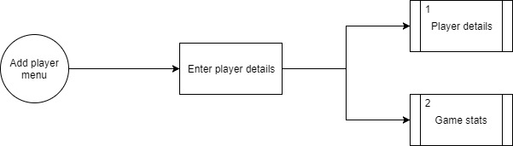

Games player, goals, assists, red cards, yellow cards

This is where the user enters the data required to be stored into the different tables of the database. The player details go into the player details table and the statistics go in the game stats table. The squad number goes in both as it is the primary key.

### Delete player

Squad number

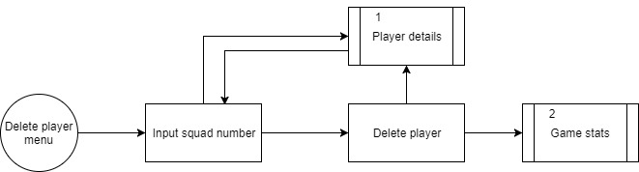

This works by making sure that there is a matching squad number in the database so that all of the data for that player can be deleted from both of the tables.

### Edit player

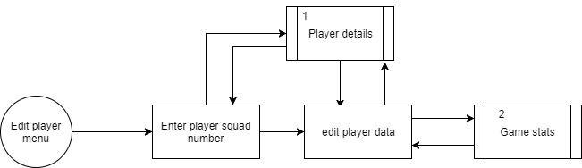

First name, surname, age, position, squad number

Squad number

Games player, goals, assists, red cards, yellow cards

This works by checking the squad number to see if there is a player with a matching squad number to the one entered. The tables then put the information for that player in the entry boxes matching the headings, for the user to edit. Once the user has edited the data it is put back into the database and updated.

### Drawing a one player graph

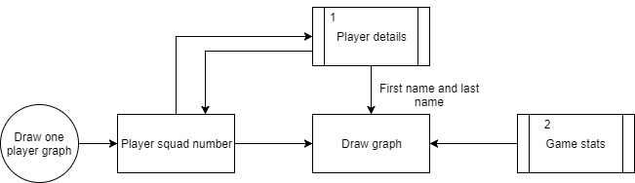

Squad number

Games player, goals, assists, red cards, yellow cards

Once again the squad number is checked and then the user can draw a graph looking at those players’ stats. The first name and last name are received from the player details table and all of the game stats are received and used to plot the graph.

### Drawing a graph to compare players

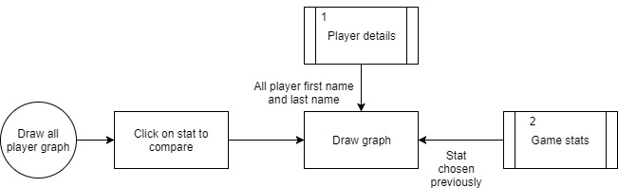

This works by the user choosing a stat they wish to compare all of the players in the database with. Once the stat is chosen all of the player names are put along the x axis to produce different bars and all of the values corresponding with the players are plotted, depending on what stat is chosen.

## Entity relationship diagrams

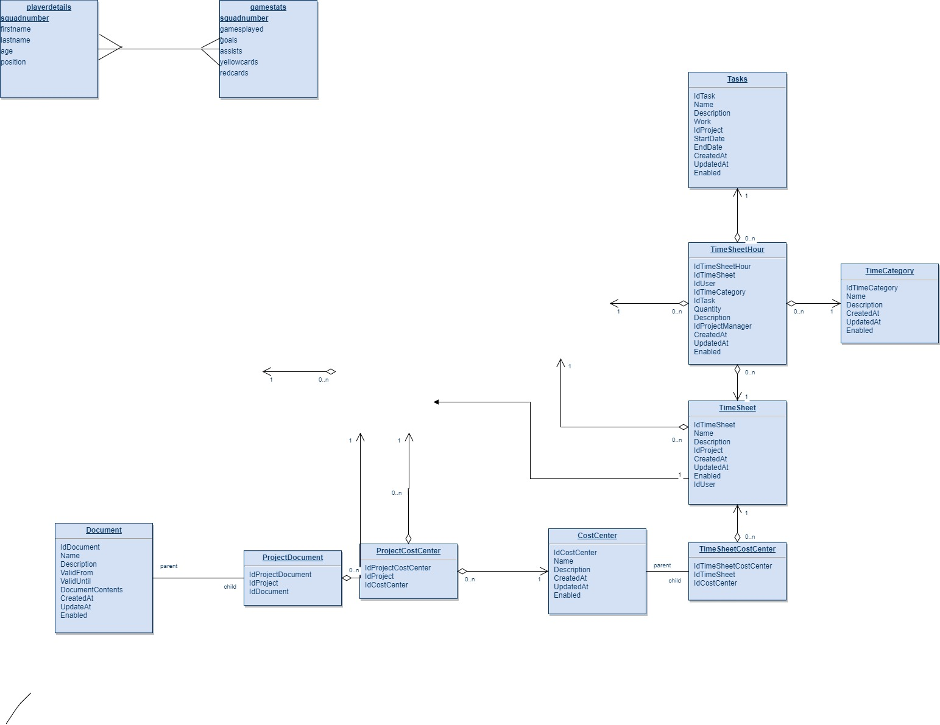

The relationship between the two tables is one to many relations as one player has many different statistics and appears many times in the gamestats table. The primary key for the tables is squadnumber. This is used to link the tables and features in both of them.

## Table structure

### Playerdetails table

This table stores the personal details of the players in the database. These records include first name of the player, the surname of the player, and the age of the player and the position the player plays in.

|  |  |  |
| --- | --- | --- |
| Field name | Data type | Description |
| squadnumber | Number | Stores the primary key, the squad number of the player. |
| firstname | Text | Stores the first name of the player |
| lastname | Text | Stores the surname of the player |
| age | Number | Stores the age of the player |
| position | Text (Dropdown menu) | Stores the position of the player |

### gamestats table

This table shows the match stats of the players in the database. The match stats are updated after every game and the table shares the squad number with the ‘playerdetails’ table so that all of the data for a player can be brought up from both tables at once.

|  |  |  |
| --- | --- | --- |
| Field name | Data type | Description |
| squadnumber | Number | Stores the primary key, the squad number of the player |
| gamesplayed | Number | Stores the amount of games the player has played |
| goals | Number | Stores the amount of goals the player has scored |
| assists | Number | Stores the amount of assists the player has made |
| yellowcards | Number | Stores the amount of yellow cards the player has received |
| redcards | Number | Stores the amount of red cards the player has recevied |

## Flowcharts

### Login flowchart

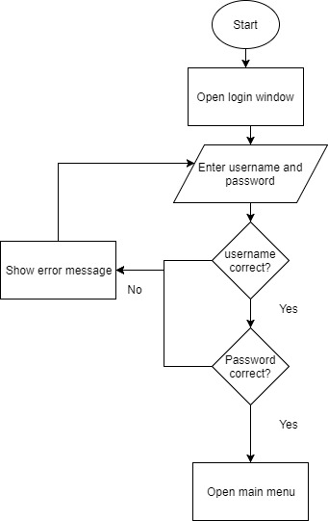

This flowchart shows how the user logs into the system. If the username and password are both correct the sure can enter the system. However if either one of them are incorrect the user will have to re enter the details.

### Untitled Diagram (1).jpgSystem flowchart

The system works by the user clicking buttons and entering data with the program opening and closing different windows as the user clicks specific buttons. It starts up by loading the main menu. The user can decide what option they would like to choose. Here are the options in more detail:

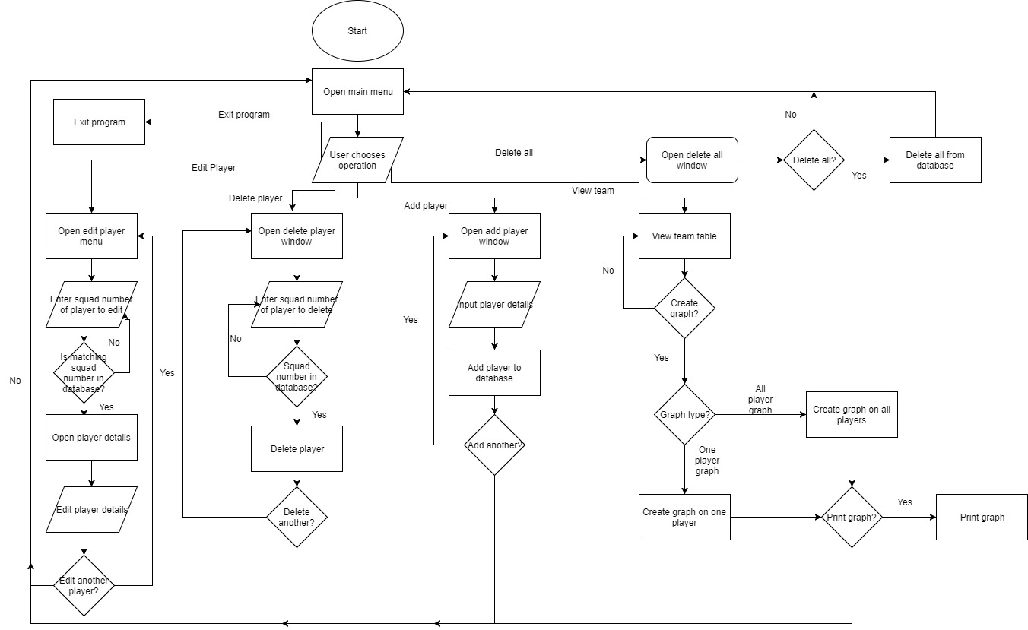

### Edit player

If the edit player button is clicked then the edit player menu will open. The user must enter a squad number and if that squad number matches one in the database then the player details will be loaded to be edited. The user then edits the details and can choose to edit another player. If the answer is yes then it will loop back around. However if the answer is no it will loop back to the main menu.



### Delete player

If the delete player button is clicked then a window asking for the user to enter a squad number will appear. Of the squad number is in the database then the program then the program will ask once more if the user wants to delete the player. If the answer is yes then it will delete the player and return to the main menu, otherwise they will just return to the main menu.

### Untitled Diagram (1).jpgAdd player

If the user chooses to add a player to the database then the add player window will appear. This will require the sure to enter the player details correctly and click the add player button. This will add the player to the database. If the user would like to add another player then the programme will loop back around, otherwise it will go back to the main menu.



### Delete all and exit program

If the user wants to exit the programme then they click on a button and the programme exits. If the want to delete the whole contents of the database then they click on the delete all button. The programme will then ask them to confirm their choice. If there answer is no then the programme returns to the main menu. However if their answer is yes then the programme deletes all of the database before returning to the main menu.



### Untitled Diagram (1).jpgView team and creating graphs

If the user wants to view the team then they can click the view team button. This will load the table of all of the sorted data. The user can then decide to create graphs on certain players or statistics. They have the choice to choose either, one player and all of their stats or multiple players with one stat. Depending on the choice that graph will be produced.

## Hierarchy chart

createallgraph

addedittodata

changedataa

user_input

delandupdate

checkandgraph

oneplayergraph

allplayergraph

graphdata

deletealll

checkdata

editplayerr

addplayerr

Viewteamm

delplayer

Main Menu

Get User

The hierarchy chart shows how the programme’s functions can be navigated through. The get user brings up the login menu. If the correct login is entered the main menu function is called. The user then chooses which function they want to carry out.

If they want to add a player the addplayerr function is called and the user_input function is called when all of the data is inputted as it saves it to the database.

If the user wants to delete a player the delplayer function is called which requests the squad number. If the squad number entered matches one in the database then the delandupdate function deletes all the data for that player with the squad number.

The delall function deletes all the data from the table. The viewteamm function brings up a table with all the data. The user can then choose to create a graph using the data in the table. The allplayergraph function asks the user to enter a stat they want to produce a graph on and the createallgraph function creates the graph. The oneplayergraph function requires the user to enter the squad number of the player they want to create a graph on. The checkandgraph function checks the squad number exists in the database and produces a graph for that player.

If the suer wants to edit a player the checkdata function asks them to enter the squad number. The changedata function then gets the data for that player and puts it into the entry boxers for the user to change. The addedittodata function deletes the old data for that player and adds the edited data to it instead.

## Input, process, output (IPSO)

### Adding a player

|  |  |
| --- | --- |
| Input | The user enters the data into each individual entry box in the window. The use then clicks the ‘Add Player’ button to submit the data entered. |
| Process | The program gets the data entered and stores the records in the correct tables in the database. The data inputted in the entry boxes are cleared ready for another player profile to be entered, |
| Output | A fresh looking window with all entry boxes cleared ready for a new player to be inputted. |

### Edit a player

|  |  |
| --- | --- |
| Input | The user inputs the squad number of the player they wish to edit, then they click the enter button. |
| Process | A query is carried out to check that there is a matching squad number in the correct table. |
| Output | If the query returns nothing then an error message is produced requiring the user to enter a different squad number. If the search returns a matching value then another window appears with all of the data relating to the squad number entered. |
| Input | The user changes the data produced previously and clicks the ‘Edit Player’ button. |
| Process | The program gets the data and uses an sql statement to update the corresponding pieces of data already stored for that player. The window is then closed showing that the query has been complete. |
| Output | The user is taken back to the main menu. |

### Delete a player

|  |  |
| --- | --- |
| Input | The user enters the squad number of the player they wish to delete. |
| Process | The program runs an sql query to see if there is a player with the matching squad number in the database. If the query returns a value then and sql statement will delete all data relating to the player with that squad number from both tables. |
| Output | If the query returned a value then the entry box will clear ready for the user to enter another value. However if there was no matching value, an error message will appear. |

### Delete all from database

|  |  |
| --- | --- |
| Input | The user clicks on a button to confirm they want to delete everything from the database. |
| Process | The program runs an sql statement to delete everything from the entire database and the two tables (but the two tables remain just the data inside them is deleted.) |
| Output | – A clear database. The user is also returned to the main menu. |

### Logging into the program

|  |  |
| --- | --- |
| Input | The user enters a username and password into the entry boxes and clicks the login button. |
| Process | An if statement is run and it checks to see if the username and password matches the correct login details required. |
| Output | If the username and password are correct the user is taken to the main menu. If they are incorrect then an error message will appear. |

### Drawing a graph for one player

|  |  |
| --- | --- |
| Input | The user enters the squad number of the player they wish to draw a graph for and click an enter button. |
| Process | An sql query is run to see if there is a matching squad number in the database. |
| Output | If there is a matching squad n umber in the database then the program will draw a graph using values from the ‘gamestats’ table as the x axis headings, for the player with the matching squad number. If there is no matching squad number then the program will show an error message. |

### Drawing a graph for all players

|  |  |
| --- | --- |
| Input | The users chooses and clicks a button for the stat they wish to compare. The button headings match the ones in the ‘gamestats’ table. |
| Process | An sql statement is run to get all of the players’ first name and surname from the database and to use them are the x axis headings. Another statement is run getting all of the values from the column with the matching heading as the button clicked, and uses them to plot the height of the bars. |
| Output | A graph is produced of each player the amount of the chosen stat from the previous menu. |

### Exit the program

|  |  |
| --- | --- |
| Input | The user clicks on the exit button on the main menu window. |
| Process | The database connection is closed making sure all of the data is secure. |
| Output | The program successfully closes. |

## Page Layout

The title label will say ‘Welcome, please login to continue” in Helvetica font that is size 16.

**Login Menu**

This label ‘Access denied will only appear if the incorrect details are entered. If not then it will not be visible to the user.

Login button that when clicked will take the user to the main menu.

The username entry box only accepts the username ‘Aaron’ (In any case/format). The program will check to see if this is correct

The password label also uses a size 12 Helvetica font and tells the user that a password needs to be entered

Login

Wrong Details

The username label uses a size 12 Helvetica font and just tells the user to enter their username into the box below

8% of screen

Title

Password:

Username:

The password entry box where the only password accepted is ‘password’ (all lowercase). The program will check to see if the correct password has been entered.

This will be the first menu to appear when the program is run. The user will need to enter the right username (“aaron”) and password (“password”) to be able to access the program. If the correct details are entered then the user will move on but if the incorrect details are entered a textbox will appear saying access denied, telling the user that there is an error with the login details then entered.

**Main Menu**

Exit button will destroy all of the windows open.

Add Player

Delete All

Delete Player

Exit

Edit Player

View players

20%

The heading of the page will be size 16 cooper black font saying ‘What would you like to do?’ It will be at the centre of the page at the top.

The edit button will take the user to the page where they can edit a player. The font used for this button is Ariel.

What would you like to do?

Takes the user to menu where they can add a player. The font used is Ariel.

This button takes the user to the ‘view players’ menu.

This is the main menu of the program and it will be where the user decides what they want to do once logging in. The user will keep on coming back to this window as all of the options are on here. Each of the buttons will take the user to the window stated on the button, depending on what the user wants to do.

The button here takes the user to the ‘delete menu’ page. This also uses an Ariel font and takes up about 5% of the main menu page.

This button will allow the user to delete all of the data in the database.

**Add player menu**

Exit button that closes the window when clicked and returns to the main menu

Games Played

Goals scored

Assists

Yellow Cards

Add Player

Exit

Red Cards

Position

Age

Squad number

Surname

First Name

25%

**Add player**

The title ‘add player’ will be size 20 with the cooper black font. It will be positioned in the top left of the window.

Entry boxes where all of the data will be entered

The add player button will get all of the values in the entry boxes and store them in the same spots in the database. All the entry boxes will be cleared for the next player to be added.

The labels for the entry boxes will match the columns for the database so the user knows where to enter specific data.

This is the add player menu where a new player can be added to the database. This window will appear when the ‘add player’ button is clicked. The user will enter the details of the player in the correct box and when the ‘add player’ button is clicked the data will disappear and get stored in the database by the program. The user can then continue entering players for as long as they want.

This will only appear if squad number does not exist in the database. If not the message will be invisible.

Entry box that will delete the player with the matching squad number from the database

‘Delete player’ heading will be size 18 and in the cooper black font.

**Delete Player menu**

Exit

**Delete Player**

Enter the squad number of the player you would like to delete:

15%

Exit button that will destroy the window.

The player with that squad number does not exist.

This will be the window to appear when the user clicks on the ‘delete player’ button in the main menu. This window is needed as authentication. The user will enter the squad number of the player and if it matches a squad number in the database then the player with that squad number will be deleted. If there is no matching squad number then the error message will appear.

**Delete all menu**

This will appear after the user clicks on the ‘delete all’ button on the main menu. It will check to see if the user wants to delete everything from the database, as once it is deleted it cannot be recovered. If the no button is clicked then the window will just close. However if the yes button is clicked then the program will delete everything from the database and then the window will close and the user will be returned to the main menu.

This button will delete all the contents from the database and then close the window.

The button will just close the window and return to the main menu

10%

No

Yes

**Are you sure you wish to delete everything from the database?**

The title will be at the top of the window and will be in the font cooper black. It will be most likely size 18.

This will be the first window to appear when the user clicks on the ‘edit player ‘button. The user will enter the squad number of the player they want to edit and the program will check to find a matching squad number in the database. Much like the ‘Delete Player’ menu if there is no match then the error message will appear. But if there is a matching squad number then a new window will open up which will allow the user to make changes to that player.

This message will only appear the squad number entered is either incorrect or does not exist in the database. Until then it is configured so that it is invisible to the user.

This button will take the user to the edit data menu where they can change the data if there is a player with that squad number in the database. If there is not then when the button is clicked, the error message will appear.

That player does not exist

Enter

**Please enter the squad number of the player you wish to edit:**

Entry box where the user enters the squad number

10%

The instruction will be at the top of the page and will be in a cooper black font. It will be around size 16.

**Edit player menu**

**Edit player details menu**

Edit player label will be size 20 and use the cooper black font

Exit button. This will close the window and cancel the users request to edit the player

Exit

This is where the user changes the data of the player. All of the data for the player previously entered will be put into the entry boxes. The user can then pick and choose what pieces of data they will edit as not all of the data will be wrong; which saves time for the user as they don’t have to re-enter all of the data. When the user clicks on the confirm button all of the data will be stored in the database, with the old data being deleted. If the user clicks on the cancel button at any point, no data will be changed and the user will be taken back to the main menu.

The entry boxes where the user will enter the data. If there is data already in the player’s data file then it will be put into the correct entry box for the user to see where the wrong piece of data is so that they can correctly edit it. If there is no data for that entry box it will be left blank for the user to enter data in to.

The headings for the data needed. These headings match the headings of the tables in the database meaning that whatever the user enters into these will display in the database under the column with the same heading.



30%

18

1

Aaron

Yellow Cards

Squad Number

Position

First Name

Surname

Age

Games

Goals

Assists

Red Cards

Confirm

**Edit player**

**View players menu**

The exit button will close this window and take the user back to the main menu.

The ‘The team’ label will use a cooper black font and it will have a font size of 20.

|  |  |  |  |  |  |  |  |  |  |
| --- | --- | --- | --- | --- | --- | --- | --- | --- | --- |
| Squad number | First name | Surname | Position | Age | Games Played | Goals | Assists | Yellow Cards | Red Cards |
| 3 | Aaron | Luckett | LB | 18 | 12 | 4 | 6 | 2 | 0 |
| 11 | Dave | Mitchell | ST | 26 | 22 | 12 | 5 | 3 | 1 |
|  |  |  |  |  |  |  |  |  |  |
|  |  |  |  |  |  |  |  |  |  |
|  |  |  |  |  |  |  |  |  |  |
|  |  |  |  |  |  |  |  |  |  |

50%

**The Team**

Exit

Graph

A scroll bar to allow the user to scroll up and down to view the whole table.

The table will have the same headings as the database and will display all of each players’ details. This is where the user can see all of the contents of the database for themselves, with the option of drawing graphs to help put the information in a more visually pleasant format.

The graph button will open a window where the user can decide what graph they want to plot and how they want to view the data in a graph form

This window is where the user can view the entire database and look at all of the data stored in it. All of the column headings in the table match the ones in the database and the user can then click on the graph button to make a graph on either; one player and all of their stats, or the entire team on one individual stat (eg. Goals)

**Type of graph window**

Exit button will take the user back to the view team menu

The title will let the user know what the buttons are the answer to. It will be size 16 and be in the cooper black font.

This button will let the user plot a graph on all the players stored in the database. The user will get to choice what stat to compare. This would be useful if you wanted to see the top goals scorer for instance.

Will take the user to the window where they can plot the graph for one player of their choice.

All Players

One Player

**What would you like to make a graph on?**

Exit

25%

This will be the first menu to appear after the graph button is clicked on the view team menu. It will let the user decide what type of graph they wish to draw; whether it be comparing the whole team on one stat, or looking at an individual player’s stats.

**Select player to graph window**

The exit button will take the user back to the view team menu.

The title will tell the user to enter the player squad number. It will be in the Helvetica font, which will also be size 12.

**Please enter the squad number of the player you wish to view graph on:**

Exit

Enter

No player exists with that squad number

30%

Entry box where the user enters the player squad number.

The enter button to submit the squad number. If the squad number matches one ion the database a graph will be plotted on that player.

The error message will be invisible at first. If the user enters a squad number which is not in the database then the error message will appear until the user enters a matching squad number

This is

This is where the user enters the squad number of the player they wish to plot a graph on. The user enters the squad number and if it matches a squad number in the database then the graph will be plotted. However if there is no match then the user will have to enter a different squad number.

The title will use a Helvetica font which is size 12

Exit button to take the user back to the view team window.

**Team graph window**

25%

Will draw a graph with all the team comparing the corresponding stat to the button clicked.

Exit

Red Cards

Yellow Cards

Assists

Goals

Games Played

**Please click a stat you wish to compare:**

This window appears when the all players button is clicked. The user decides what stat to compare the team on. Once a button is clicked, a graph will be produced showing all of the players and the value for that stat.

**One player graph**

50%

This is what the program will draw using matplotlib. It will produce a bar for each column heading and stat. It will help the user view the players’ stats easily and review their performances.

Stat chosen

50%

Each player and the stat chosen will produce a bar. This will make it easy for the user to compare players.

This is the graph that will be produced when the user clicks on one of the buttons on the team graph menu, in this case goals. It will display all of the players in the database and the stat matching each player.

## Pseudo code

### Login menu

FUNCTION getuser:

text <- entusername

password <- entpass

text <- text.upper

IF text <- "AARON" AND password <- "password":

lbl2.configure(text<-"Access granted")

FUNCTION mainmenu

window.destroy

ELSE:

lbl2.configure(text<- "Access denied")

ENDIF

ENDFUNCTION

This is the login function and works by getting the values the user entered and turning them into the variable names ‘text’ and ‘password’. If they match the username ‘AARON’ and password ‘password’ then the main menu window will open. If not then the error label will appear.

### Drawing a graph for one player

FUNCTION oneplayergraph

FUNCTION checkandgraph

squadnum <- enter

x_axis <-['Games Played','Goals','Assists','Yellow Cards','Red cards']

y_axis<-[]

SELECT * FROM playerdetails WHERE squadnumber <- ?''', (squadnum,)

check <- fetchone

IF check is None:

error1.configure(text<-"This player does not exist")

ELSE:

SELECT gamesplayed, goals, assists, yellowcards, redcards FROM gamestats WHERE squadnumber <- ?''', (squadnum,)

player <- fetchall

FOR column in player:

y_axis.append(column[0])

y_axis.append(column[1])

y_axis.append(column[2])

y_axis.append(column[3])

y_axis.append(column[4])

ENDFOR

SELECT firstname, lastname FROM playerdetails WHERE squadnumber <- ?''', (squadnum,)

Name<- fetchall

plt.bar(x_axis, y_axis, align<-'center')

This draws a graph for one player. It works by having the table headings as the bar heading for the graph. It gets all of the values for this and plots it to the corresponding headings to produce the bars. It works in a list format with a for loop putting the values in the y axis list.

plt.title(name)

plt.legend()

plt.show()

ENDIF

ENDFUNCTION

### Drawing a graph for all players and one stat

FUNCTION createallgraph(yaxis):

SELECT lastname FROM playerdetails

data <-fetchall

x_axis<-[]

y_axis<-[]

FOR row in data:

x_axis.append(row[0])

ENDFOR

for row in yaxis:

y_axis.append(row[0])

ENDFOR

plt.bar(x_axis, y_axis, align<-'center')

plt.xlabel('Player')

plt.legend()

plt.show()

This works by getting a variable ‘yaxis’ variable from another function. There are five functions in total that will return a different list for that variable but in the example it is goals that are returned. That function works by using an sql statement to get all of the players’ goals values and put them in a list. The createallgraph function then gets the first name and last name from another sql query to produce the bar headings on the x axis. The y-axis variable then gets plotted producing the graph

ENDFUNCTION

FUNCTION creategraphgoals():

SELECT goals FROM gamestats

yaxis <- fetchall

createallgraph(yaxis)

ENDFUNCTION

### Deleting a player

first_name <- Entry(delplayer)

FUNCTION delplayer

FUNCTION del_and_update:

delete <- first_name

DELETE FROM playerdetails WHERE playerdetails.squadnumber <-(delete,)

DELETE FROM gamestats WHERE gamestats.squadnumber <- (delete,)

first_name.delete(0,END)

conn.commit

ENDFUNCTION

This works by the user entering a value for the squad number of the player they want to delete. The variable is then passed to the del_and_update fuction where the sql statement deletes the data from each of the tables.

### Adding a player to the database

FUNCTION addplayerr:

FUNCTION user_input:

first_name <- player_firstname

last_name <- player_lastname

age_ <- age

position_ <- variable

gamesplayed_ <- games_played

goals_ <- goals_scored

assists_ <- assist

yellowcards_ <- yellow_cards

redcards_ <- red_cards

squadnumber <- squad_number

INSERT INTO playerdetails(firstname, lastname, squadnumber, age, position) VALUES

(first_name, last_name, squadnumber, age_, position_)

INSERT INTO gamestats(squadnumber, gamesplayed, goals, assists, yellowcards, redcards) VALUES

(squadnumber, gamesplayed_, goals_, assists_, yellowcards_, redcards_)

player_firstname.delete(0,END)

player_lastname.delete(0,END)

age.delete(0,END)

position <- ""

This works by getting the data entered into the entry boxes and turning them into suitable variables. An sql query then inserts them into the database, under the correct headings and in the correct tables. The entry boxes are then cleared of the data once it is inserted so that the user can enter more data for another player if they choose to do so.

games_played.delete(0,END)

goals_scored.delete(0,END)

assist.delete(0,END)

yellow_cards.delete(0,END)

red_cards.delete(0,END)

squad_number.delete(0,END)

conn.commit

ENDFUNCTION

### Edit player function

Squadnum<-ent

player <- SELECT firstname, lastname, squadnumber, age FROM playerdetails WHERE playerdetails.squadnumber <- (squadnum,)

FOR row in player:

playerfirstname <- row[0]

playerlastname <- row[1]

playersquadnumber <- row[2]

playerage <- row[3]

firstname.insert(END, playerfirstname)

lastname.insert(END, playerlastname)

squadnumber1.insert(END, playersquadnumber)

age2.insert(END, playerage)

ENDFOR

stats <- SELECT gamesplayed, goals, assists, yellowcards, redcards FROM gamestats WHERE gamestats.squadnumber <- (squadnum,)

FOR row in stats:

This function works beforehand. An sql query gets the data from the squad number of the player the user entered. Two for statements put the data into the matching headings in the window, so that the user can see the data for that player already entered. This makes it much easier for them to edit data.

playergp <- row[0]

playergoals <- row[1]

playerassists <- row[2]

playeryellowcards <- row[3]

playerredcards <- row[4]

gamesplayed.insert(END, playergp)

goals2.insert(END, playergoals)

assists2.insert(END, playerassists)

yellowcards.insert(END, playeryellowcards)

redcards.insert(END, playerredcards)

FUNCTION addeditteddata:

DELETE FROM playerdetails WHERE playerdetails.squadnumber <- (squadnum,)

DELETE FROM gamestats WHERE gamestats.squadnumber <- (squadnum,)

conn.commit

first_name <- firstname

last_name <- lastname

age_ <- age2

position_ <- variable

gamesplayed_ <- gamesplayed

goals_ <- goals2

assists_ <- assists2

yellowcards_ <- yellowcards

redcards_ <- redcards

squadnumber <- squadnumber1

INSERT INTO playerdetails(firstname, lastname, squadnumber, age, position) VALUES

(first_name, last_name, squadnumber, age_, position_)

INSERT INTO gamestats(squadnumber, gamesplayed, goals, assists, yellowcards, redcards) VALUES

(squadnumber, gamesplayed_, goals_, assists_, yellowcards_, redcards_)

conn.commit

changedata.destroy

The second part deletes the data for that player currently in the database. It then adds the new updated data into the database which can then be viewed by the user.

ENDFUNCTION

ENDFUNCTION

### Delete all function

FUNCTION deletealll:

FUNCTION delalldata:

DELETE FROM playerdetails

DELETE FROM gamestats

deleteall.destroy

ENDFUNCTION

This function consists of two sql queries that simply delete everything from the database leaving the user with two empty tables.

### Validation

IF len(first_name)>15:

ELSEIF len(last_name)>15:

ELSEIF len(age_) > 2 :

ELSEIF check_exists is not None:

ELSEIF first_name.isalpha() AND last_name.isalpha() AND age_.isdigit() AND gamesplayed_.isdigit() AND goals_.isdigit() AND assists_.isdigit() AND yellowcards_.isdigit() AND redcards_.isdigit() AND squadnumber.isdigit:

INSERT INTO playerdetails(firstname, lastname, squadnumber, age, position) <-

(first_name, last_name, squadnumber, age_, position_)

INSERT INTO gamestats(squadnumber, gamesplayed, goals, assists, yellowcards, redcards) <-

(squadnumber, gamesplayed_, goals_, assists_, yellowcards_, redcards_)

player_firstname.delete(0,END)

player_lastname.delete(0,END)

age.delete(0,END)

position <- ""

This is a form of validation when adding and editing a players data before inserting them into a database. The user must make sure that the conditions are met otherwise a message box will appear explaining what they have done wrong. If all of the conditions are met then the data will be stored. The conditions are that the data cannot be too long, the fields must be entered in the correct form (eg. A name can have no numbers in them) and that the squad number must be unique.

games_played.delete(0,END)

goals_scored.delete(0,END)

assist.delete(0,END)

yellow_cards.delete(0,END)

red_cards.delete(0,END)

squad_number.delete(0,END)

conn.commit()

ELSE:

ENDIF

## Sql statements/queries

### Creating the database with tables

CREATE TABLE playerdetails(firstname TEXT, lastname TEXT, squadnumber INT, age INT, position TEXT)

CREATE TABLE IF NOT EXISTS gamestats(squadnumber TEXT, gamesplayed INT, goals INT, assists INT, yellowcards INT, redcards INT )

These sql queries connect the user to the database. The two tables ‘playerdetails’ and ‘gamestats’ are created if they do not already exist in the database. These lines set up the database to have the two tables which all of the data will be stored in later on in the code.

### Plotting graph for all the players comparing one stat

SELECT lastname FROM playerdetails

This selects all of the last names of the players from the ‘playerdetails’ table in the database. It then puts them one by in a list to be able to plot the graph required.

### Plotting graph for one player and all statistics

SELECT goals FROM gamestats

SELECT assists FROM gamestats

SELECT yellowcards FROM gamestats

SELECT redcards FROM gamestats

SELECT gamesplayed FROM gamestats

These functions get all of the values in the gamestats table and will insert them into a list which will then be used when creating the graph for the player.

### Error checking sql query

SELECT * FROM playerdetails WHERE squadnumber = ?''', (squadnum,)

This sql query is used for error checking and works by selecting data from the ‘playerdetails’ table where the squad number is equal to the value entered by the user previously. If the query returns no value, then and error message will appear. But if there is a matching value another operation will be carried out.

### Selecting data from both tables at the same time

SELECT firstname, lastname, playerdetails.squadnumber, age, position, gamesplayed, goals, assists, yellowcards, redcards from playerdetails, gamestats WHERE playerdetails.squadnumber = gamestats.squadnumber

This works by selecting the values from both the ‘gamestats’ and ‘playerdetails’ table to be placed in a table for the user to view. The variable ‘playerdetails.squadnumber’ is used to specify which table to get the squad number from, as they both contain the primary key. This stops the program getting the squad number twice.

### Deleting from the database

DELETE FROM playerdetails WHERE playerdetails.squadnumber = ? ''',(delete,)

DELETE FROM gamestats WHERE gamestats.squadnumber = ? ''',(delete,)

These queries simply delete the data from each of the table where the squadnumber matches the value the user had entered previously.

### Deleting all from the database

DELETE FROM playerdetails

DELETE FROM gamestats

this queries delete all of the data and information stored in both of the table in the database.

### Adding data to the database

INSERT INTO playerdetails(firstname, lastname, squadnumber, age, position) VALUES (?, ?, ?, ?, ?)",

(first_name, last_name, squadnumber, age_, position_)

INSERT INTO gamestats(squadnumber, gamesplayed, goals, assists, yellowcards, redcards) VALUES (?, ?, ?, ?, ?, ?)",

(squadnumber, gamesplayed_, goals_, assists_, yellowcards_, redcards_))

These add the different values (eg. First_name, age_, goals_ and squadnumber) to the two tables corresponding to what data they store inside of them. The variables and column headings of the tables match so that the right data is stored in the right place.

## The code

1. **import** sqlite3
2. **import** random
3. **from** tkinter **import** *
4. **from** tkinter **import** ttk
5. **import** matplotlib.pyplot as plt
6. **import** matplotlib.dates as mdates
7. **from** dateutil **import** parser
8. **from** matplotlib **import** style
9. style.use('fivethirtyeight')
11. #CONNECT TO DATABASE
12. conn = sqlite3.connect('Football.db')
13. c = conn.cursor()
14. #CREATES DATABASE TABLES IS THEY DO NOT EXIST
15. **def** create_table():
16. c.execute('CREATE TABLE IF NOT EXISTS playerdetails(firstname TEXT, lastname TEXT, squadnumber INT, age INT, position TEXT)') #creates playerdetails table
17. c.execute('CREATE TABLE IF NOT EXISTS gamestats(squadnumber TEXT, gamesplayed INT, goals INT, assists INT, yellowcards INT, redcards INT )') #creates gamestats table


21. create_table()
23. ###-----------------------------------------------------LOGIN WINDOW---------------------------------------------------
24. **def** getuser():
25. text = entusername.get() #gets the value entered in the unsername entry box
26. password = entpass.get() #gets the value entered in the password entry box
27. text = text.upper() #turns the variable into uppercase text
28. #CHECKS THE LOGIN
29. **if** text == "AARON" **and** password == "password": #checks the inputs with accepted values
30. lbl2.configure(text="Acess granted") #changes label to the text
31. mainmenu() #opens the main menu
32. window.destroy() #destroys login window
33. **else**:
34. lbl2.configure(text= "Access denied") #turns label into text
35. messagebox.showinfo("ERROR","Please enter the correct username and password to successfully login.") #call message box to display error message

38. #CREATE LOGIN WINDOW
39. window = Tk()
40. window.title('Welcome')
41. window.geometry("335x200")
42. window.configure(background="crimson")
44. #CREATE TITLE
45. lblnst = Label(window, text="Welcome, please login to continue: ", bg="crimson", font=("Helvetica",16))
46. lblnst.pack()
48. #CREATE USERNAME ENTRY BOX
49. lblusername = Label(window, text="Username:", bg="crimson", font=("Helvatica",12))
50. entusername = Entry(window) #creates variable for data entered
51. lblusername.pack()
52. entusername.pack()
54. #CREATE PASSWORD ENTRY BOX
55. lblpassword = Label(window, text ="Password:", bg="crimson", font=("Helvatica",12))
56. entpass = Entry(window,show='*') #creates variable for data entered
57. lblpassword.pack()
58. entpass.pack()
60. #LOGIN BUTTON
61. btn = Button(window, text="Login",command=getuser,bg="white")
62. btn.pack()
64. #LABEL TO SAY IF ACCESS HAS BEEN GAINED
65. lbl2 = Label(window, text="", bg="crimson" )
66. lbl2.pack()



71. ###--------------------------------------MAIN MENU-------------------------------------------------------
72. **def** mainmenu():
73. #CREATE WINDOW
74. window2 = Tk()
75. window2.title("Main Menu")
76. window2.geometry("800x300")
77. window2.configure(background="crimson")
79. #CREATE TITLE LABEL
80. mainlabel = Label(window2, text = "What would you like to do?",bg="crimson",font=("Cooper Black",16))
81. mainlabel.grid(row=1,column=2,padx=10,pady=10)
83. #VIEW TEAM BUTTON
84. viewteam = Button(window2, text="View team", font=("Ariel",18), command=viewteamm)
85. viewteam.grid(column=1,row=2,padx=10,pady=10)
87. #EXIT PROGRAM
88. exitb = Button(window2,text="Exit", font=("Ariel",23),command=exit)
89. exitb.grid(column=6,row=1,padx=10,pady=10)
91. #DELETE PLAYER BUTTON
92. deleteplayer = Button(window2, text="Delete player", font=("Ariel",18), command=delplayer)
93. deleteplayer.grid(column=1,row=3,padx=10,pady=10)
95. #ADD PLAYER BUTTON
96. addplayer = Button(window2, text="Add player" ,font=("Ariel",18), command=addplayerr)
97. addplayer.grid(column=3,row=2,padx=10,pady=10)
99. #EDIT PLAYER BUTTON
100. editplayer =Button(window2,text="Edit player",font=("Ariel",18), command=editplayerr)
101. editplayer.grid(column=3,row=3,padx=10,pady=10)
103. #DELETE ALL BUTTON
104. deleteall=Button(window2,text="Delete All",font=("Areil",18),command=deletealll)
105. deleteall.grid(column=2,row=4,padx=10,pady=10)

108. ###-----------------------------------------------------VIEW TEAM-------------------------------------
109. **def** viewteamm():
111. **def** createallgraph(yaxis):
112. #GETS DATA TO BE PLOTTED
113. c.execute('SELECT lastname FROM playerdetails')
114. data = c.fetchall()
116. x_axis=[]
117. y_axis=[]
119. #PUTS DATA INTO LISTS FOR X AND Y AXIS
120. **for** row **in** data:
121. x_axis.append(row[0])
123. **for** row **in** yaxis:
124. y_axis.append(row[0])
126. #PLOTS THE GRAPH
127. plt.bar(x_axis, y_axis, align='center')
128. plt.xlabel('Player')
129. plt.legend()
130. plt.show()
132. #SELECTS GOALS FROM TABLE AND RETURNS YAXIS TO PLOT IN GRAPH
133. **def** creategraphgoals():
134. c.execute('SELECT goals FROM gamestats')
135. yaxis = c.fetchall()
136. createallgraph(yaxis)
137. #SELECTS ASSISTS FROM TABLE AND RETURNS YAXIS TO PLOT IN GRAPH
138. **def** creategraphassists():
139. c.execute('SELECT assists FROM gamestats')
140. yaxis=c.fetchall()
141. createallgraph(yaxis)
142. #SELECTS YELLOW CARDS FROM TALE AND RETURNS YAXIS TO PLOT IN GRAPH
143. **def** creategraphyellow():
144. c.execute('SELECT yellowcards FROM gamestats')
145. yaxis=c.fetchall()
146. createallgraph(yaxis)
147. #SELECTS RED CARDS FROM TABLE AND RETURNS YAXIS TO PLOT IN GRAPH
148. **def** creategraphred():
149. c.execute('SELECT redcards FROM gamestats')
150. yaxis=c.fetchall()
151. createallgraph(yaxis)
152. #SELECTS GAMES PLAYED FROM TABLE AND RETURNS YAXIS TO PLOT IN GRPAH
153. **def** creategraphplayed():
154. c.execute('SELECT gamesplayed FROM gamestats')
155. yaxis=c.fetchall()
156. createallgraph(yaxis)


160. **def** allplayergraph():
161. #CREATE WINDOW
162. playerg=Tk()
163. playerg.title("Graph")
164. playerg.geometry("800x200")
165. playerg.configure(background="crimson")
166. #TITLE LABEL
167. question = Label(playerg, text= "What would you like to compare?",bg="crimson",font=("Cooper Black",16))
168. question.grid(column=3,row=1,padx=10,pady=10)
169. #GETS DATA FOR GOALS SCORED
170. goalsb = Button(playerg, text="Goals", font=("Ariel",16),command=creategraphgoals)
171. goalsb.grid(column=1,row=3,padx=10,pady=10)
172. #GETS DATA FOR ASSISTS MADE
173. assistsb = Button(playerg, text="Assists", font=("Ariel",16),command=creategraphassists)
174. assistsb.grid(column=2,row=3,padx=10,pady=10)
175. #GETS DATA FOR GAMES PLAYED
176. gamesplayedb=Button(playerg, text="Games Played", font=("Ariel",12),command=creategraphplayed)
177. gamesplayedb.grid(column=3,row=3,padx=10,pady=10)
178. #GETS DATA FOR YELLOW CARDS
179. yellowb=Button(playerg, text="Yellow Cards", font=("Ariel",12),command=creategraphyellow)
180. yellowb.grid(column=4,row=3,padx=10,pady=10)
181. #GETS DATA FOR RED CARDS RECIEVED
182. redb =Button(playerg, text="Red Cards", font=("Ariel",12),command=creategraphred)
183. redb.grid(column=5,row=3,padx=10,pady=10)
184. #CANCEL BUTTON
185. cancelb = Button(playerg, text="Cancel", font=("Ariel",12),command=playerg.destroy)
186. cancelb.grid(column=5,row=1,padx=10,pady=10)






194. **def** oneplayergraph():
196. **def** checkandgraph():
197. squadnum = enter.get()
198. x_axis=['Games Played','Goals','Assists','Yellow Cards','Red cards']
199. y_axis=[]
200. #CHECKS TO SEE IF THE SQUADNUMBER EXISTS
201. c.execute('''''SELECT * FROM playerdetails WHERE squadnumber = ?''', (squadnum,))
202. check = c.fetchone()
203. **if** check **is** None:
204. #PRODUCES ERROR MESSAGE
205. error1.configure(text="This player does not exist")
206. **else**:
207. #ENTERS DATA FOR Y xis
208. c.execute('''''SELECT gamesplayed, goals, assists, yellowcards, redcards FROM gamestats WHERE squadnumber = ?''', (squadnum,))
209. player = c.fetchall()
210. **for** column **in** player:
211. y_axis.append(column[0])
212. y_axis.append(column[1])
213. y_axis.append(column[2])
214. y_axis.append(column[3])
215. y_axis.append(column[4]) #puts the player details in the y axis list
217. c.execute('''''SELECT firstname, lastname FROM playerdetails WHERE squadnumber = ?''', (squadnum,))
218. name=c.fetchall() #selects the player name from the database and puts it as the title of the bar chart
219. #CREATE BAR CHART
220. plt.bar(x_axis, y_axis, align='center')
221. plt.title(name)
222. plt.legend()
223. plt.show()

226. #CREATES WINDOW AND TITLE LABEL
227. selectplayer = Tk()
228. question = Label(selectplayer, text= "Which player would you like to see?",bg="crimson",font=("Cooper Black",16))
229. selectplayer.title("Graph")
230. selectplayer.geometry("500x200")
231. selectplayer.configure(background="crimson")
233. #TELLS THEM WHAT TO DO
234. instruc = Label(selectplayer, text= "Enter the player squadnumber",bg="crimson",font=("Cooper Black",16))
235. instruc.grid(column=2,row=1,padx=10,pady=10)
236. #CREATE THE ENTER BUTTON
237. enter = Entry(selectplayer)
238. enter.grid(column=2,row=2,padx=10,pady=10)
239. enterb = Button(selectplayer, text="Enter", font=("Ariel",12),command=checkandgraph)
240. enterb.grid(column=2,row=3,padx=10,pady=10)
241. #CREATES ERROR MESSAGE
242. error1 = Label(selectplayer,text="",bg="crimson",font=("Ariel",12))
243. error1.grid(column=2,row=4,padx=10,pady=10)
244. #CREATES EXIT BUTTON
245. exitwindow = Button(selectplayer,text="Exit",font=("Ariel",18),command=selectplayer.destroy)
246. exitwindow.grid(column=3,row=1,padx=10,pady=10)




252. **def** graphdata():
253. graphdata=Tk()
254. graphdata.title("Graph Data")
255. graphdata.geometry("800x200")
256. graphdata.configure(background="crimson")
258. #MAIN LABEL
259. question = Label(graphdata, text = "What would you like to make a graph on?", bg="crimson",font=("Cooper Black",16))
260. question.grid(column=2,row=1,padx=10,pady=10)
262. #BUTTON TO GRAPH ALL PLAYERS
263. allplayers = Button(graphdata, text="All Players", font=("Ariel",18),command=allplayergraph)
264. allplayers.grid(column=1,row=2,padx=10,pady=10)
265. #BUTTON TO GRAPH ONE PLAYER
266. oneplayer= Button(graphdata,text="One player", font=("Ariel",18),command=oneplayergraph)
267. oneplayer.grid(column=3,row=2,padx=10,pady=10)
268. #EXIT
269. exit1 = Button(graphdata,text="Exit",font=("Ariel",18),command=graphdata.destroy)
270. exit1.grid(column=3,row=1,padx=10,pady=10)

273. #SELECT DATA FROM DATABASE
274. c.execute('''''SELECT firstname, lastname, playerdetails.squadnumber, age, position, gamesplayed, goals, assists, yellowcards, redcards from playerdetails, gamestats WHERE playerdetails.squadnumber = gamestats.squadnumber ''')
275. playerdetails = c.fetchall()
277. #CREATES TABLE
278. viewteam= Tk()
279. viewteam.title("Team")
280. viewteam.configure(background="crimson")
281. tree = ttk.Treeview(viewteam, columns=('col1','col2','col3','col4','col5','col6','col7','col8','col9','col10'))
283. #GIVES COLUMNS HEADINGS
284. tree.column('col1', width=100, anchor='center')
285. tree.column('col2', width=100, anchor='center')
286. tree.column('col3', width=100, anchor='center')
287. tree.column('col4', width=100, anchor='center')
288. tree.column('col5', width=100, anchor='center')
289. tree.column('col6', width=100, anchor='center')
290. tree.column('col7', width=100, anchor='center')
291. tree.column('col8', width=100, anchor='center')
292. tree.column('col9', width=100, anchor='center')
293. tree.column('col10', width=100, anchor='center')
294. tree.heading('col1', text='Firstname')
295. tree.heading('col2', text='Last Name')
296. tree.heading('col3', text='Squadnumber')
297. tree.heading('col4', text='Age')
298. tree.heading('col5', text='Position')
299. tree.heading('col6', text='Games Played')
300. tree.heading('col7', text='Goals')
301. tree.heading('col8', text='Assists')
302. tree.heading('col9', text='Yellow Cards')
303. tree.heading('col10', text='Red Cards')
305. #INSERTS DATA INTO TABLE
306. **for** row **in** playerdetails:
307. tree.insert('', 'end', text="", values=(row[0], row[1], row[2], row[3], row[4], row[5], row[6], row[7], row[8] ,row[9]))
308. tree.grid(column=1,row=1,padx=1,pady=1)
310. #EXIT BUTTON
311. exitt = Button(viewteam,text="Exit", font=("Ariel",18),command=viewteam.destroy)
312. exitt.grid(column=2,row=1,padx=5,pady=10)
314. #GRAPH BUTTON
315. graphforall = Button(viewteam,text="Graph", font=("Ariel",18),command=graphdata)
316. graphforall.grid(column=1,row=2,padx=1,pady=10)



321. ###----------------------------------------DELETING A PLAYER-------------------------------------------
322. **def** delplayer():
324. #DELETES PLAYER FROM DATABASE
325. **def** del_and_update():
326. delete = squad_number.get()
327. #CHECKS TO SEE IF THE SQUADNUMBER EXISTS
328. c.execute('''''SELECT * FROM playerdetails WHERE squadnumber = ?''', (delete,))
329. check = c.fetchone()
330. **if** check **is** None:
331. #PRODUCES ERROR MESSAGE
332. error_lbl.configure(text="This player does not exist")
333. **else**:
334. c.execute('''''DELETE FROM playerdetails WHERE playerdetails.squadnumber = ? ''',(delete,))
335. c.execute('''''DELETE FROM gamestats WHERE gamestats.squadnumber = ? ''',(delete,)) #deltes data from player with matching squad number from both tables in the database
336. error_lbl.configure(text="This player has been deleted") #tells user the player has been successfully deleted
337. squad_number.delete(0,END)
338. conn.commit()
340. #CREATES WINDOW
341. delplayer = Tk()
342. delplayer.title("Delete player")
343. delplayer.geometry("500x500")
344. delplayer.configure(background="crimson")
346. #TABLE LABEL
347. deleteplayer=Label(delplayer, font=("Ariel",20), text="Delete Player", background="crimson")
348. deleteplayer.grid(column=1,row=1,padx=10,pady=10)
350. #NAME LABEL
351. squadnum = Label(delplayer,font=("Ariel",12),text="Player Squadnumber", background="crimson")
352. squad_number = Entry(delplayer)
353. squadnum.grid(column=1,row=2,padx=10,pady=10)
354. squad_number.grid(column=2,row=2,padx=10,pady=10)
356. #DELETE BUTTON
357. delplayerb = Button(delplayer,text="Delete Player", font=("Ariel",23),command=del_and_update)
358. delplayerb.grid(column=2,row=3)
360. #ERROR LABEL
361. error_lbl = Label(delplayer,text="",bg="crimson",font=("Ariel",12))
362. error_lbl.grid(column=2,row=4,padx=10,pady=10)
364. #CREATES EXIT BUTTON
365. exitb = Button(delplayer,text="Exit", font=("Ariel",23),command=delplayer.destroy)
366. exitb.grid(column=5,row=1,padx=10,pady=10)
368. ###-----------------------------------------ADD A PLAYER---------------------------------------------
369. **def** addplayerr():
371. #ADDS PLAYER TO DATABASE
372. **def** user_input():
373. first_name = player_firstname.get()
374. last_name = player_lastname.get()
375. age_ = age.get()
376. position_ = variable.get()
377. gamesplayed_ = games_played.get()
378. goals_ = goals_scored.get()
379. assists_ = assist.get()
380. yellowcards_ = yellow_cards.get()
381. redcards_ = red_cards.get()
382. squadnumber = squad_number.get() #gets the variables from the entry boxes
383. c.execute('''''SELECT * FROM playerdetails WHERE squadnumber = ?''', (squadnumber,))
384. check_exists = c.fetchone()
385. **if** len(first_name)>15:
386. messagebox.showinfo("ERROR","Please enter make sure the firstname of the player is less than 16 characters and only contains text.") #checks to see if firstname is less than 15 characters
387. **elif** len(last_name)>15:
388. messagebox.showinfo("ERROR","Please make sure the surname of the player is less than 16 characters and only contains text.") #checks that only text has been entered
389. **elif** len(age_) > 2 :
390. messagebox.showinfo("ERROR","Please make sure the age of the player is a umber and is smaller than 100.") #checks the age entered is less than 100
391. **elif** check_exists **is** **not** None:
392. messagebox.showinfo("ERROR","A player with that squad number already exists.") #checks the player exists in the database
393. **elif** first_name.isalpha() **and** last_name.isalpha() **and** age_.isdigit() **and** gamesplayed_.isdigit() **and** goals_.isdigit() **and** assists_.isdigit() **and** yellowcards_.isdigit() **and** redcards_.isdigit() **and** squadnumber.isdigit():
394. c.execute("INSERT INTO playerdetails(firstname, lastname, squadnumber, age, position) VALUES (?, ?, ?, ?, ?)",
395. (first_name, last_name, squadnumber, age_, position_))
396. c.execute("INSERT INTO gamestats(squadnumber, gamesplayed, goals, assists, yellowcards, redcards) VALUES (?, ?, ?, ?, ?, ?)",
397. (squadnumber, gamesplayed_, goals_, assists_, yellowcards_, redcards_))  #checks to see if if correct characters/number have been enterd and if so adds the player into the database
398. player_firstname.delete(0,END)
399. player_lastname.delete(0,END)
400. age.delete(0,END)
401. position = ""
402. games_played.delete(0,END)
403. goals_scored.delete(0,END)
404. assist.delete(0,END)
405. yellow_cards.delete(0,END)
406. red_cards.delete(0,END)
407. squad_number.delete(0,END) #clears the entry boxes
408. conn.commit()
409. **else**:
410. messagebox.showinfo("ERROR","Please make sure the correct details have been entered in the correct format.") #displays error message
412. #CREATE WINDOW
413. addplayer = Tk()
414. addplayer.title("Add player")
415. addplayer.geometry("500x600")
416. addplayer.configure(background="crimson")
418. #CREATE ADDPLAYER LABEL
419. newplayer=Label(addplayer, font=("Ariel",20), text="Add player", background="crimson")
420. newplayer.grid(column = 1, row = 1, padx = 10, pady= 10)
422. #FIRSTNAME ENTRY BOX
423. player_firstname = Entry(addplayer)
424. player_first = Label(addplayer, font=("Ariel",12), text="First name", background="crimson")
425. player_first.grid(column = 1, row= 3,padx=10, pady= 10)
426. player_firstname.grid(column = 2, row= 3, padx=10,pady=10)
428. #LASTNAME ENTRY BOX
429. player_lastname = Entry(addplayer)
430. player_last = Label(addplayer, font=("Ariel",12), text="Surname", background="crimson")
431. player_last.grid(column=1,row=4,padx=10,pady=10)
432. player_lastname.grid(column=2,row=4,padx=10,pady=10)
434. #AGE ENTRY BOX
435. age = Entry(addplayer)
436. age2 = Label(addplayer, font=("Ariel",12), text="Age",background="crimson")
437. age2.grid(column = 1, row= 6,padx=10,pady=10)
438. age.grid(column=2,row=6,padx=10,pady=10)
440. #POSITION ENTRY BOX
441. variable = StringVar(addplayer)
442. variable.set("")
443. position = OptionMenu(addplayer, variable, "GK", "LB", "RB", "CB", "CDM", "CM", "CAM", "LM", "RM", "RW", "LW", "ST") #creates a dropdown box
444. pos = Label(addplayer, font=("Ariel",12), text="Position", background="crimson")
445. pos.grid(column=1,row=7,padx=10,pady=10)
446. position.grid(column=2,row=7,padx=10,pady=10)
448. #GAMES PLAYED ENTRY BOX
449. games_played = Entry(addplayer)
450. games = Label(addplayer, font=("Ariel",12), text="Games Played", background="crimson")
451. games.grid(column=1,row=8,padx=10,pady=10)
452. games_played.grid(column=2,row=8,padx=10,pady=10)
454. #GOALS SCORED ENTRY BOX
455. goals_scored = Entry(addplayer)
456. goals = Label(addplayer, font=("Ariel",12), text="Goals Scored", background="crimson")
457. goals.grid(column=1,row=9,padx=10,pady=10)
458. goals_scored.grid(column=2,row=9,padx=10,pady=10)
460. #ASSISTS ENTRY BOX
461. assist = Entry(addplayer)
462. assissts = Label(addplayer, font=("Ariel",12), text="Assists", background="crimson")
463. assissts.grid(column=1,row=10,padx=10,pady=10)
464. assist.grid(column=2,row=10,padx=10,pady=10)
466. #YELLOW CARDS ETRY BOX
467. yellow_cards = Entry(addplayer)
468. yellow = Label(addplayer, font=("Ariel",12), text="Yellow Cards", background="crimson")
469. yellow.grid(column=1,row=11,padx=10,pady=10)
470. yellow_cards.grid(column=2,row=11,padx=10,pady=10)
472. #RED CARDS ENTRY BOX
473. red_cards = Entry(addplayer)
474. red = Label(addplayer, font=("Ariel",12), text="Red Cards", background="crimson")
475. red.grid(column=1,row=12,padx=10,pady=10)
476. red_cards.grid(column=2,row=12,padx=10,pady=10)
478. #ADD PLAYER BUTTON
479. addplayerb = Button(addplayer,text="Add Player", font=("Ariel",23),command=user_input)
480. addplayerb.grid(column=2,row=13)
482. #EXIT BUTTON
483. exitb = Button(addplayer,text="Exit", font=("Ariel",23),command=addplayer.destroy)
484. exitb.grid(column=5,row=1,padx=10,pady=10)
486. #SQUAD NUMBER ENTRY
487. squad_number = Entry(addplayer)
488. squad = Label(addplayer, font=("Ariel",12), text="Squad Number", background="crimson")
489. squad.grid(column=1,row=5,padx=10,pady=10)
490. squad_number.grid(column=2,row=5,padx=10,pady=10)



495. ###-----------------------------------------EDIT A PLAYER--------------------------------------------
496. **def** editplayerr():
497. editplayer = Tk()
498. editplayer.title("Edit player")
499. editplayer.geometry("800x200")
500. editplayer.configure(background="crimson")
502. **def** changedata():
503. squadnum=ent.get()
504. changedata = Tk()
505. changedata.title("Edit Player")
506. changedata.geometry("500x600")
507. changedata.configure(background="crimson")
509. #TITLE LABEL
510. title=Label(changedata,text="Edit The Data",font=("Cooper Black",20),background="crimson")
511. title.grid(column=1,row=1,padx=10,pady=10)
513. #FISRTNAME EDIT
514. first = Label(changedata,text="Firstname",font=("Ariel",12),background="crimson")
515. first.grid(column=1,row=2,padx=10,pady=10)
516. firstname = Entry(changedata)
517. firstname.grid(column=2,row=2,padx=10,pady=10)
519. #LASTNAME EDIT
520. last=Label(changedata,text="Surname",font=("Ariel",12),background="crimson")
521. last.grid(column=1,row=3,padx=10,pady=10)
522. lastname=Entry(changedata)
523. lastname.grid(column=2,row=3,padx=10,pady=10)
525. #SQUAD NUMBER EDIT
526. squadnum = Label(changedata,text="Squad Number",font=("Ariel",12),background="crimson")
527. squadnum.grid(column=1,row=4,padx=10,pady=10)
528. squadnumber1=Entry(changedata)
529. squadnumber1.grid(column=2,row=4,padx=10,pady=10)
531. #AGE EDIT
532. age = Label(changedata,text="Age",font=("Ariel",12),background="crimson")
533. age.grid(column=1,row=5,padx=10,pady=10)
534. age2=Entry(changedata)
535. age2.grid(column=2,row=5,padx=10,pady=10)
537. #POSITION EDIT
538. variable = StringVar(changedata)
539. variable.set("")
540. position = OptionMenu(changedata, variable, "GK", "LB", "RB", "CB", "CDM", "CM", "CAM", "LM", "RM", "RW", "LW", "ST") #create sdropdown menu
541. pos = Label(changedata, font=("Ariel",12), text="Position", background="crimson")
542. pos.grid(column=1,row=6,padx=10,pady=10)
543. position.grid(column=2,row=6,padx=10,pady=10)
545. #GAMES PLAYED
546. games = Label(changedata,text="Games Played",font=("Ariel",12),background="crimson")
547. games.grid(column=1,row=7,padx=10,pady=10)
548. gamesplayed=Entry(changedata)
549. gamesplayed.grid(column=2,row=7,padx=10,pady=10)
551. #GOALS EDIT
552. goals = Label(changedata,text="Goals Scored",font=("Ariel",12),background="crimson")
553. goals.grid(column=1,row=8,padx=10,pady=10)
554. goals2 = Entry(changedata)
555. goals2.grid(column=2,row=8,padx=10,pady=10)
557. #ASSISTS EDIT
558. assists = Label(changedata,text="Assists",font=("Ariel",12),background="crimson")
559. assists.grid(column=1,row=9,padx=10,pady=10)
560. assists2 =Entry(changedata)
561. assists2.grid(column=2,row=9,padx=10,pady=10)
563. #YELLOW CARDS
564. yellow= Label(changedata,text="Yellow Cards",font=("Ariel",12),background="crimson")
565. yellow.grid(column=1,row=10,padx=10,pady=10)
566. yellowcards=Entry(changedata)
567. yellowcards.grid(column=2,row=10,padx=10,pady=10)
569. #RED CARDS
570. red= Label(changedata,text="Red Cards",font=("Ariel",12),background="crimson")
571. red.grid(column=1,row=11,padx=10,pady=10)
572. redcards=Entry(changedata)
573. redcards.grid(column=2,row=11,padx=10,pady=10)
575. #INSERT DATA TO BE CHANGED
576. squadnum=ent.get()
577. player = c.execute('SELECT firstname, lastname, squadnumber, age FROM playerdetails WHERE playerdetails.squadnumber = ?', (squadnum,))
578. **for** row **in** player:
579. playerfirstname = row[0]
580. playerlastname = row[1]
581. playersquadnumber = row[2]
582. playerage = row[3]
583. firstname.insert(END, playerfirstname)
584. lastname.insert(END, playerlastname)
585. squadnumber1.insert(END, playersquadnumber)
586. age2.insert(END, playerage)
587. stats = c.execute('SELECT gamesplayed, goals, assists, yellowcards, redcards FROM gamestats WHERE gamestats.squadnumber = ?', (squadnum,))
588. **for** row **in** stats:
589. playergp = row[0]
590. playergoals = row[1]
591. playerassists = row[2]
592. playeryellowcards = row[3]
593. playerredcards = row[4]
594. gamesplayed.insert(END, playergp)
595. goals2.insert(END, playergoals)
596. assists2.insert(END, playerassists)
597. yellowcards.insert(END, playeryellowcards)
598. redcards.insert(END, playerredcards) #gets the data from the database and inserts it into the entry boxes matching the data (eg. firstname will go into the firstname entry box to be changed if needed)

601. **def** addeditteddata():
602. c.execute('''''DELETE FROM playerdetails WHERE playerdetails.squadnumber = ? ''', (squadnum,))
603. c.execute('''''DELETE FROM gamestats WHERE gamestats.squadnumber = ? ''',(squadnum,)) #deletes old data from the database
604. conn.commit()
605. first_name = firstname.get()
606. last_name = lastname.get()
607. age_ = age2.get()
608. position_ = variable.get()
609. gamesplayed_ = gamesplayed.get()
610. goals_ = goals2.get()
611. assists_ = assists2.get()
612. yellowcards_ = yellowcards.get()
613. redcards_ = redcards.get()
614. squadnumber = squadnumber1.get() #ggets variables from entry boxes
615. c.execute('''''SELECT * FROM playerdetails WHERE squadnumber = ?''', (squadnumber,))
616. check_exists = c.fetchone()
617. **if** len(first_name)>15:
618. messagebox.showinfo("ERROR","Please enter make sure the firstname of the player is less than 16 characters and only contains text.") #checks that the firstname is less than 16 characters long
619. **elif** len(last_name)>15:
620. messagebox.showinfo("ERROR","Please make sure the surname of the player is less than 16 characters and only contains text.") #checks only text has been entered
621. **elif** len(age_) > 2 :
622. messagebox.showinfo("ERROR","Please make sure the age of the player is a umber and is smaller than 100.") #checks age is less than 100
623. **elif** check_exists **is** **not** None:
624. messagebox.showinfo("ERROR","A player with that squad number already exists.") #checks that a player with (new) squad number does not already exit
625. **elif** first_name.isalpha() **and** last_name.isalpha() **and** age_.isdigit() **and** gamesplayed_.isdigit() **and** goals_.isdigit() **and** assists_.isdigit() **and** yellowcards_.isdigit() **and** redcards_.isdigit() **and** squadnumber.isdigit():
626. c.execute("INSERT INTO playerdetails(firstname, lastname, squadnumber, age, position) VALUES (?, ?, ?, ?, ?)",
627. (first_name, last_name, squadnumber, age_, position_))
628. c.execute("INSERT INTO gamestats(squadnumber, gamesplayed, goals, assists, yellowcards, redcards) VALUES (?, ?, ?, ?, ?, ?)",
629. (squadnumber, gamesplayed_, goals_, assists_, yellowcards_, redcards_))  #inserts new data into the database to replace the old outdated data
630. firstname.delete(0,END)
631. lastname.delete(0,END)
632. age2.delete(0,END)
633. position = ""
634. gamesplayed.delete(0,END)
635. goals2.delete(0,END)
636. assists2.delete(0,END)
637. yellowcards.delete(0,END)
638. redcards.delete(0,END)
639. squadnumber1.delete(0,END)
640. conn.commit()
641. changedata.destroy() #clears entry boxes
642. **else**:
643. messagebox.showinfo("ERROR","Please make sure the correct details have been entered in the correct format.") #displays error message



648. #ENTER BUTTON
649. enter=Button(changedata,text="Enter",font=("Ariel",20),command = addeditteddata)
650. enter.grid(column=2,row=12,padx=10,pady=10)





657. **def** checkdata():
658. squadnum = ent.get()
659. c.execute('SELECT * FROM playerdetails WHERE squadnumber=?', (squadnum,))
660. row = c.fetchone()
661. **if** row **is** None:
662. errorlbl.configure(text="No player with that squad number exists") #dispalys error label is no match
663. **else**:
664. changedata()
665. editplayer.destroy()



670. #ENTRY LABEL
671. playernum = Label(editplayer, font=("Ariel",11),text="Please enter the squad number of the player you wish to edit:",background="crimson")
672. playernum.grid(column=1,row=2,padx=10,pady=10)
673. ent = Entry(editplayer)
674. ent.grid(column=2,row=2,padx=10,pady=10)
676. #EXIT BUTTON
677. exitb = Button(editplayer,text="Exit", font=("Ariel",23),command=editplayer.destroy)
678. exitb.grid(column=5,row=1,padx=10,pady=10)
680. #ENTER BUTTON
681. enter = Button(editplayer,text="Enter",font=("Ariel",20),command=checkdata)
682. enter.grid(column=5,row=3,padx=10,pady=10)
684. #ERROR LABEL
685. errorlbl = Label(editplayer,text="",font=("Ariel",12),background="crimson")
686. errorlbl.grid(column=1,row=3,padx=10,pady=10)


690. ###DELETE ALL FROM DATABASE--------------------------------------------------------------------------------------------------------------------
691. **def** deletealll():
692. #CREATES WINDOW
693. deleteall = Tk()
694. deleteall.title("Are You Sure?")
695. deleteall.geometry("700x150")
696. deleteall.configure(background="crimson")
698. **def** delalldata():
699. c.execute('DELETE FROM playerdetails')
700. c.execute('DELETE FROM gamestats')
701. deleteall.destroy() #deletes all from database


705. #explain label
706. explain=Label(deleteall,text="Are you sure you want to delete everything in the database?",font=("Cooper black",12),background="crimson")
707. explain.grid(column=2,row=1,padx=10,pady=10)
709. #YES BUTTON
710. yes=Button(deleteall,text="Yes",font=("Cooper Black",10),command=delalldata)
711. yes.grid(column=1,row=3,padx=10,pady=10)
713. #NO BUTTON
714. no=Button(deleteall,text="No",font=("Cooper Black",10),command=deleteall.destroy)
715. no.grid(column=3,row=3,padx=10,pady=10)

# Testing

To test the program and to make sure everything works, I am going to use a series of white box tests. Each test will have a screenshot of the result, as well as any adjustments made to the program if the program didn’t do what was expected.

## Testing table

|  |  |  |  |  |
| --- | --- | --- | --- | --- |
| Test Number | Test Data | Description | Expected Result | Actual Result |
| 1 | “bill”  “12345” | Enter an incorrect user name and incorrect password to login the program | The error message to appear | The error message produces the message “Access Denied” |
| 2 | “bill”  “password” | Enter an incorrect username and correct password to login to the program | The error message should appear | The error message produces the message “Access denied” |
| 3 | “aaron”  “12345” | Enter a correct username and incorrect password to login to the program | The error message should appear | The error message produces the message “Access denied” |
| 4 | “aaron”  “password” | Enter the correct username and password to login to the program. | The login window should close and the main menu window should appear | The login window closes and the main menu window is opened |
| 5 | Click on the ‘Yes’ button in the delete all window | The user will click on the yes button labelled ‘Yes’ to delete everything from the database | The window will close and all of the data in the database will be deleted | All of the data is deleted from the database |
| 6 | Click on the ‘No’ button in the delete all window | The user will click on the no button labelled ‘No’ to return to the main menu | The window will close and the user will return to the main menu. No data should be deleted. | The window is closed and the user is returned to the main menu |
| 7 | 14 | Enter a squad number for a player to be deleted. The squad number will not match any in the database | An error message should appear saying “No player with that squad number exists” | An error message displaying the message appears |
| 8 | 10 | The squad number entered will match a squad number in the database | The player will be deleted from the database | A message appeared saying that the player has been deleted from the database. The player was removed from the database |
| 9 | aaaaaaaaaaaaaaaa | The first name when adding a player will be more than 15 characters long | An error message will appear telling the user the first name of the player is too long | An error message appears saying the first name needs to be less than 16 characters long and only contain text |
| 10 | Aaron | The first name of the player would be less than 15 characters long | The program would accept the string | The program accepts that value and goes on to check the next field |
| 11 | bbbbbbbbbbbbbbbb | The surname of the player would be too long for the program to add | An error message will appear telling the user to enter a surname that is less than 15 characters long | An error message appears telling the user that the surname needs to be less than 16 characters and only be text |
| 12 | Luckett | The surname of the player would be a suitable character length | The program would accept the name with the correct string length | The program accepts the value and stores the surname in the database |
| 13 | 102 | The age number length is larger than (So any number above 99) | The program would produce an error message | An error message appears saying the age of the player needs to be less than 101 or below 0 |
| 14 | 25 | The age length between 0 and 99) | The program would accept the value | The program moves on to check the next field of entry |
| 15 | 14 | The squad number entered is one that a player in the database already has | The program would produce an error message | An error message appears saying the squad number is already in the database |
| 16 | 22 | The squad number entered is one that no player in the database has | The program would accept that squad number | The program goes on to check the next field of entry |
| 17 | 44r0n | The first name of the player contains numbers | The program should produce an error window | An error message is produced |
| 18 | Luck311 | The surname of the player contains numbers | The program should produce an error message | An error message is produced telling the user the incorrect format has been used |
| 19 | 9f | The age of the player contains letters | An error message should appear | An error message appears telling the user something has been inputted wrong |
| 20 | Gg | The amount of games played inputted contains letters | An error message box should pop up explaining the error | Error box appears telling the user they have entered something wrong |
| 21 | 44 | The amount of games played inputted is a number | The program should accept the value entered | The program moves on to check the next field of entry |
| 22 | Hj | The amount of goals inputted contains a letter | The program should reveal an error message | An error box appears telling the user the details entered are incorrect and will not be accepted |
| 23 | 21 | The amount of goals inputted is a whole number | The program should accept the value entered | The program moves on to check the next entry box |
| 24 | 8j | The amount of assists inputted contains letters | An error message should appear | An error box appears telling the user to enter a correct value for this entry box |
| 25 | 12 | The amount of assists inputted is a whole number | The program should accept the value entered | The value is accepted |
| 26 | Nj | The amount of yellow cards inputted contains letters | An error window should appear with a message explaining the error | The error box appears |
| 27 | 3 | The amount of yellow cards inputted is a whole number | The program should allow that value to be entered | The program moves onto the next entry box to check that input |
| 28 | 2.04 | The amount of red cards inputted is not a whole number (Contains a decimal place) | An error message should appear on screen | The error box appears telling the user an incorrect value has been inputted |
| 29 | 1 | The amount of red cards inputted is a whole number | The program should allow that value to be entered | The program accepts the value |
| 30 | fhyu | The squad number entered is not a whole number | An error window should pop up | The error window appears |
| 31 | Click on add player with correct values in each box | With all values correct, the user clicks on the add player button to put the players’ details in the database | All entry boxes should be cleared and the player should be added to the database | The entry boxes are cleared and the values are stored in the database |
| 32 | 12 | In the delete player window, a squad number that is not in the database is entered into the entry box | An error message should appear explaining that there is no matching squad number | An error message appears telling the user there is no match |
| 33 | 10 | The squad number of the player wanting to be deleted is entered which matches a squad number in the database | The entry box is cleared and a message saying the player has been deleted. The player and all of their details are removed from the database | The player with the matching squad number is deleted with all of their data |
| 34 | Bb | The squad number entered in the edit player window does not match one in the database | An error message appears telling the user there is no matching squad number in the database | An error message appears telling the user that there is no matches |
| 35 | 9 | The squad number entered matches one stored in a database | The player with the matching squad number details are brought up in the matching entry boxes | The program brings up all of the data related to the matching squad number for the user to edit |
| 36 | The edit player button is clicked on | If all of the details entered is correct the user can click on the edit player button | The window should close and the player with the matching squad number is updated in the database | The players stats are updated and changed in the database |
| 37 | 77 | The squad number the user wants to produce a graph on does not exist in the database | An error message should appear | The error message appears telling the user there is no matching squad number in the database |
| 38 | 11 | The squad number of the player the user wants to make a graph on exists in the database | The program should produce a graph on the player with all of the data displayed correctly in a bar chart | A graph is produced on the player with the matching squad number |
| 39 | Click in the ‘goals button’ | A graph should be produced on all of the players and the amount of goals they have scored | Graph comparing goals should appear | A graph is produced on the amount of goals each player has scored |
| 40 | Click on the ‘assists button’ | A graph should be produced on all of the players and the amount of assists they have made | Graph comparing assists should appear | A graph is produced on the amount of assists each player has made |
| 41 | Click on the ‘games played’ button | Produces a graph on all of the players and the amount of games they have received | Graph comparing the amount of game splayed should appear | A graph is produced on the amount of games each player has played |
| 42 | Click on the ‘yellow cards’ button | Makes a graph on the amount of yellow cards each player has received | Graph comparing the amount of yellow cards should appear | A graph is produce don the amount of yellow cards each player has received |
| 43 | Click on the ‘Red cards’ button | Produces a bar chart comparing the amount of red cards each player has received | Graph comparing red cards should pop up | A graph is produced on how many red cards each player has received |
| 44 | Click on the exit button on the main menu | The exit button will allow the user to leave the program | All of the windows should be destroyed which allows the user to exit the program easily | The whole program is closed |

## Testing screenshots

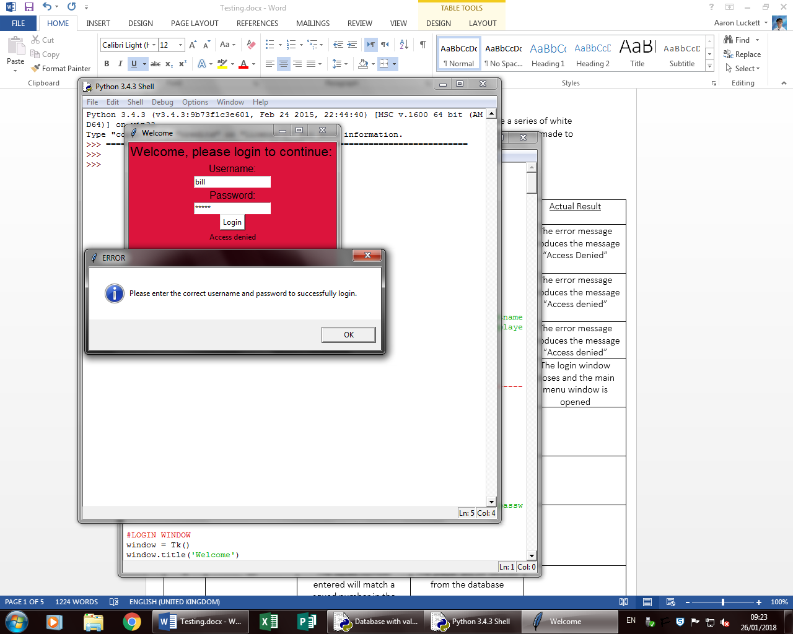Test 1

An error message and error box appears to show what the user has entered is incorrect

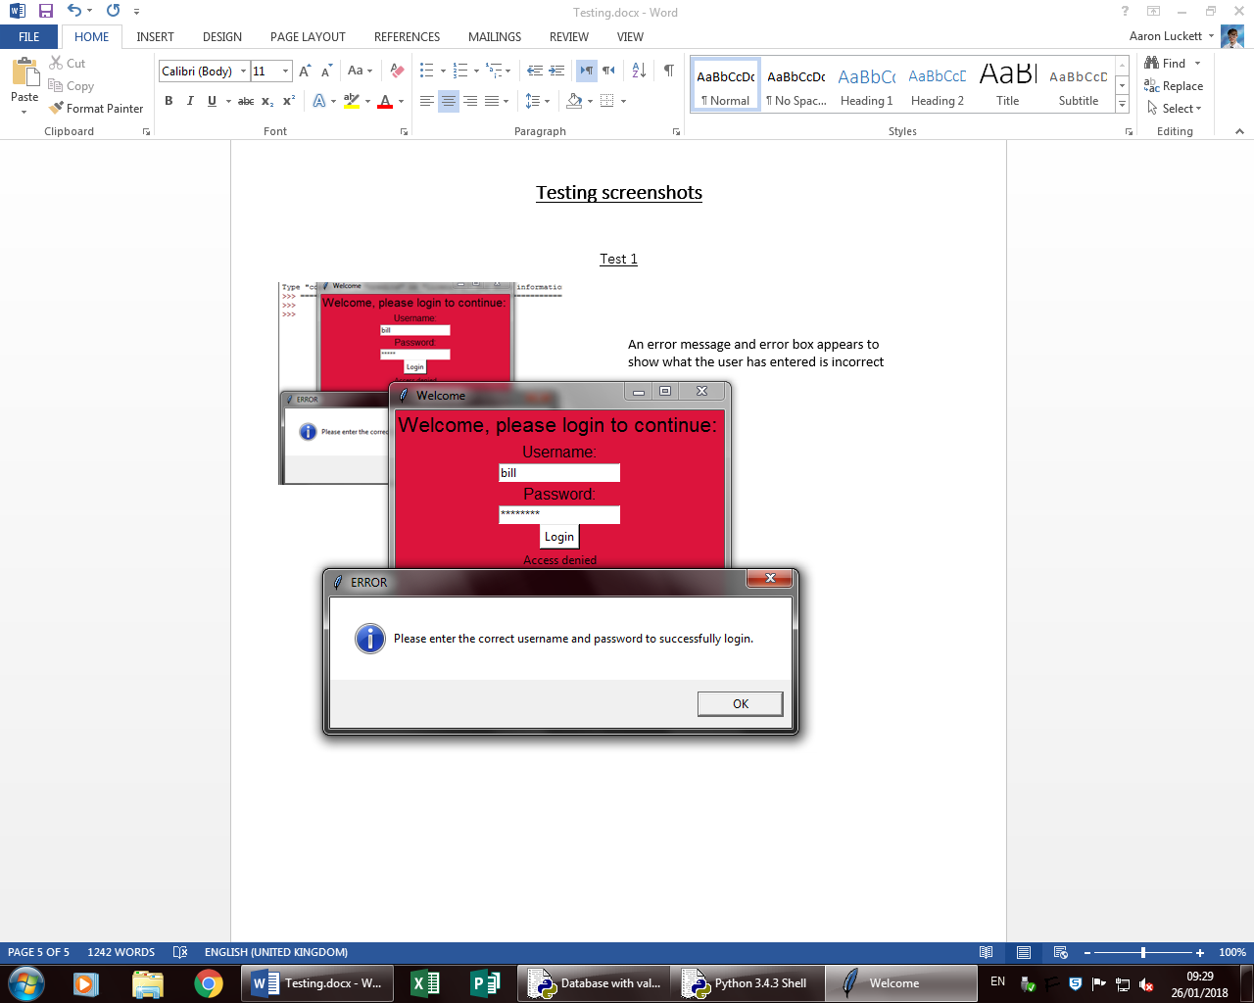Test 2

An error message and box appear as the username is incorrect

Test 3

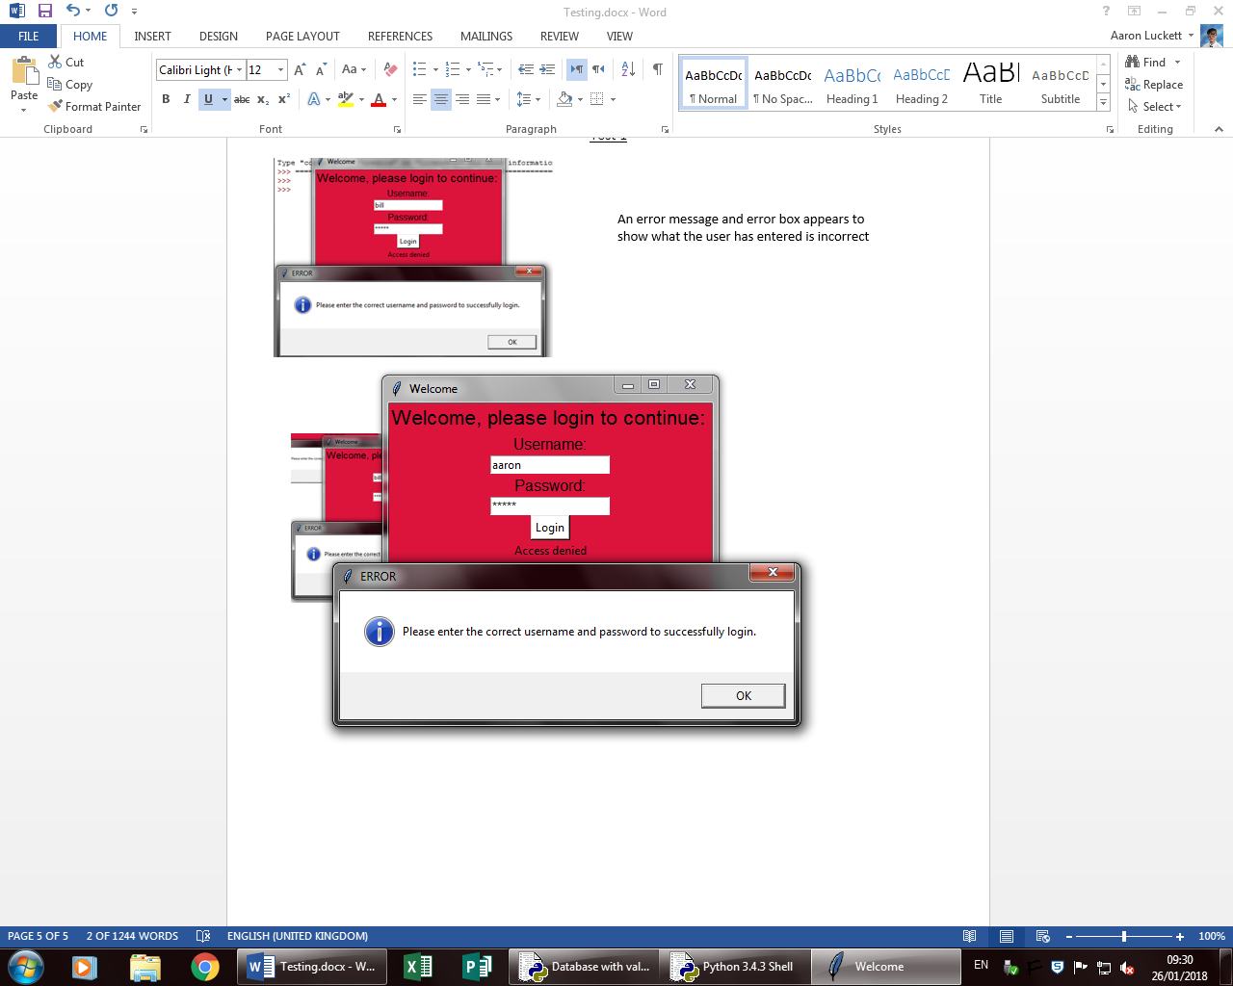

An error message and box appear as the password is incorrect

Test 4

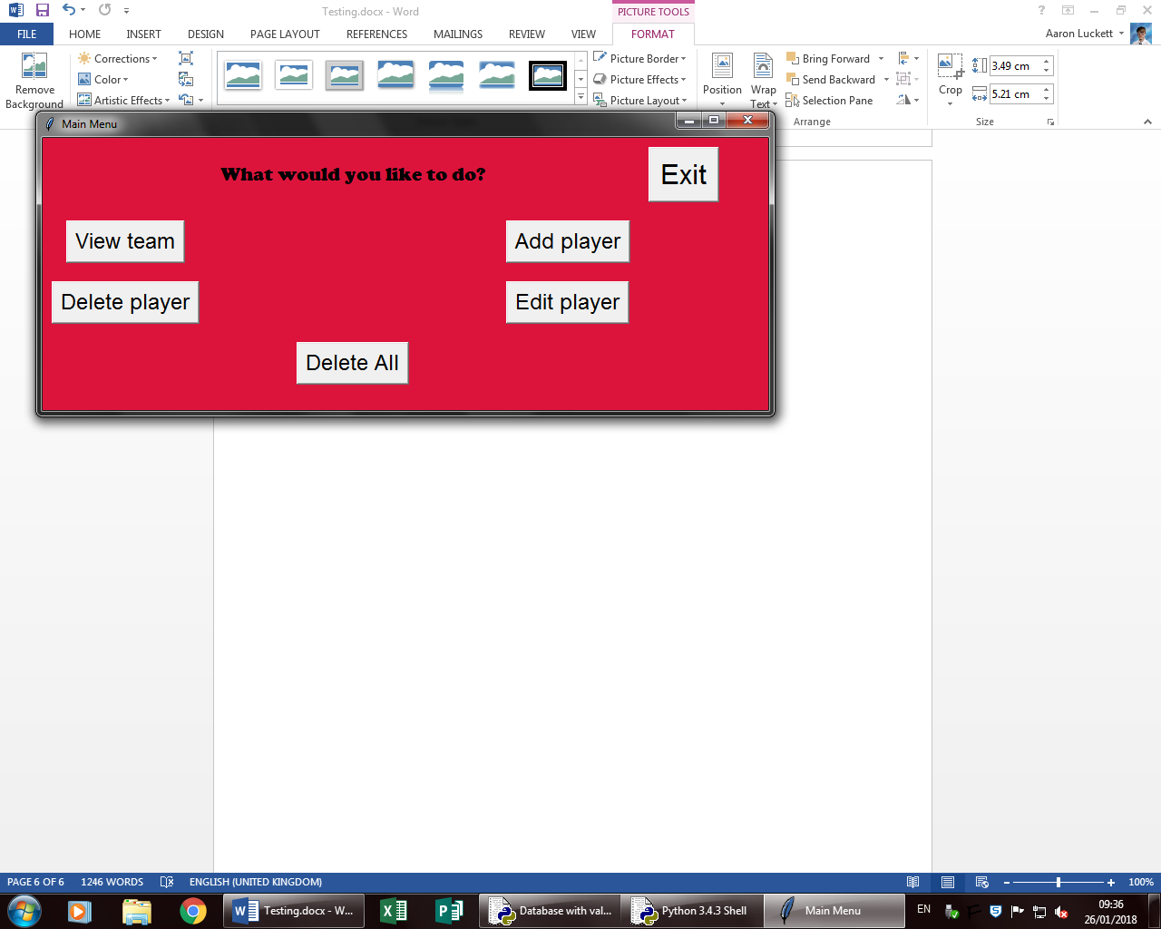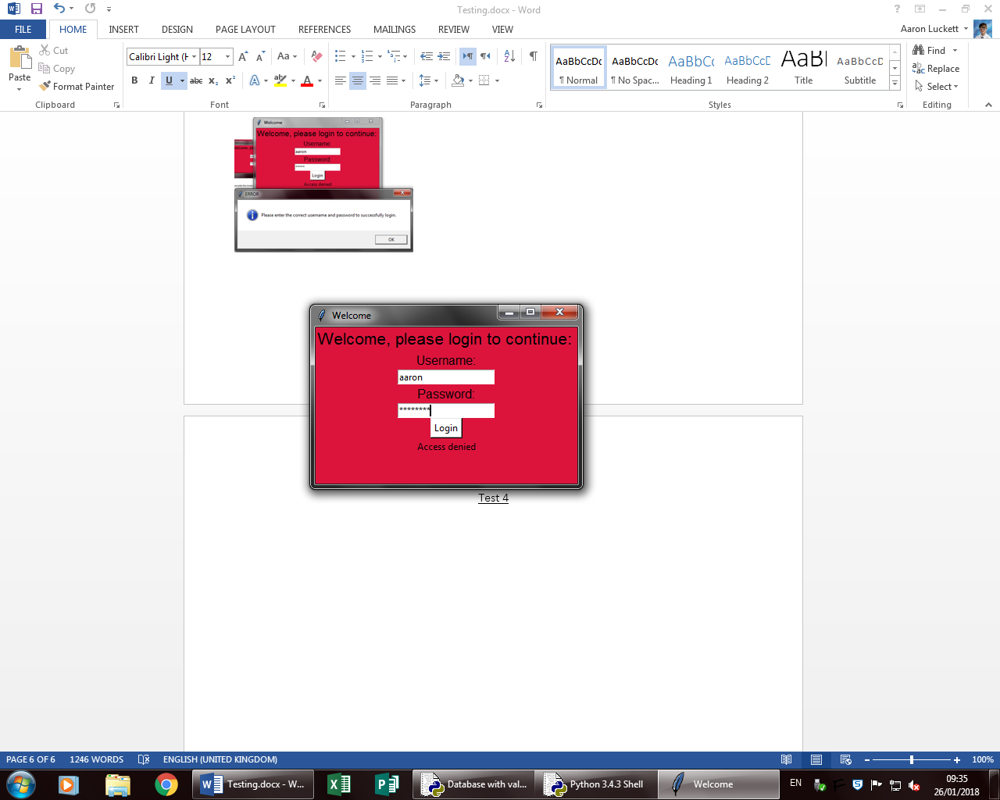

The main menu opens as the username and password are correct

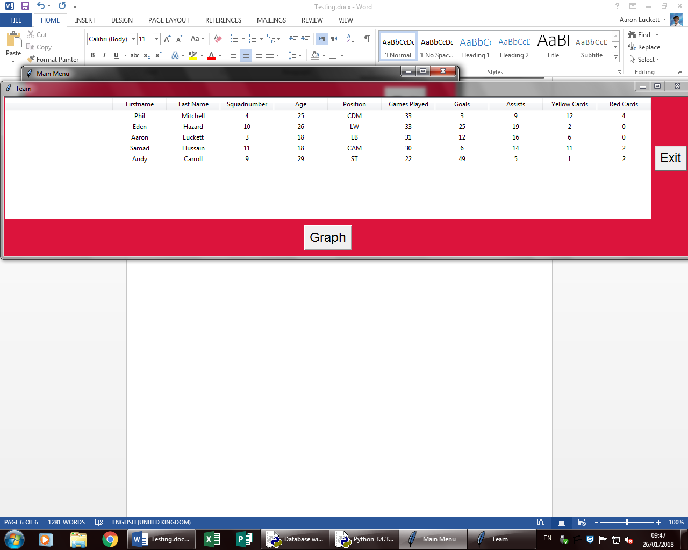Test 5

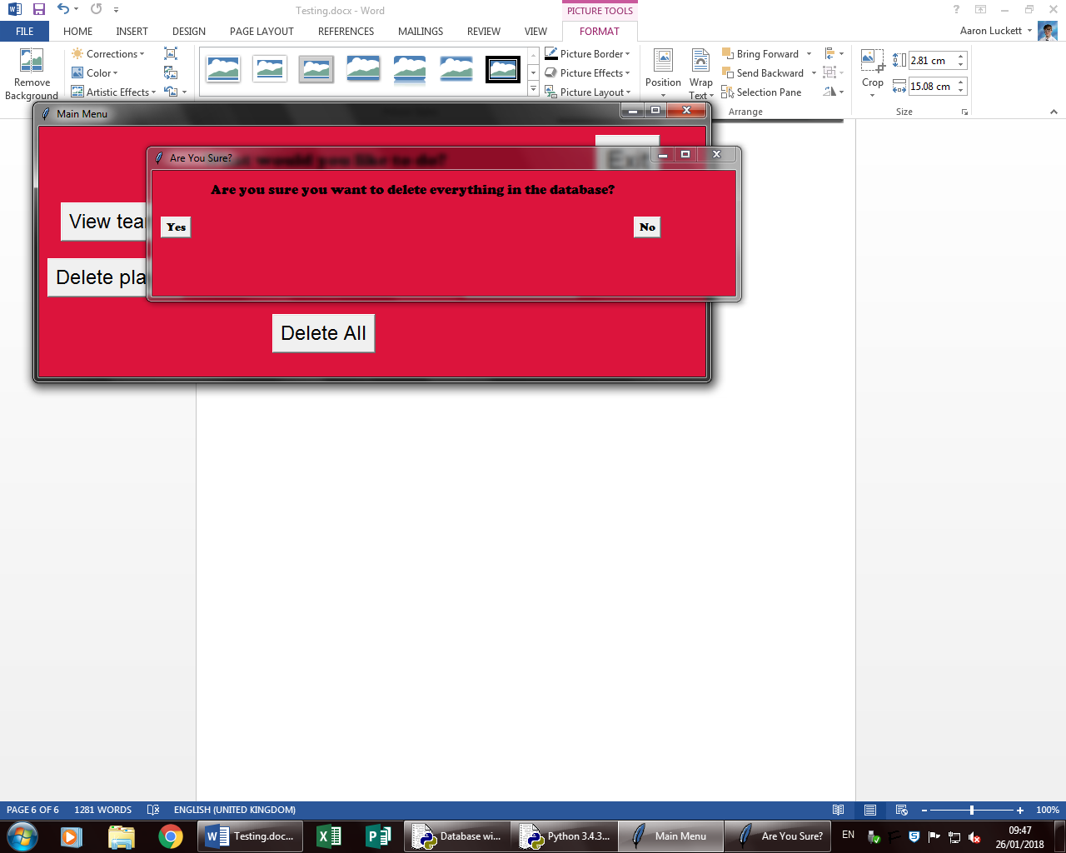

Data in the table for user to view

User deletes all by clicking the yes button

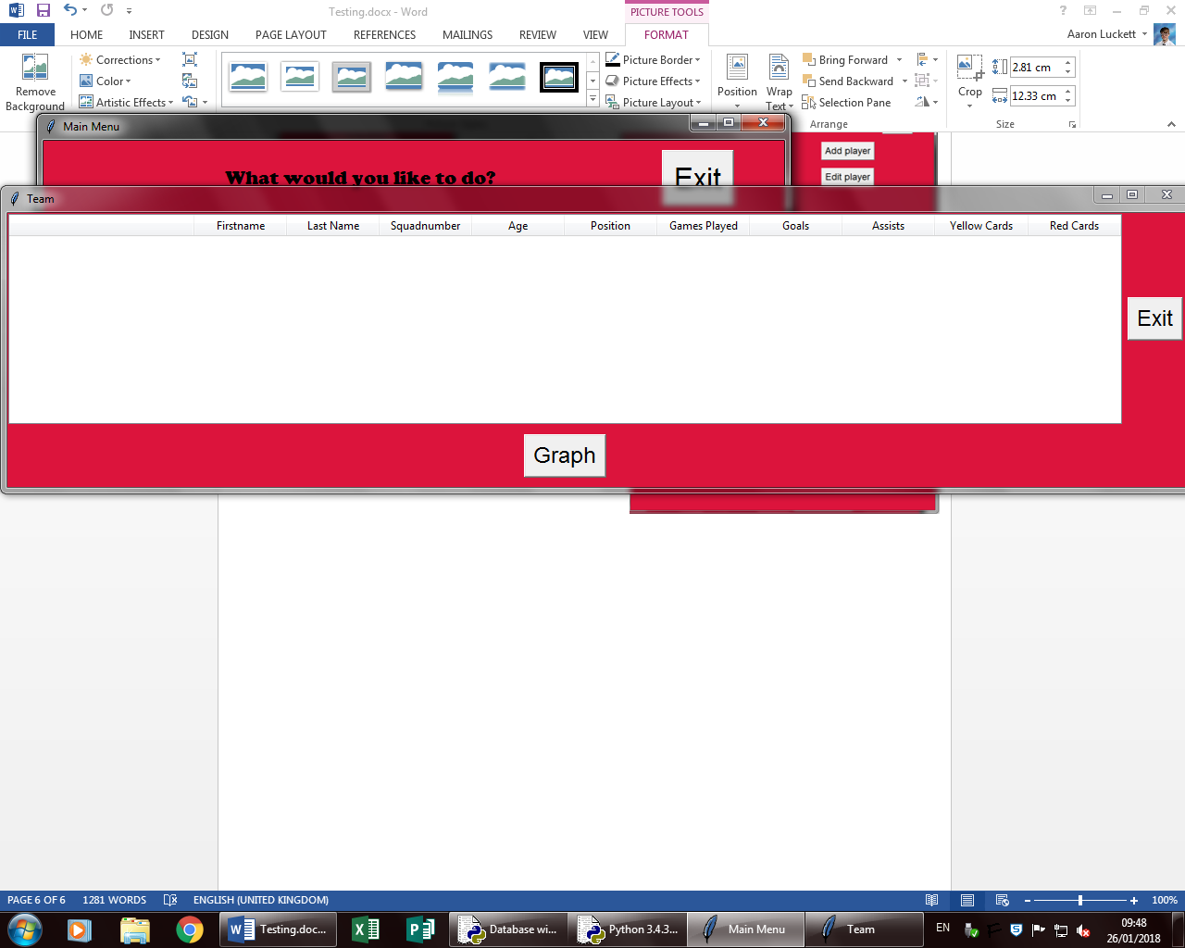

All of the data is cleared from the database

All data is removed from the table

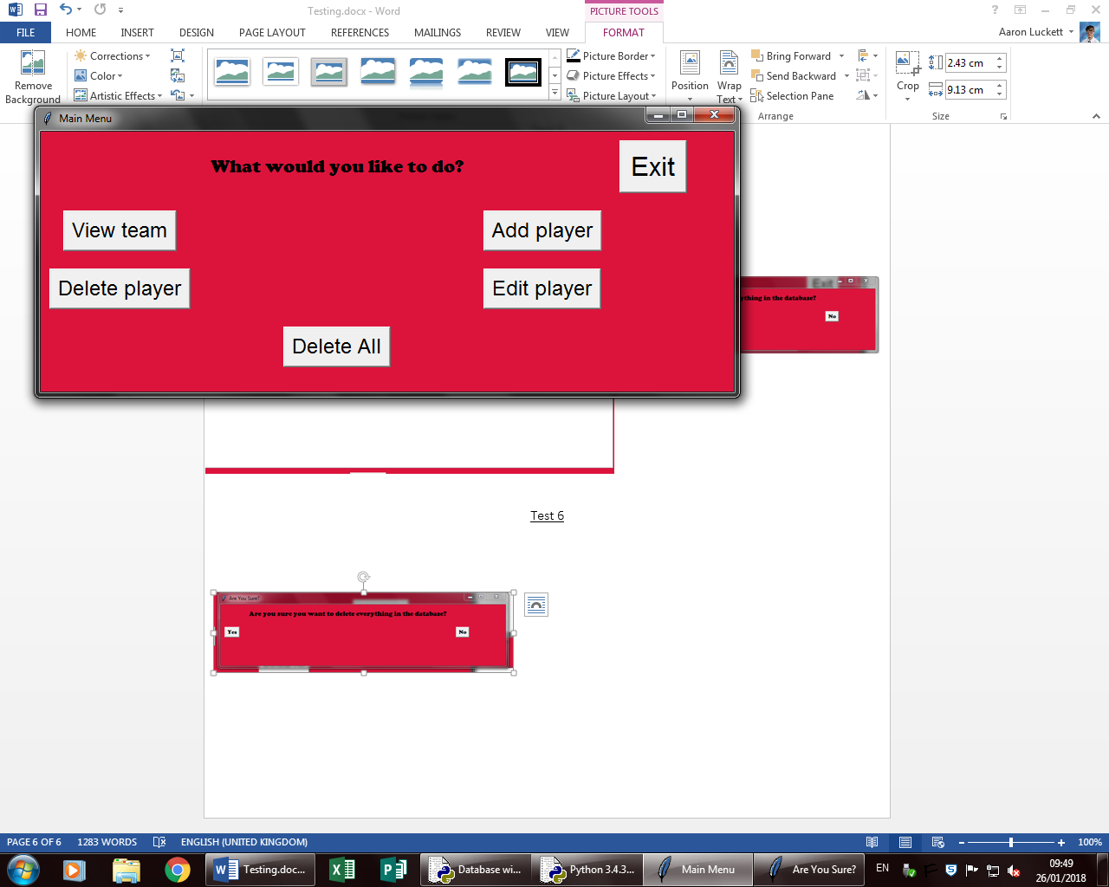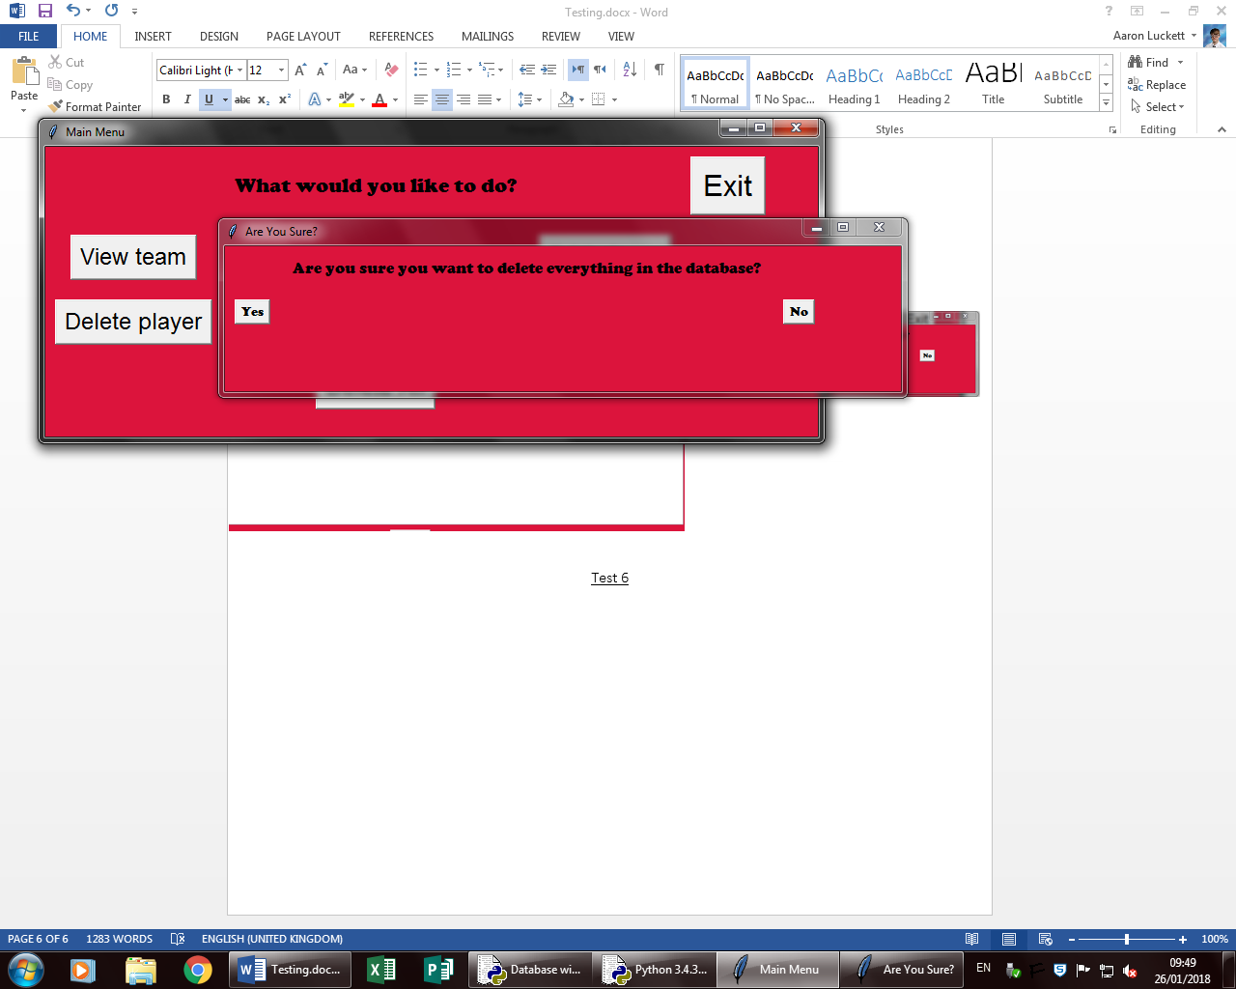

The user clicks the no button and is returned to the main menu

Test 6

Test 7

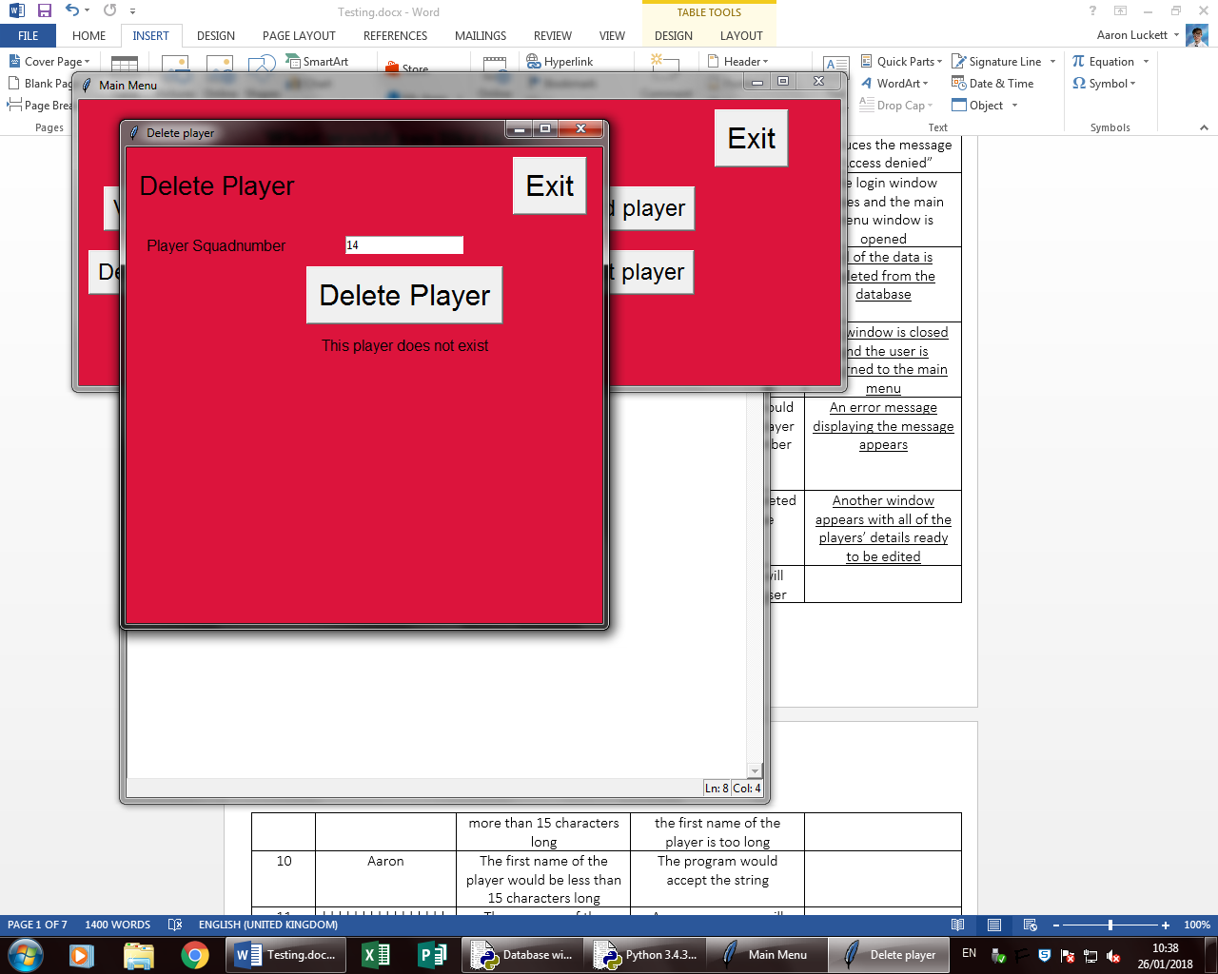

If there is no player with the squad number that matches the on the user enters, an error message will appear

Test 8

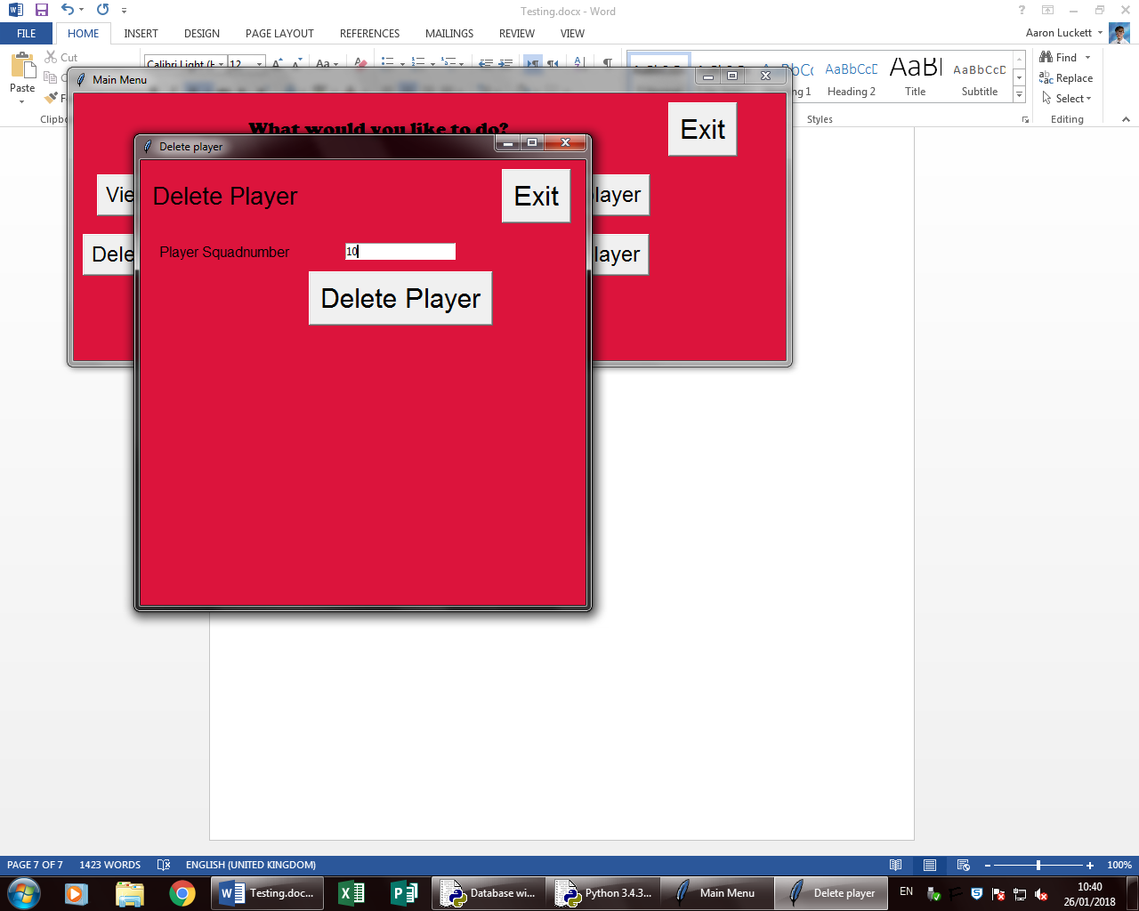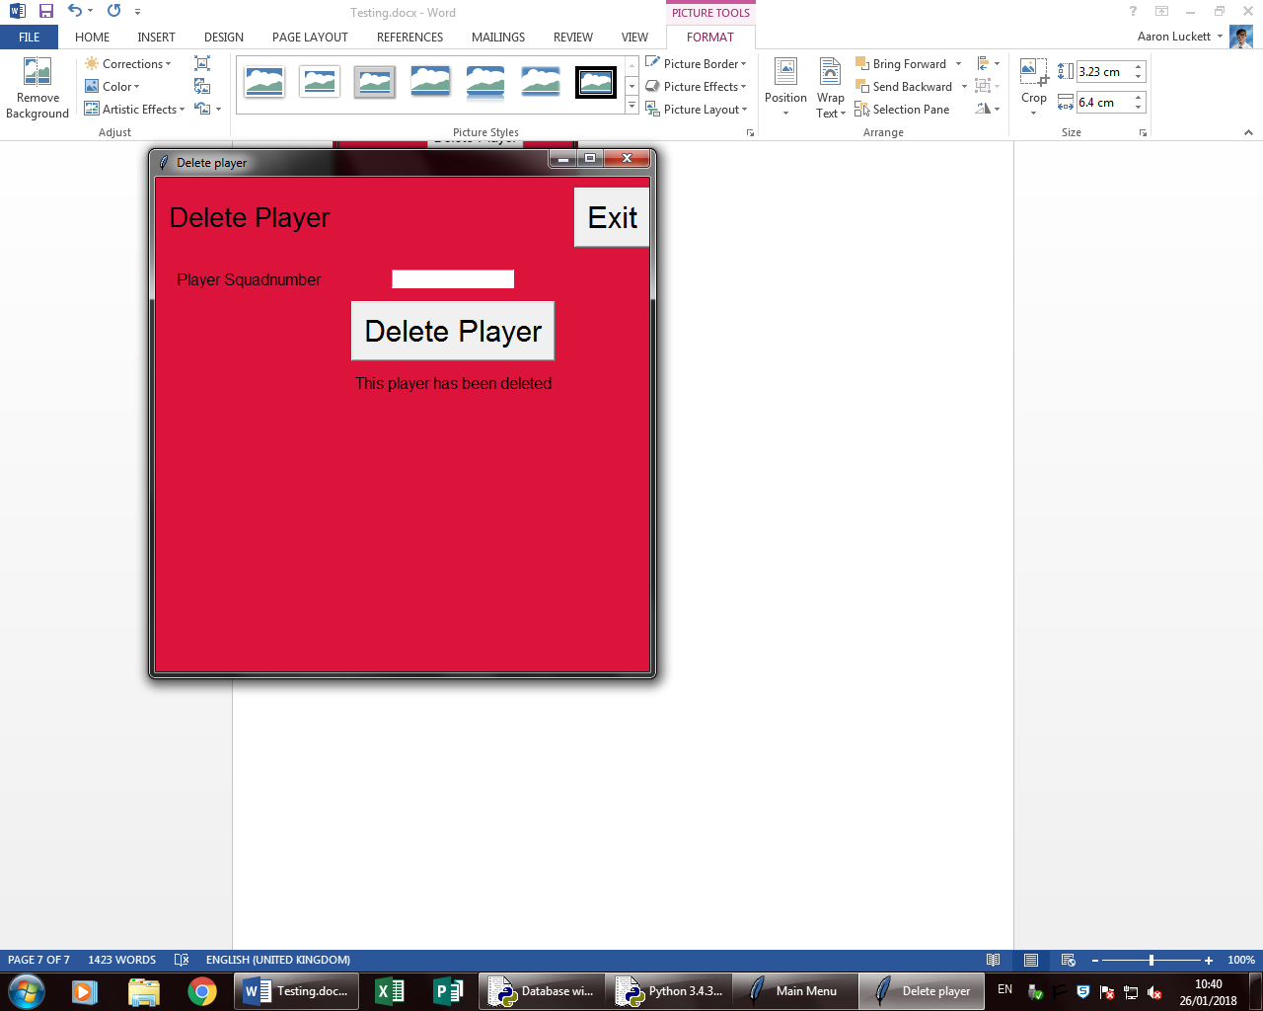

When a squad number that matches one in the database is entered and the button is clicked, the message appears and the player is deleted

Test 9

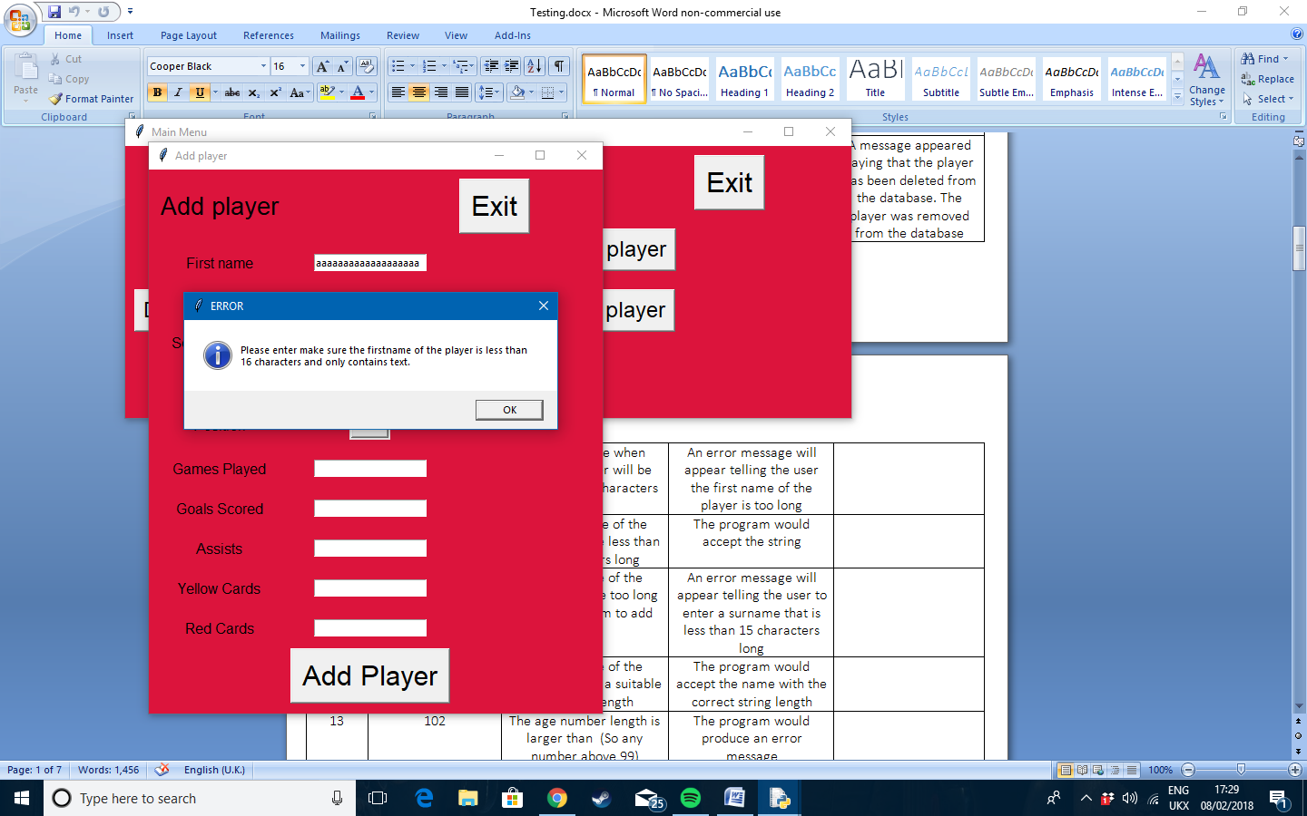

An error message appears saying what the user entered was incorrect

Test 10

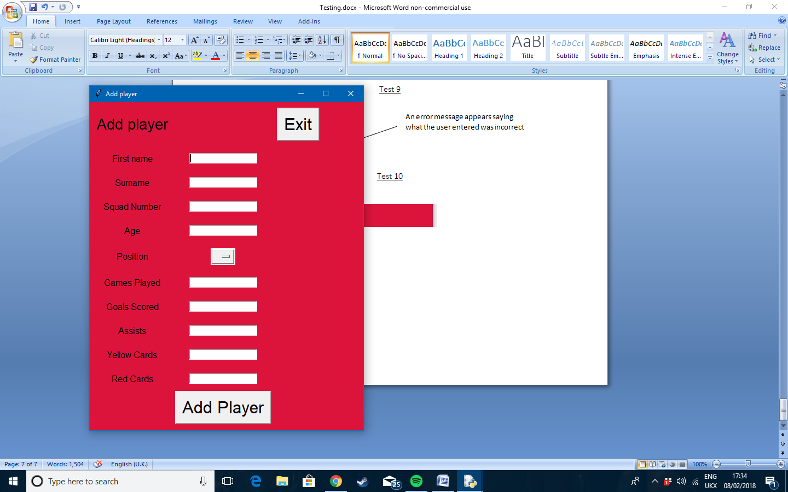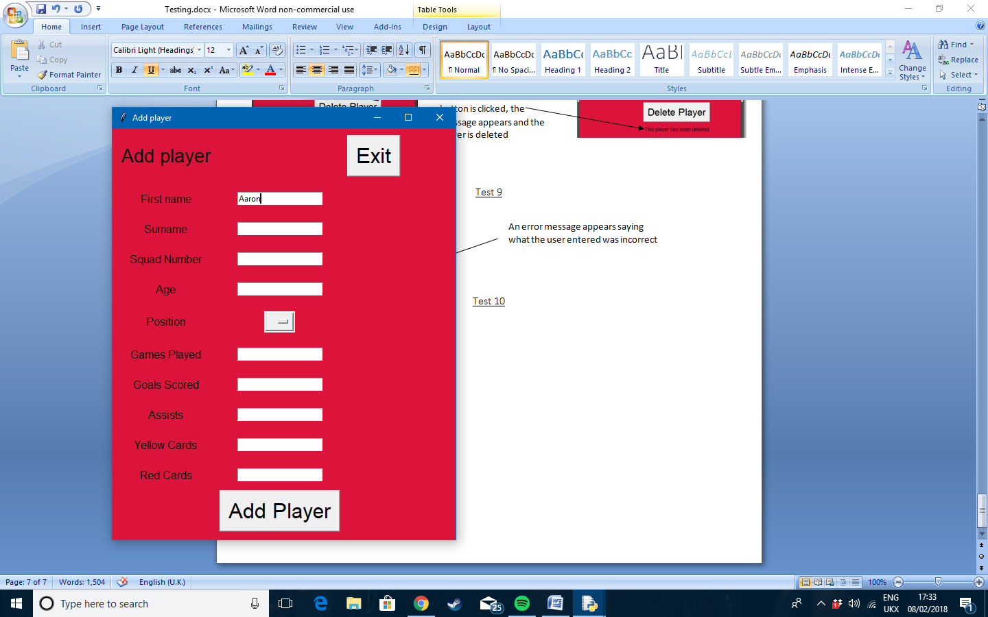

A correct input is entered and the program accepts the value. When add player is clicked the first name is cleared and entered into the database

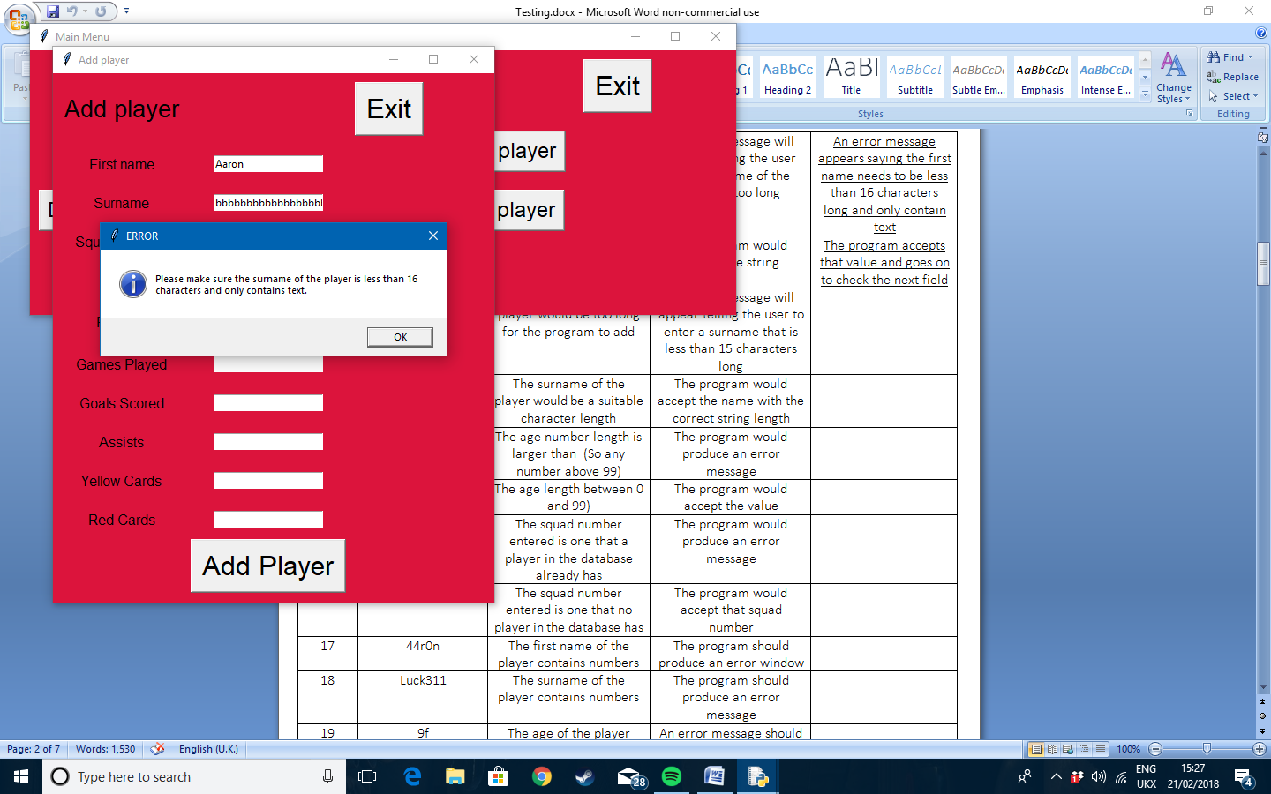Test 11

Error message appears telling the user what is wrong with their input

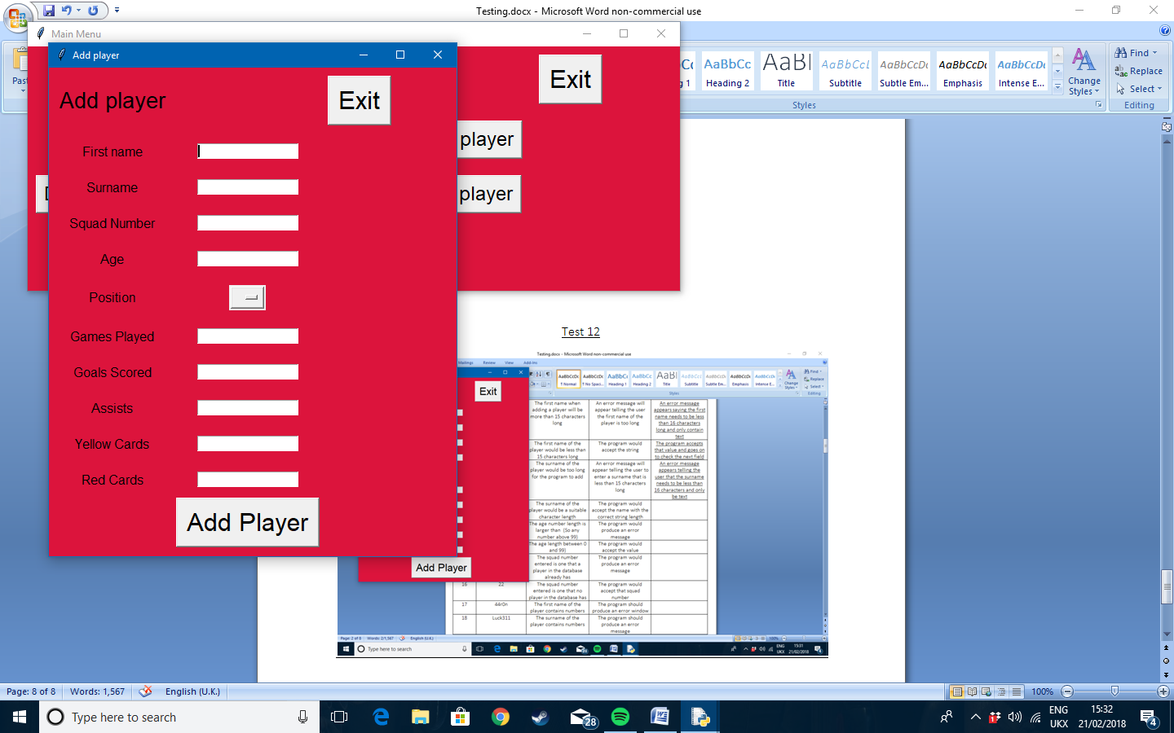Test 12

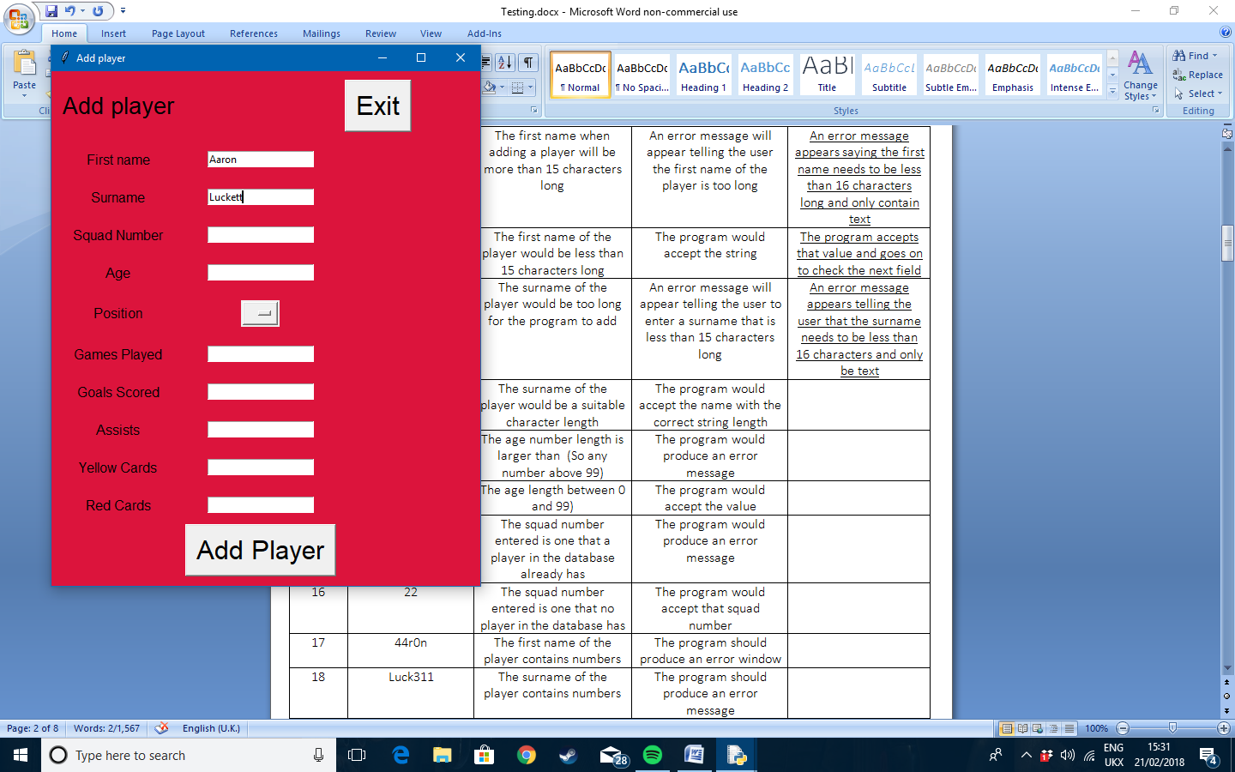

The program accepts the value and stores the surname in the database when the player is added

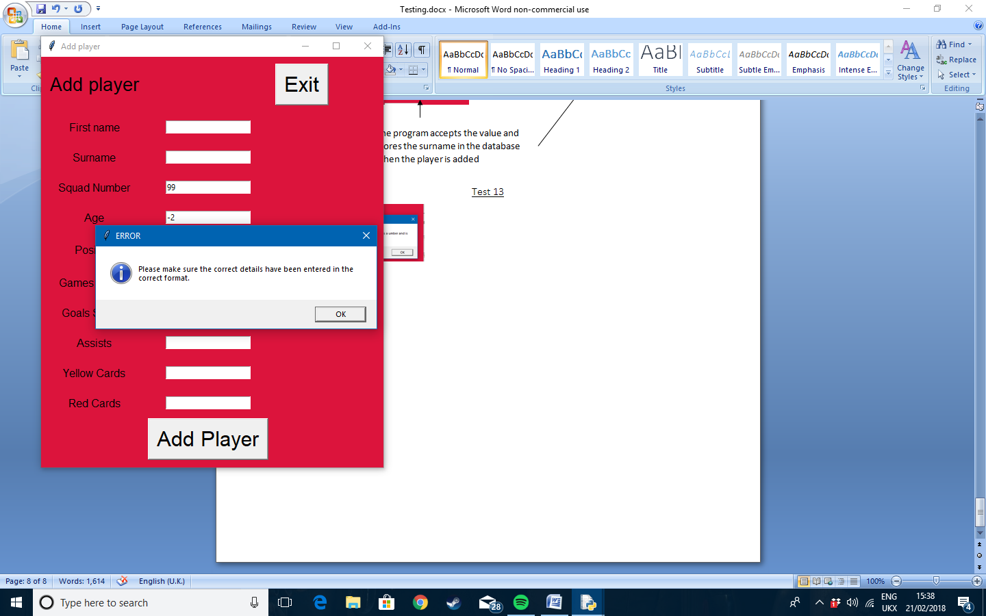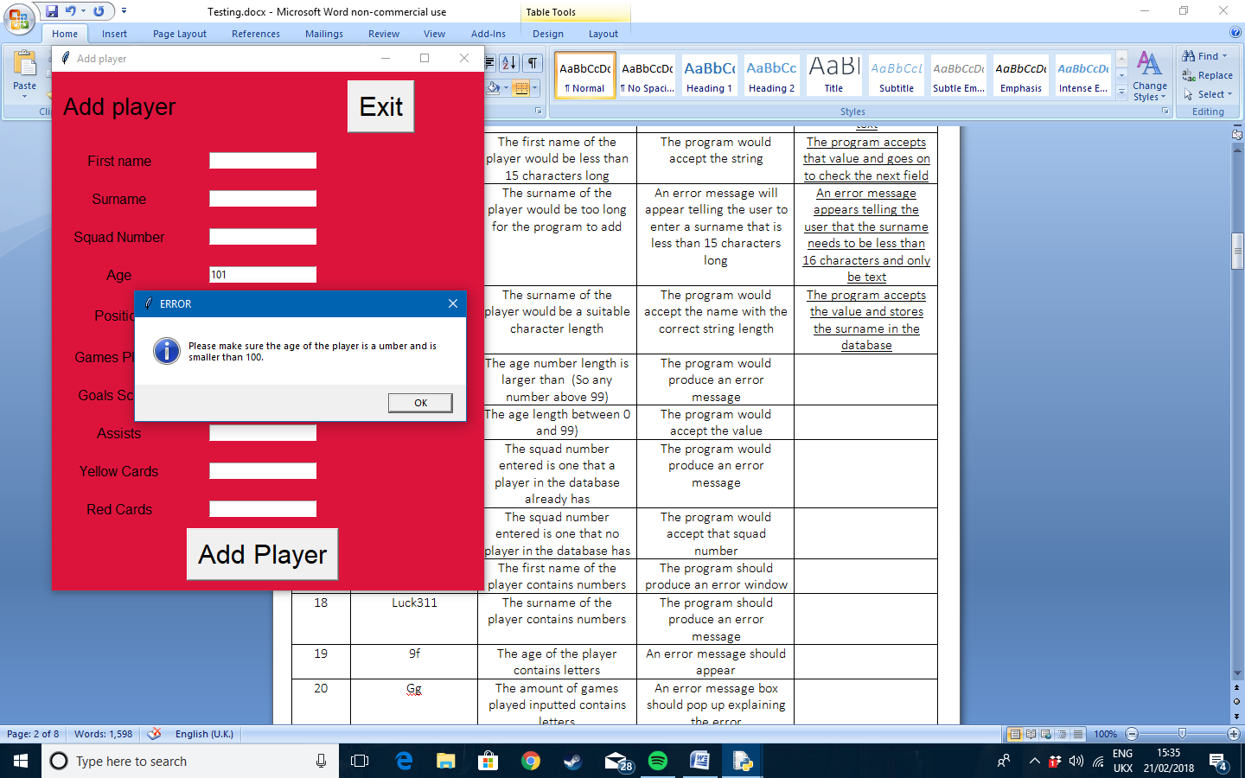Test 13

Error message appears if age if above 100. (Also appears if age is less than 0)

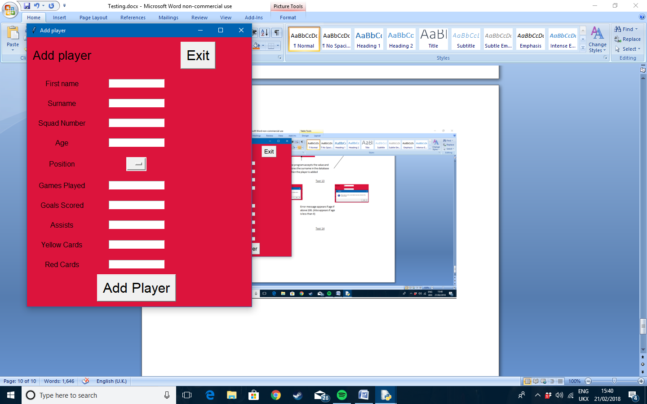Test 14

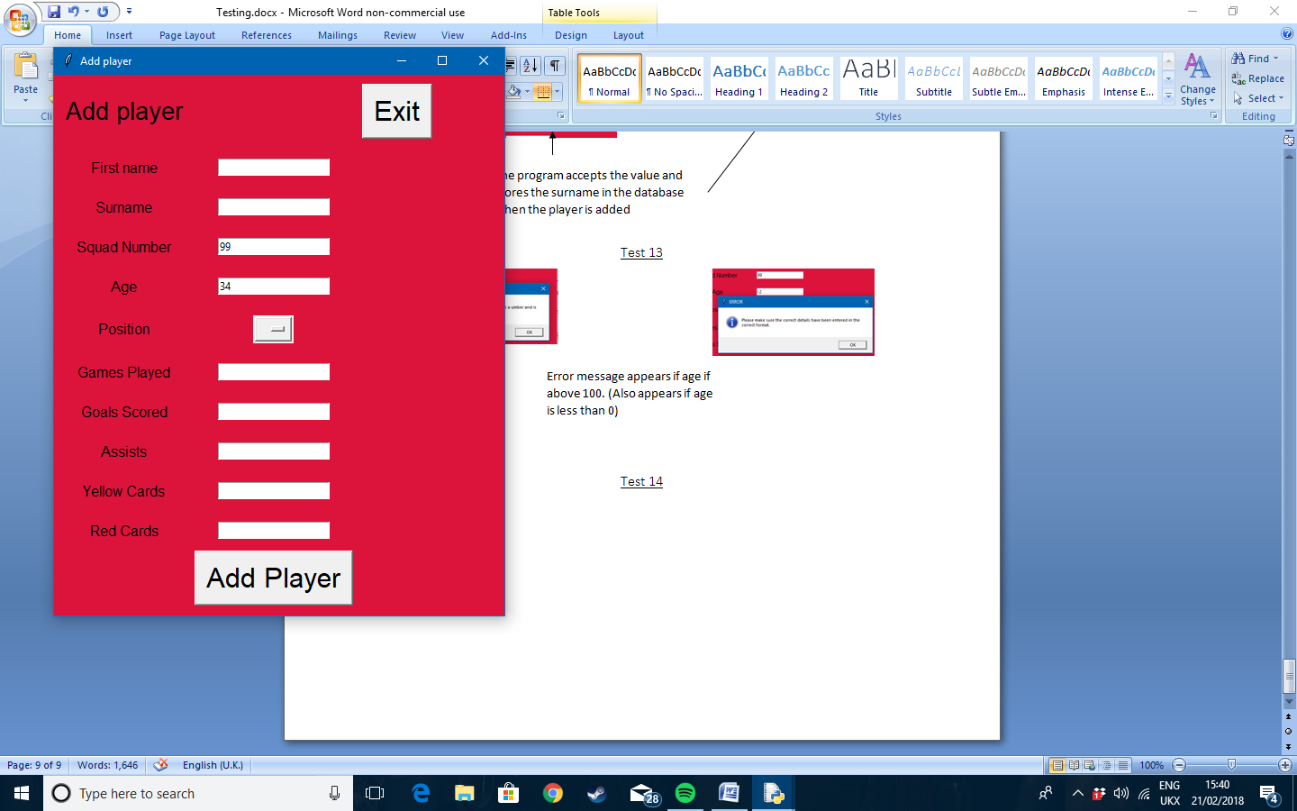

Value is accepted and added to the database when correct

Test 15 and 16

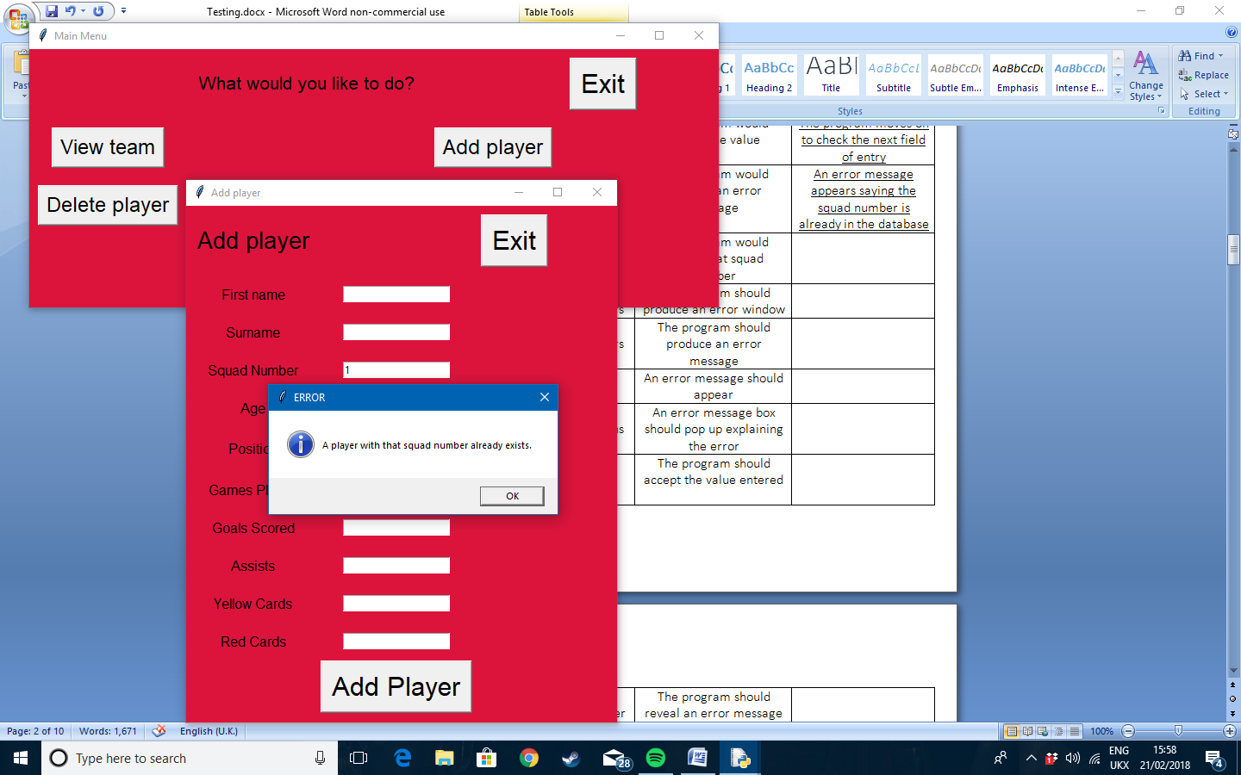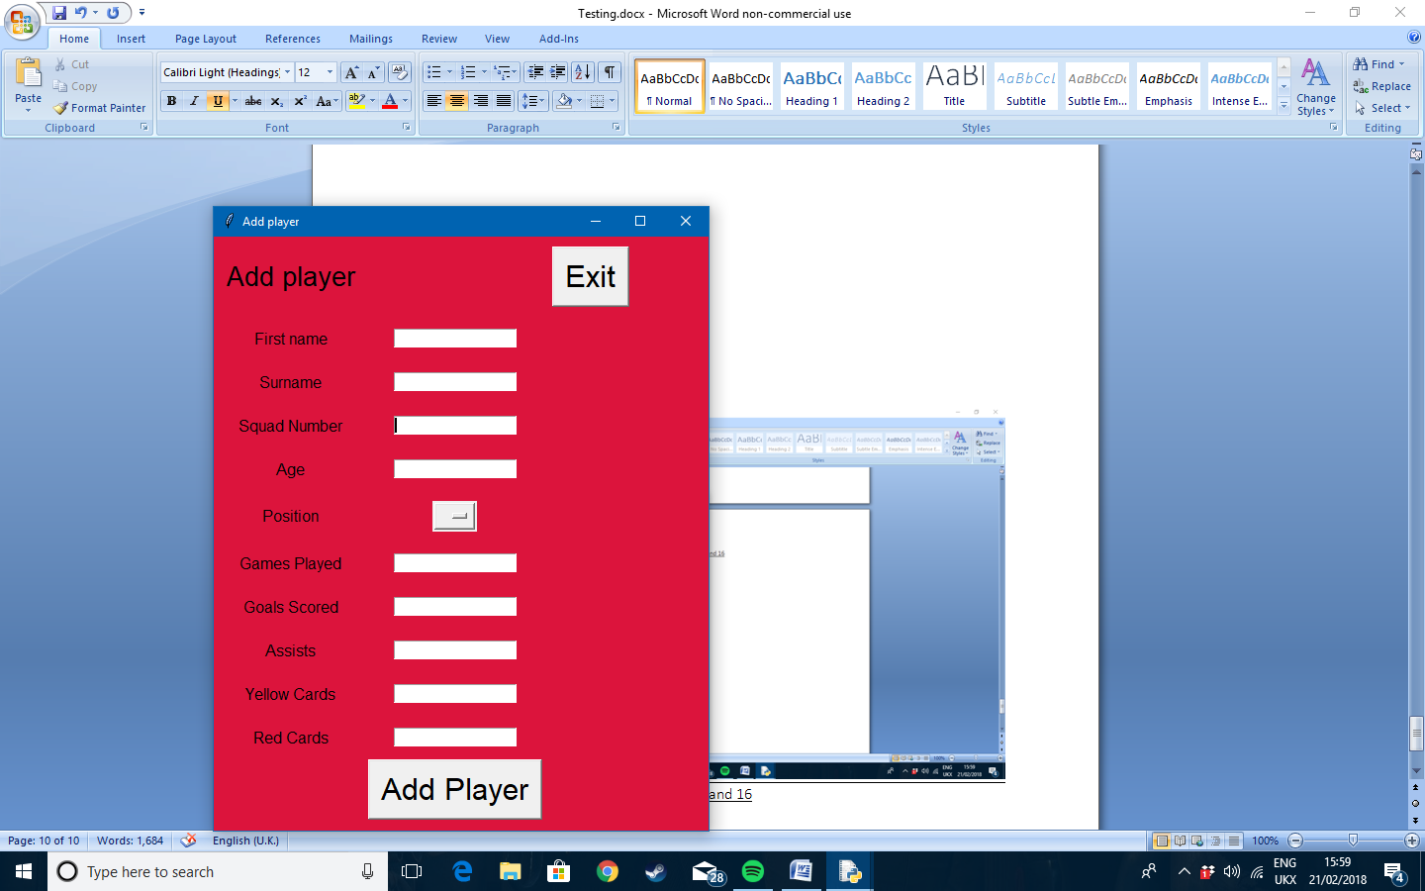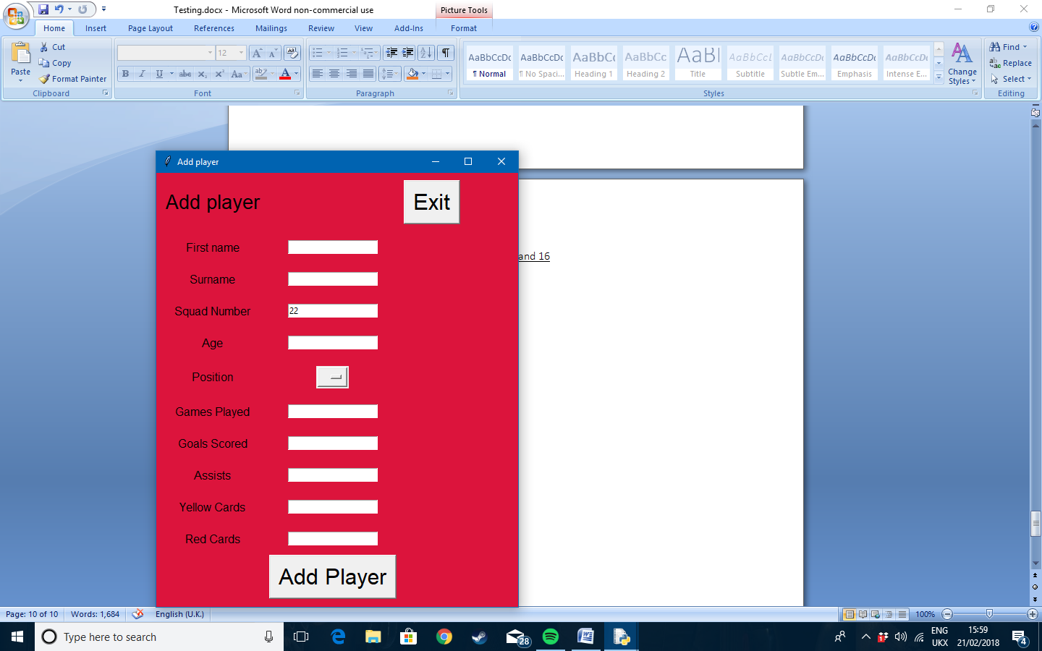

When a squad number that is already stored in the database is entered an error message appears. However when there is no matching squad number already stored the program stores it into the database

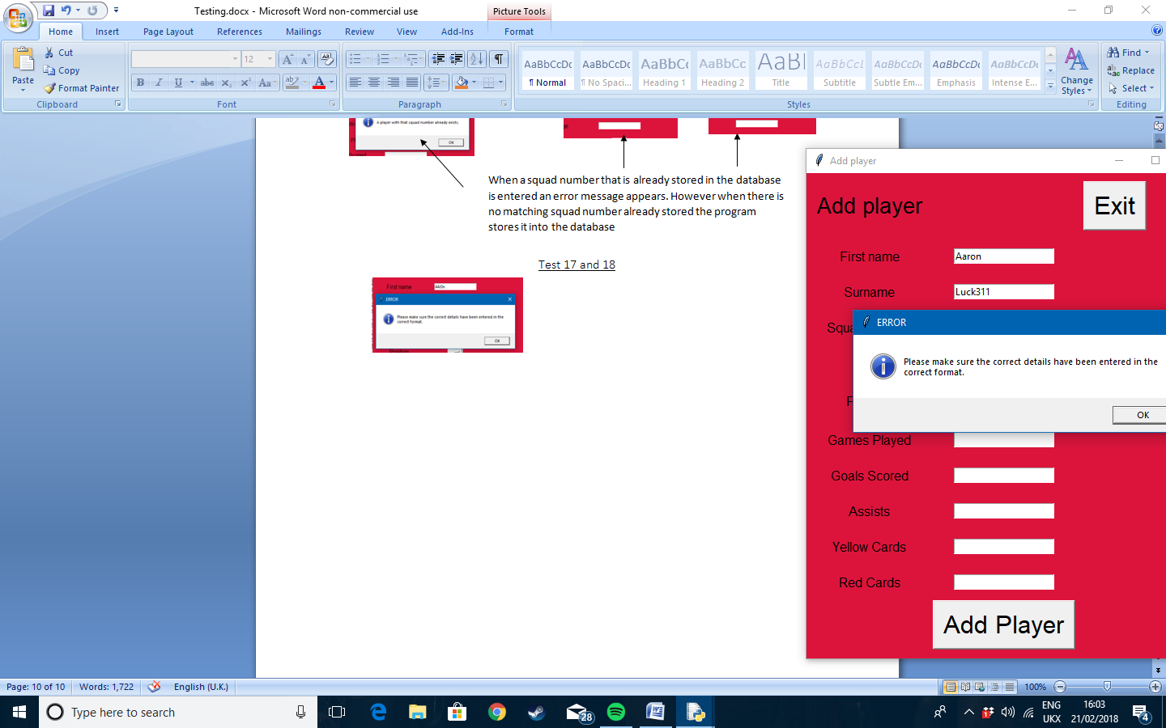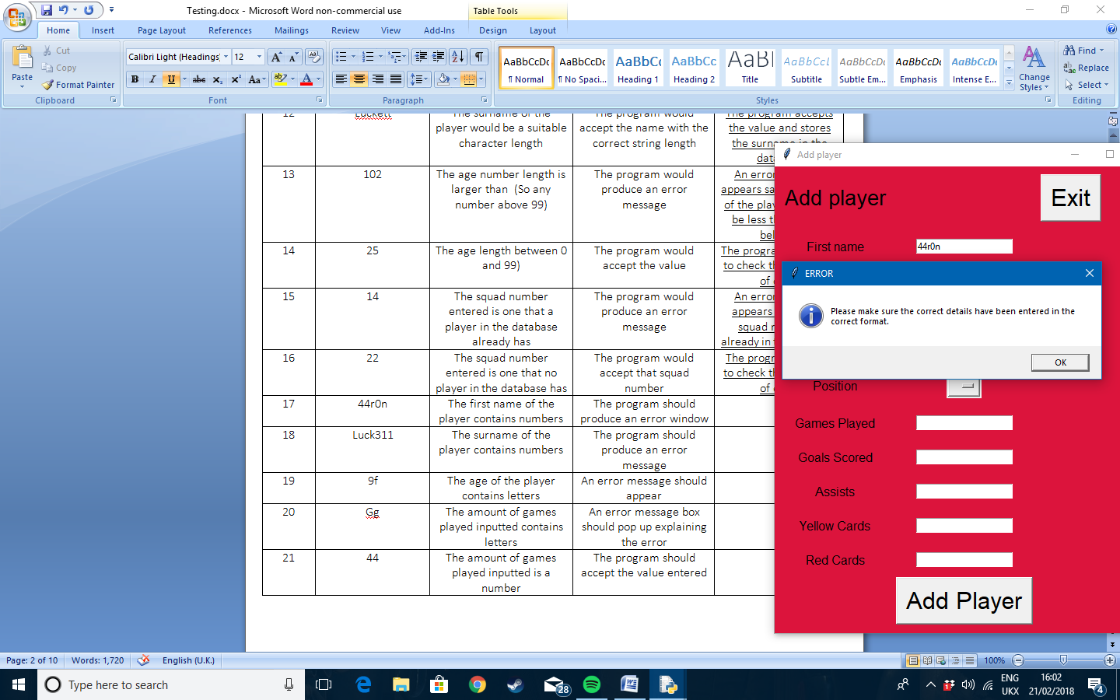Test 17 and 18

When the first name or the surname contains anything but letters, the database tells the user in the form of an error message

Test 19

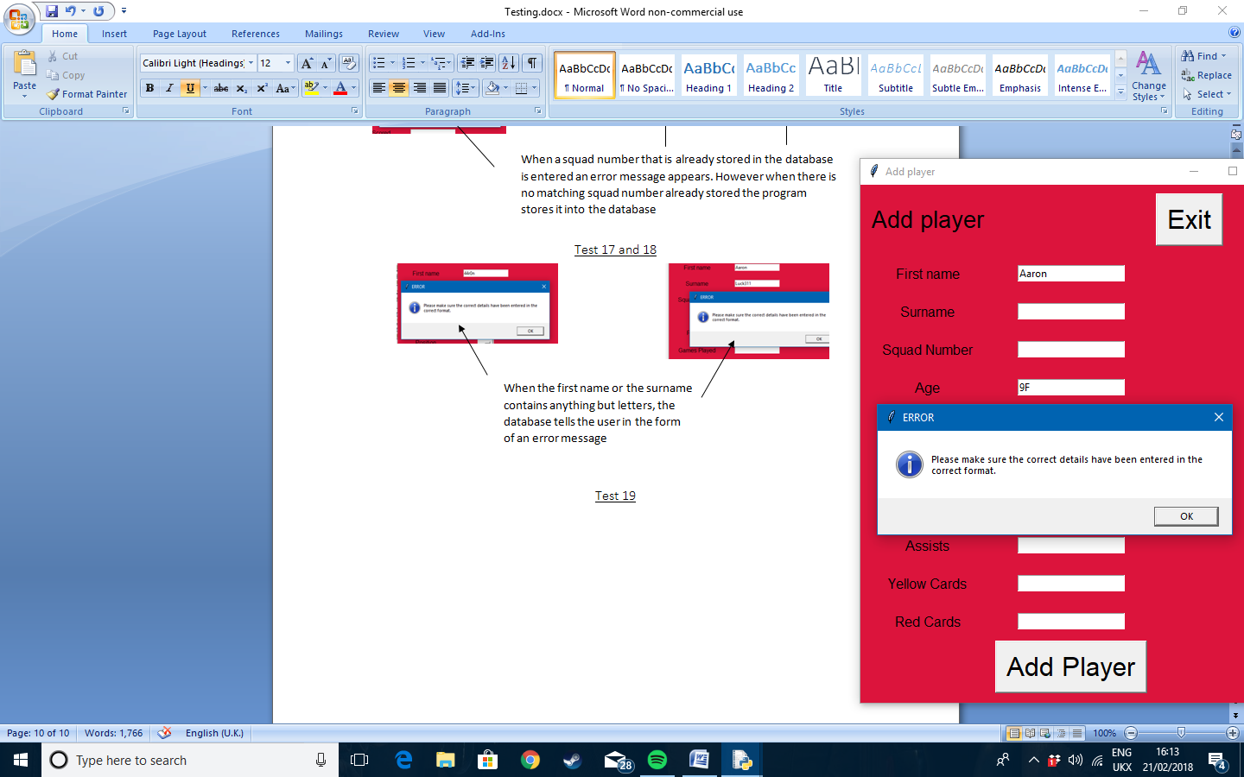

The error message appears telling the user that the incorrect details have been entered

Test 20 and 21

When something that does not contain an integer is entered for games played an error box appears. When a number is entered however, the program accepts the value and store sit into the database

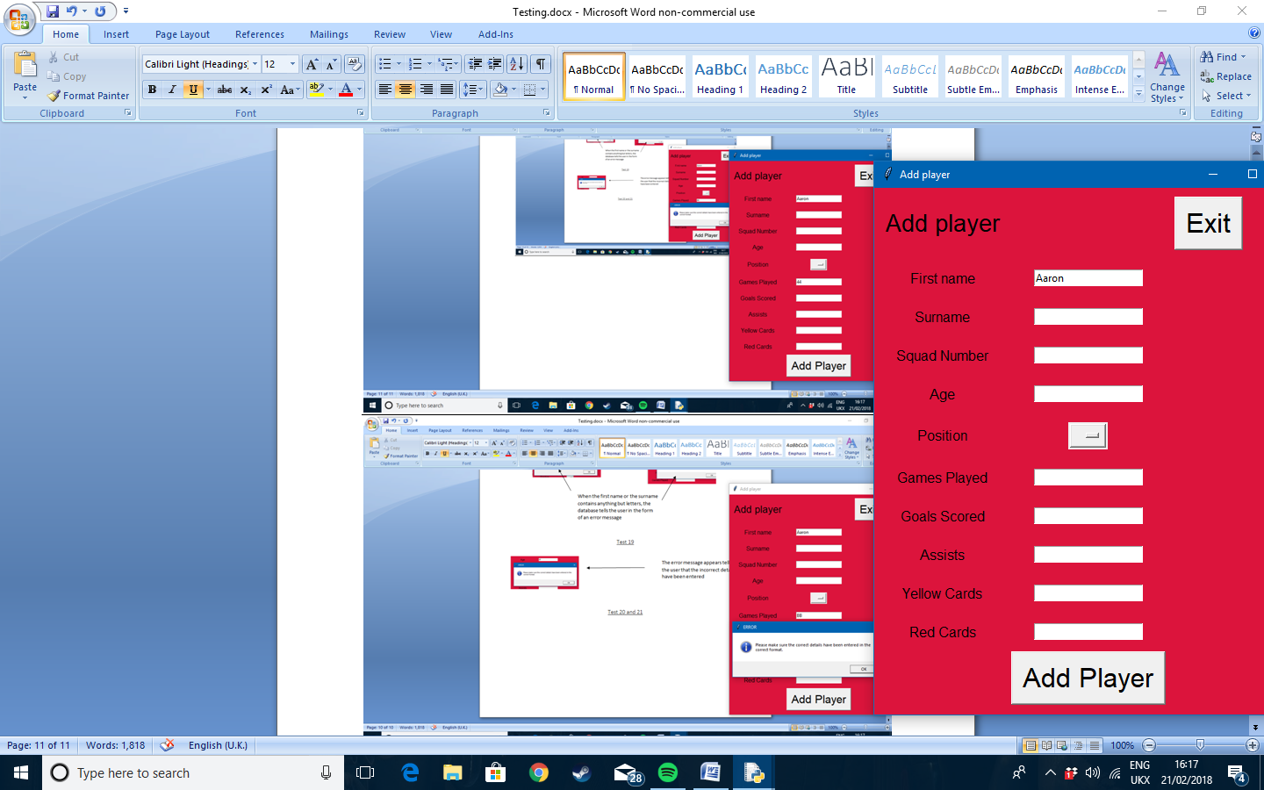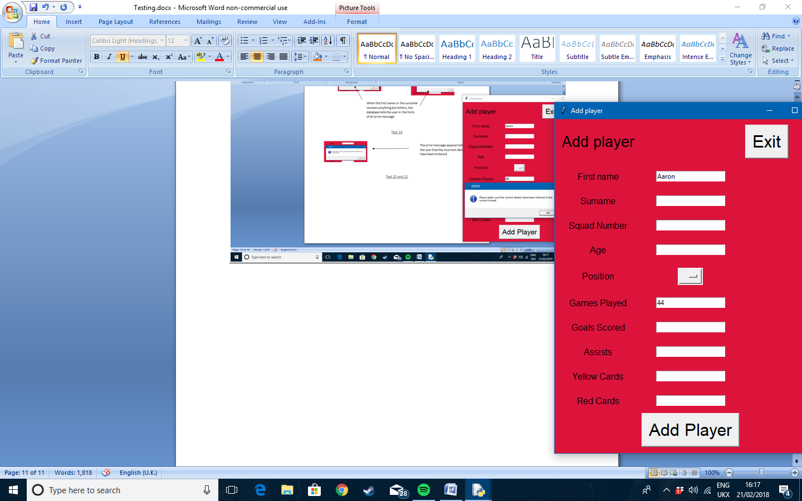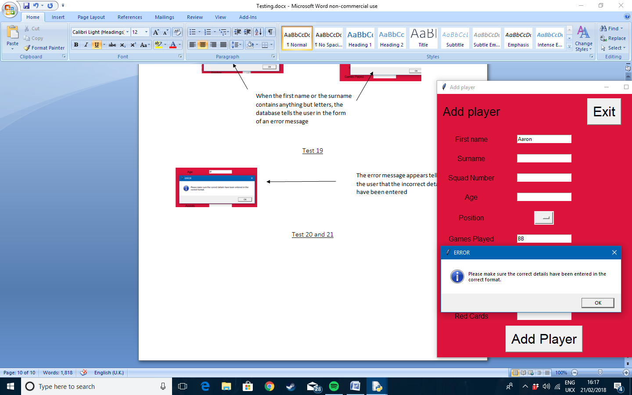

Test 22 and 23

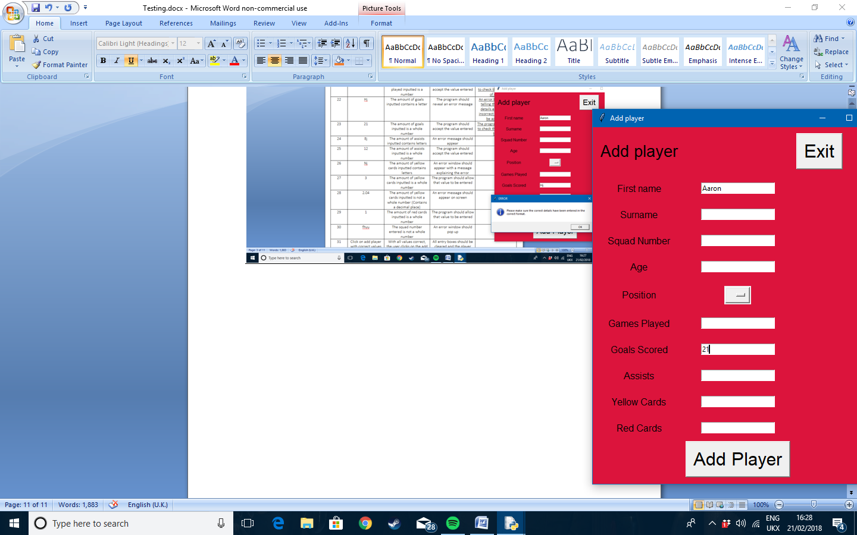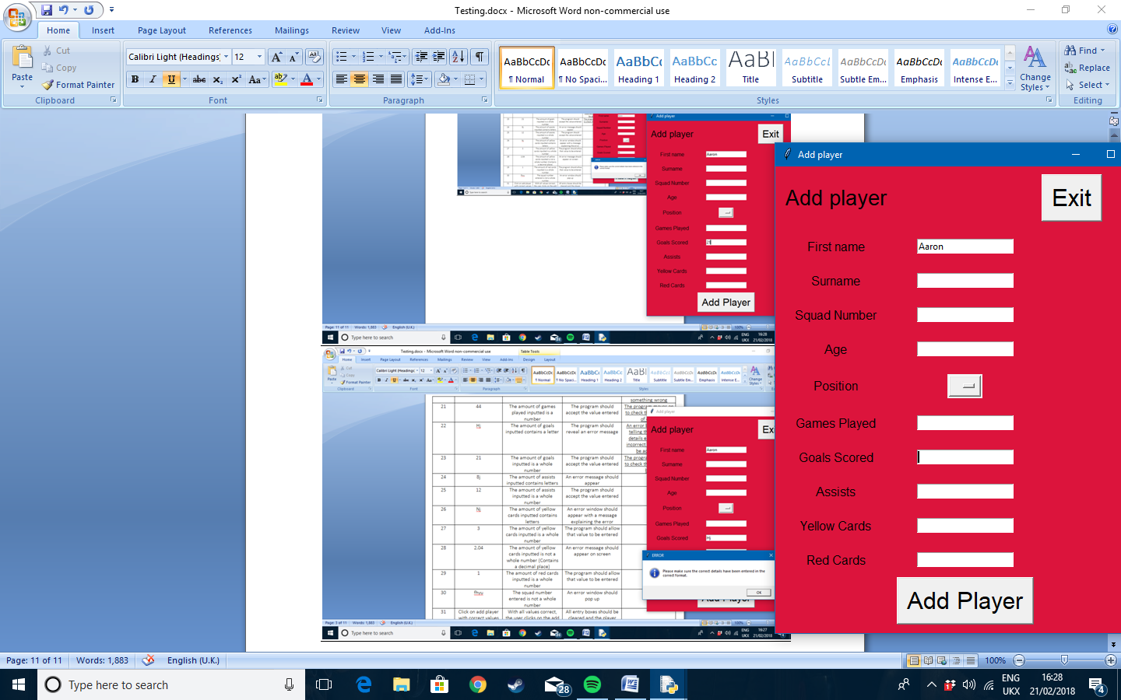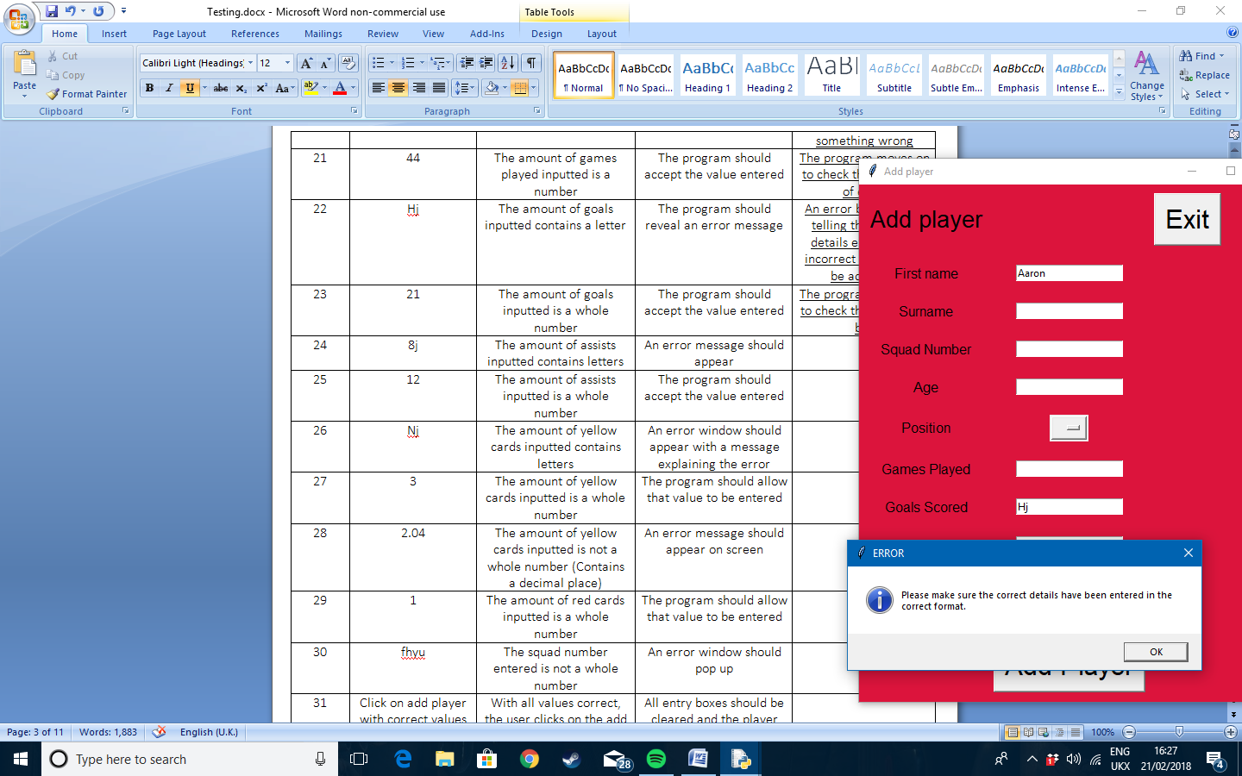

When the amount of goals scored entered is not a number the error message appears. However when an accepted value is entered the program moves on to the next entry box

Test 24 and 25

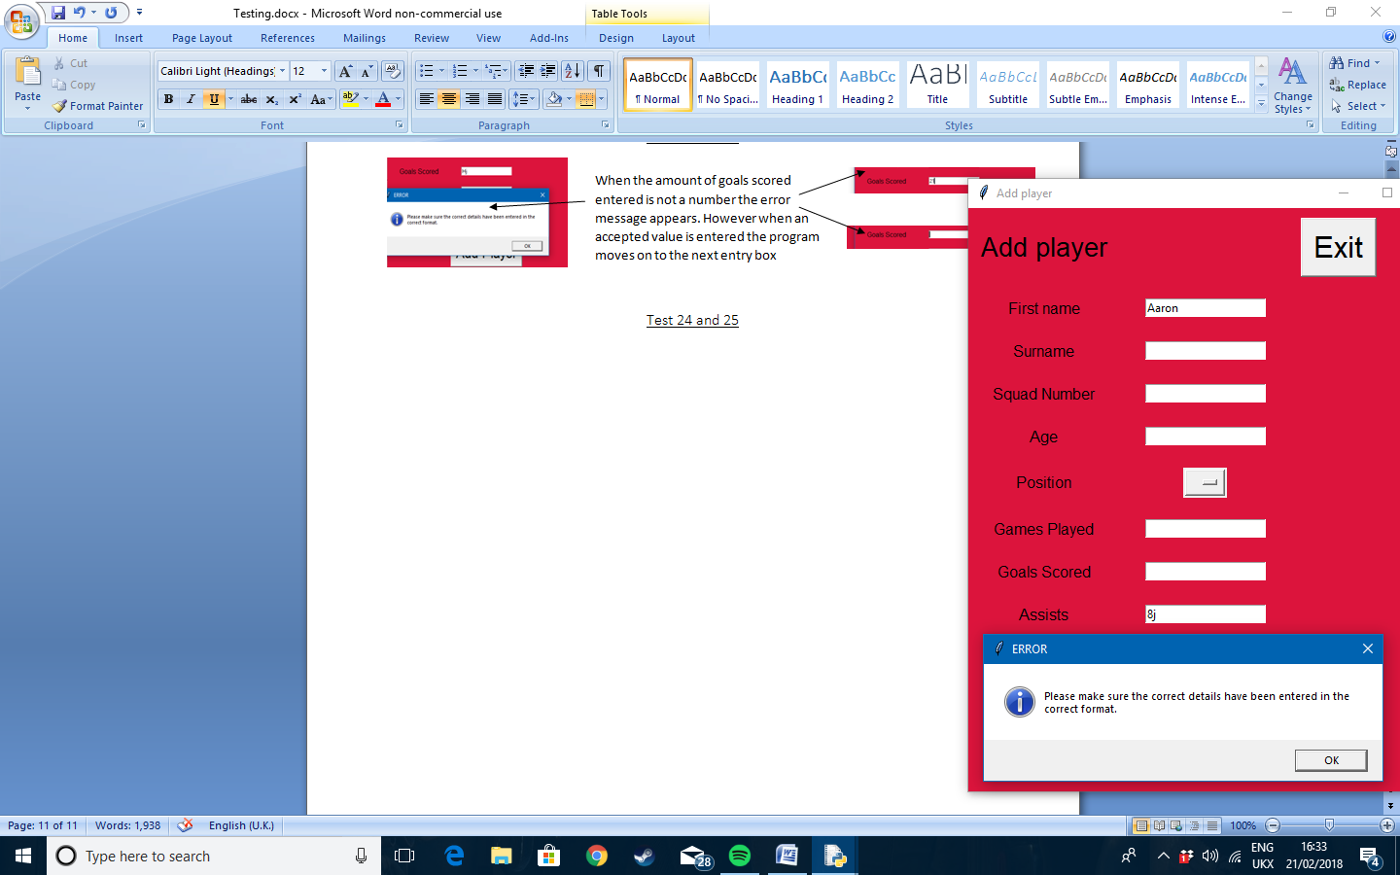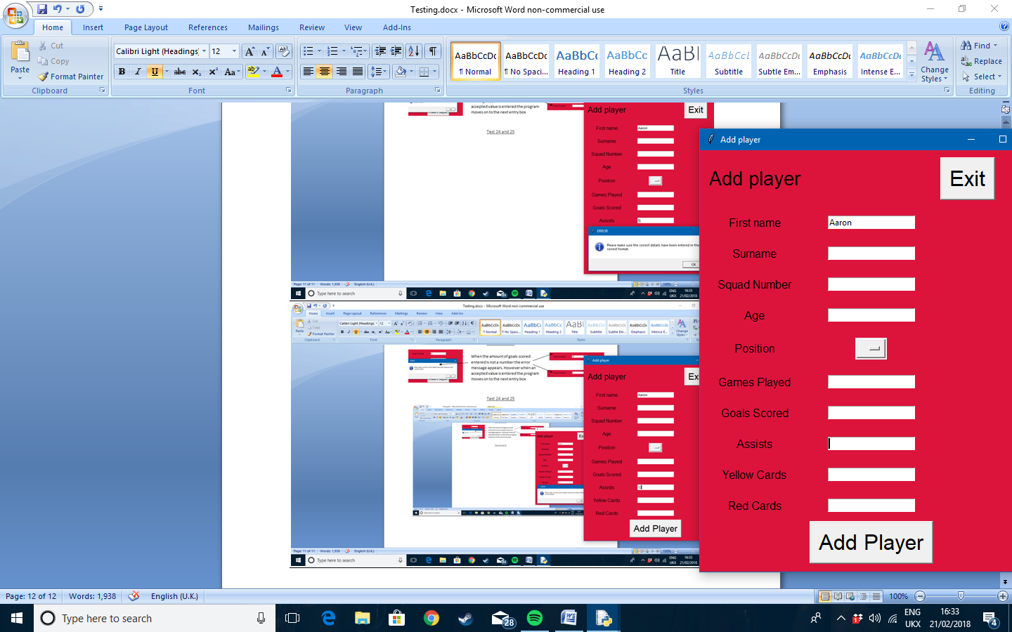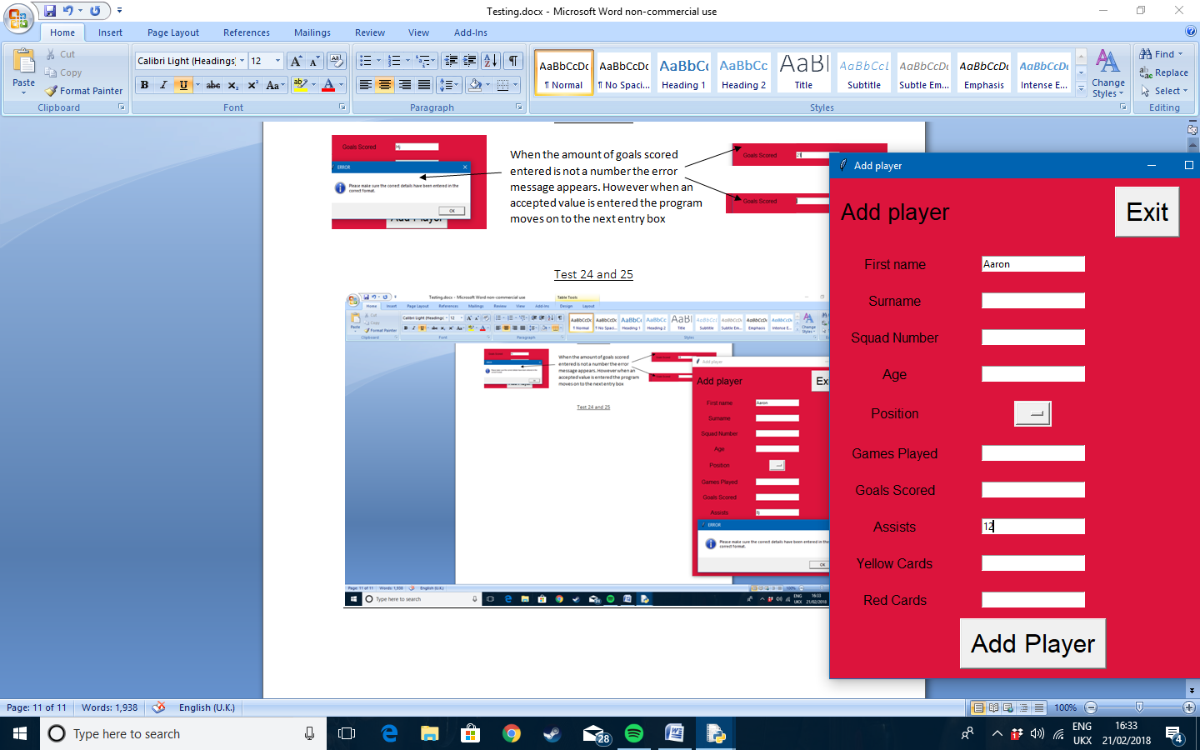

When the amount of assists made is not a whole number the error message will appear. If the value entered is a whole number it will be accepted

Test 26 and 27

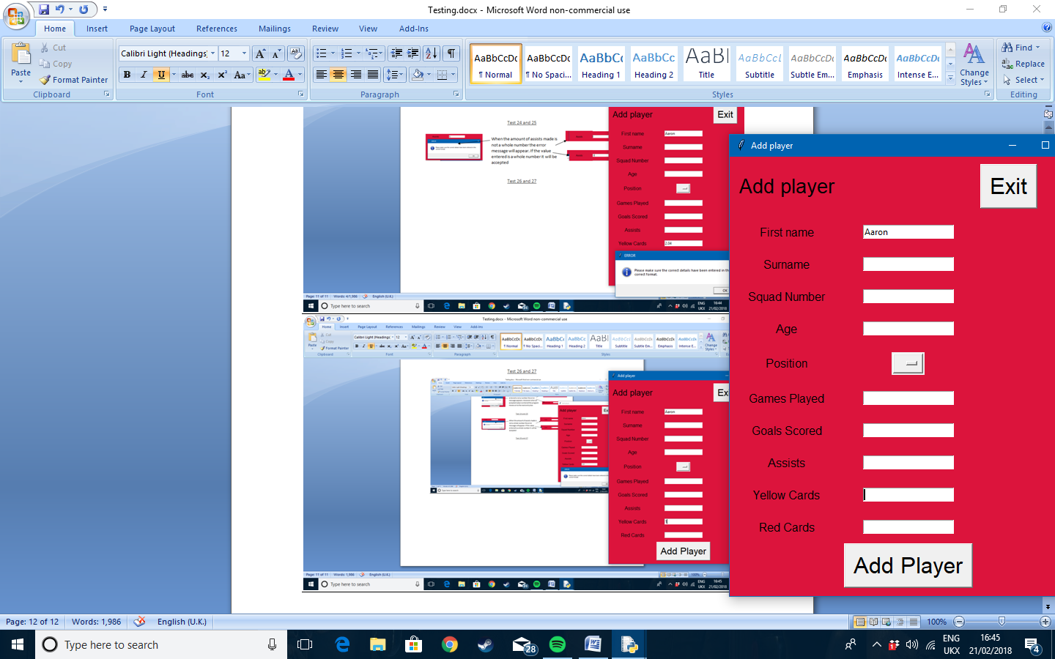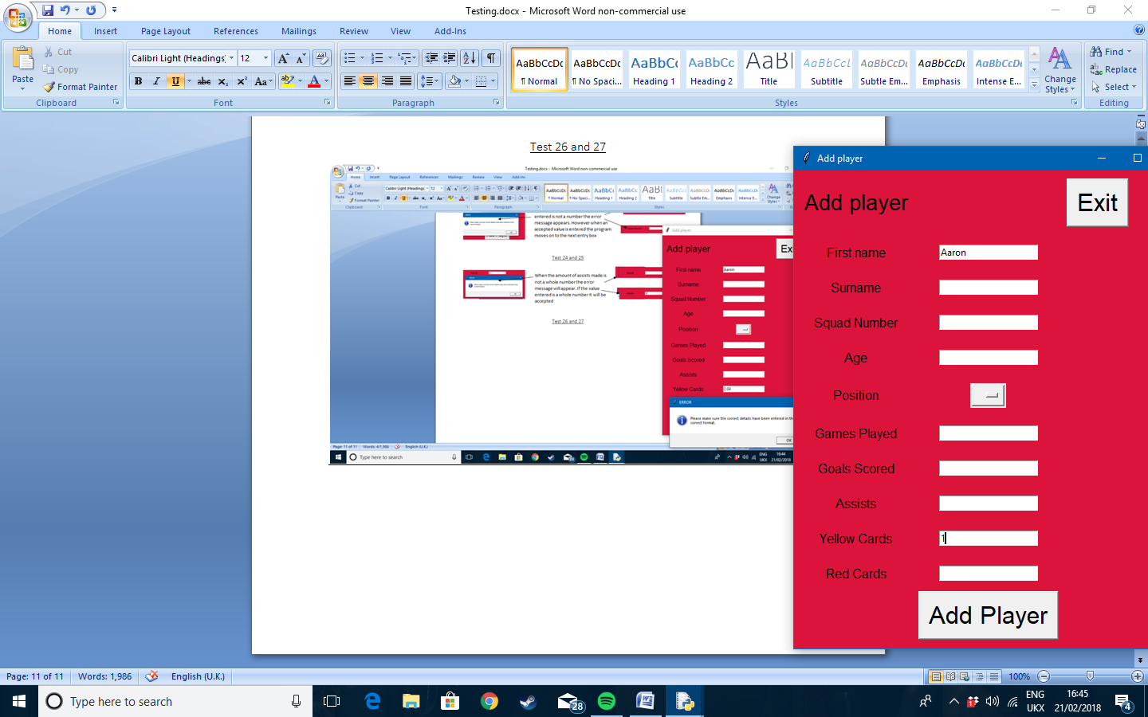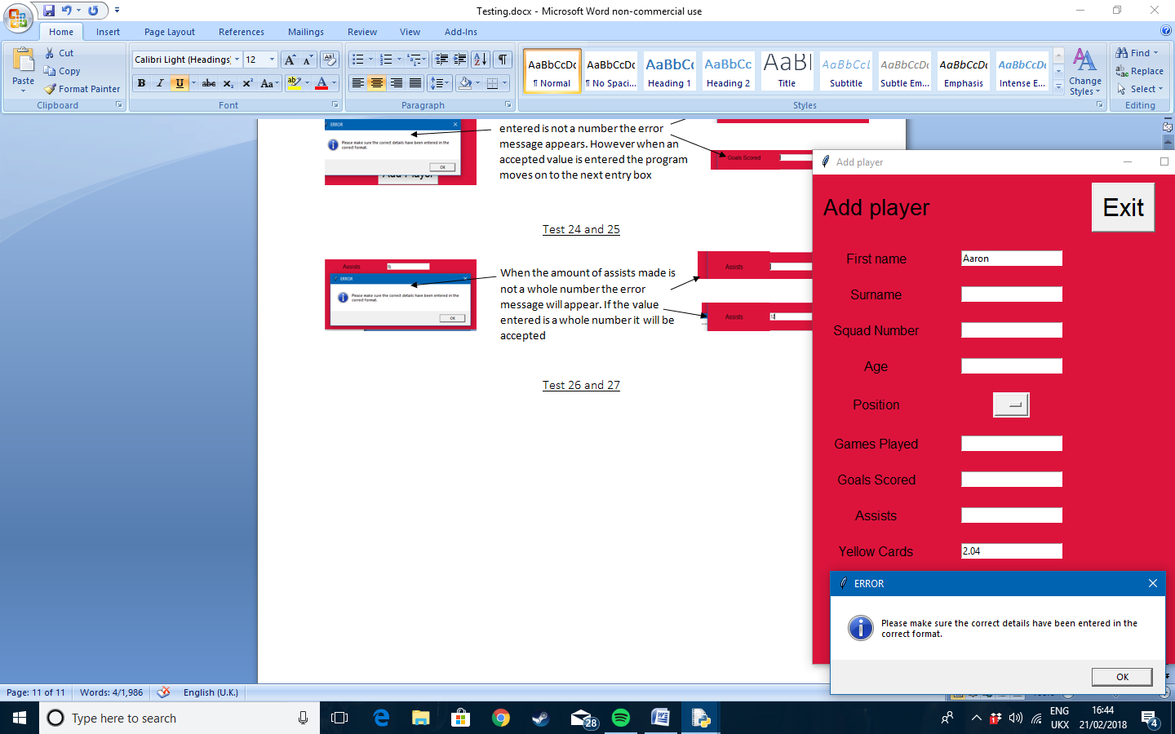

When an entry that is not a whole number is entered the error box appears. If a correct value is entered, the program moves on or stores that value

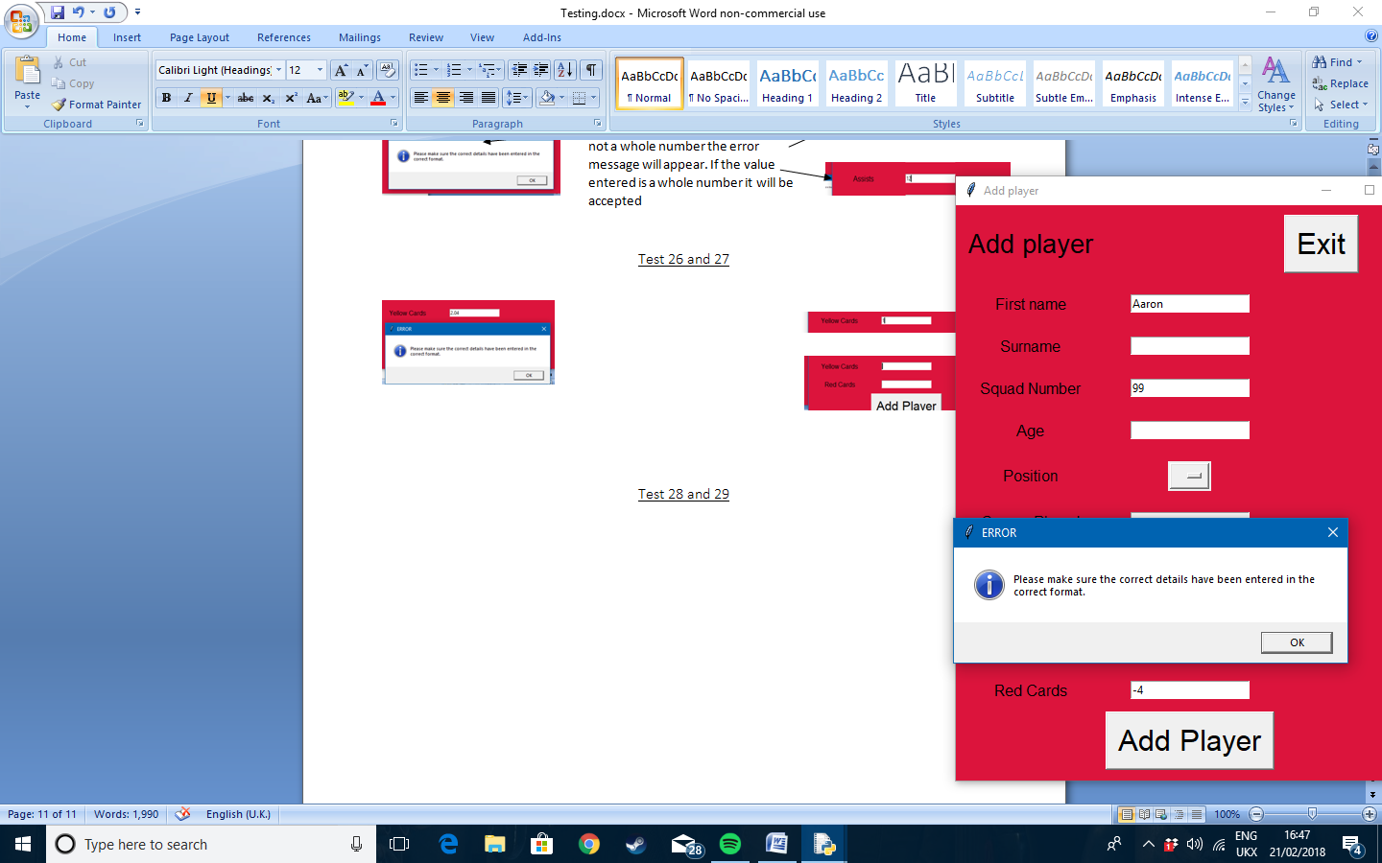Test 28 and 29

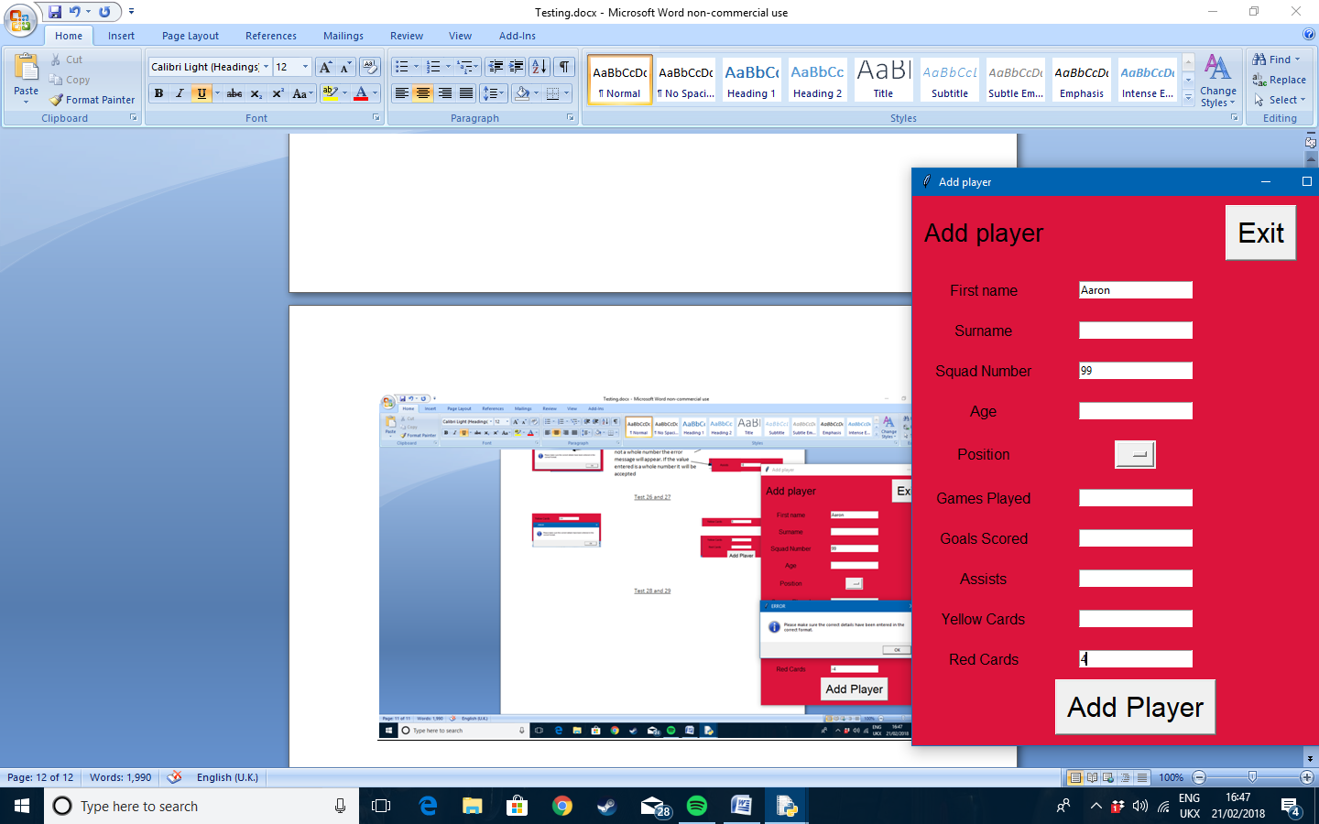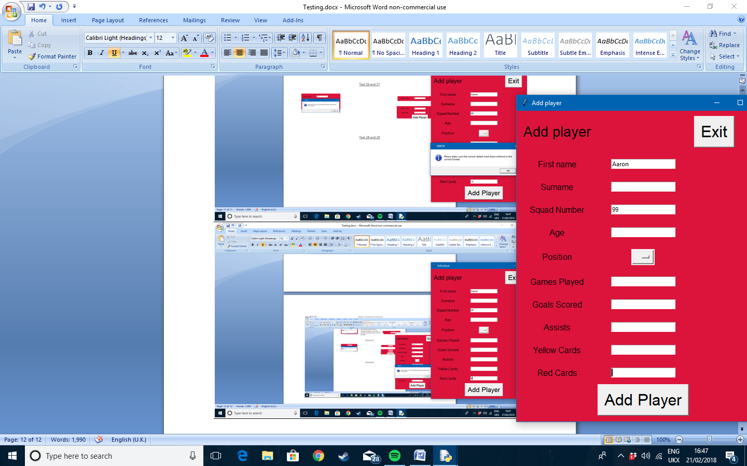

When an incorrect entry is inputted the error box appears. When a correct value is entered, the program accepts it and adds it to the database.

Test 30

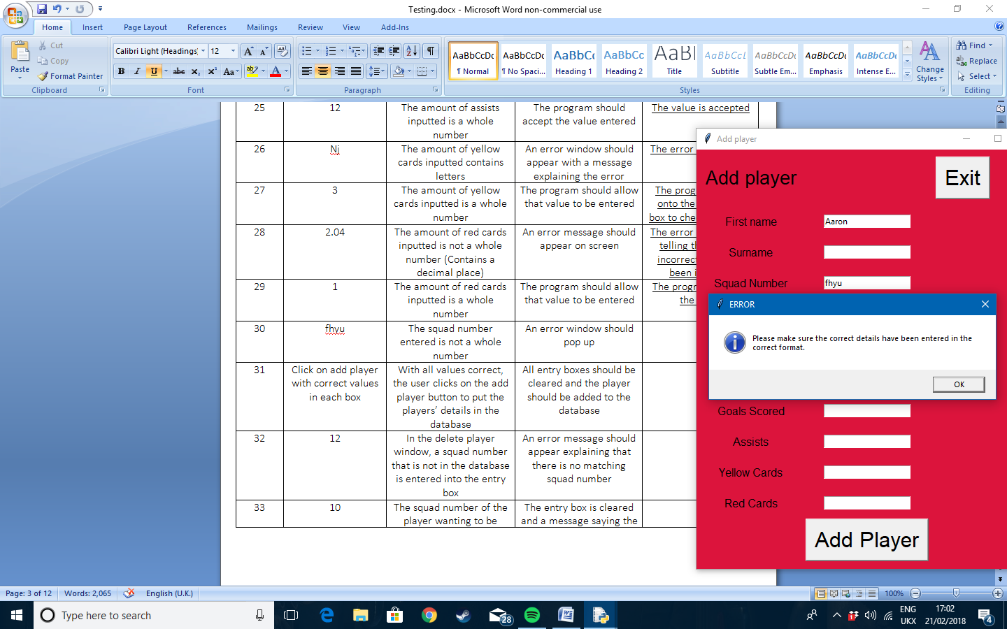

When the squad number is not a number the error message appears

Test 31

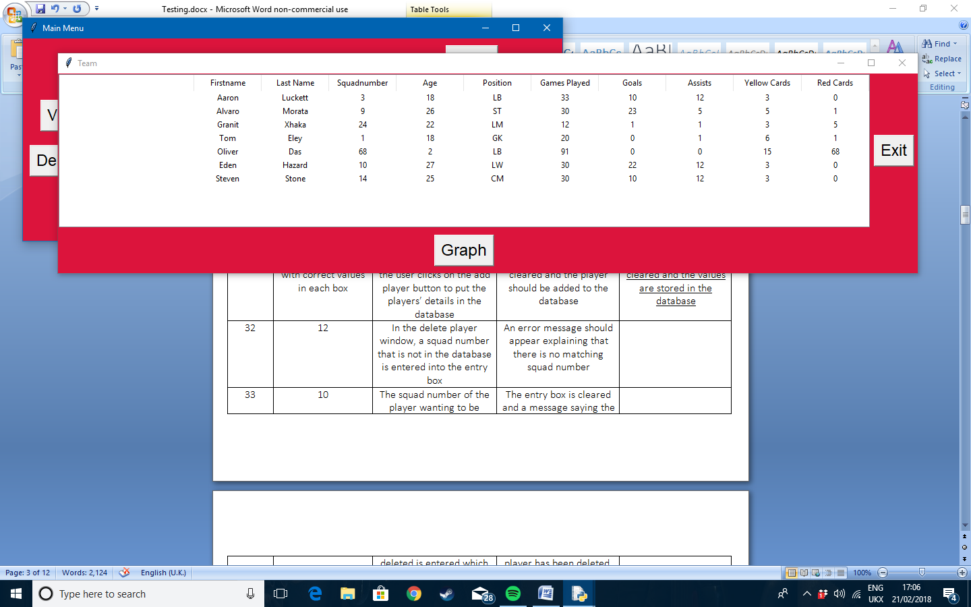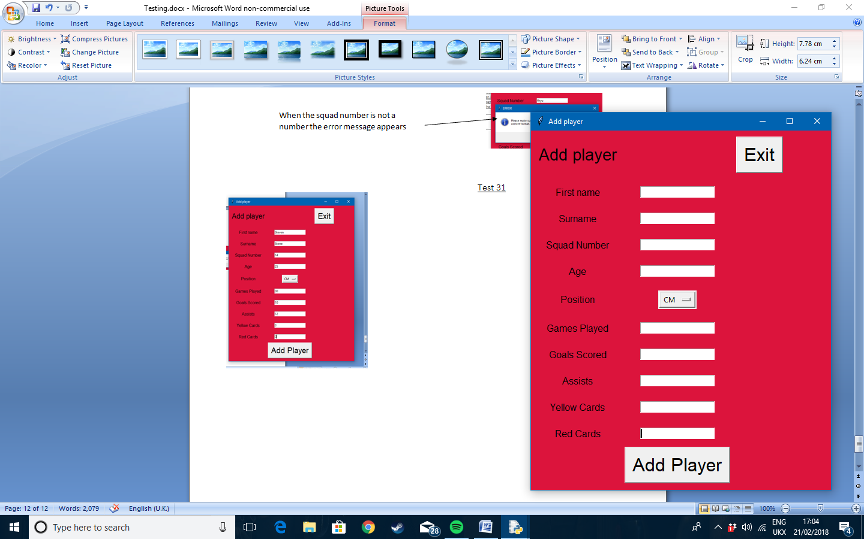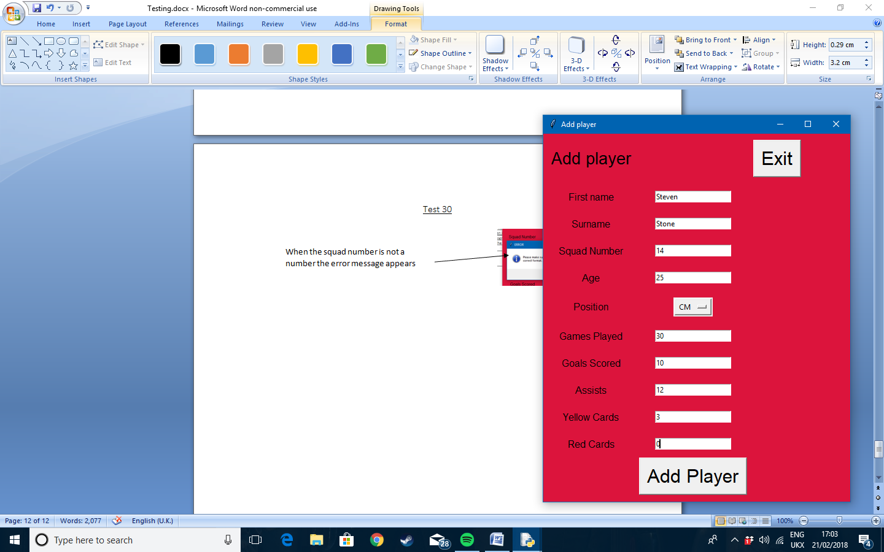

When all of the correct values are entered into each field of entry. The program will clear all of the entry boxes and stores them in the database

Test 32

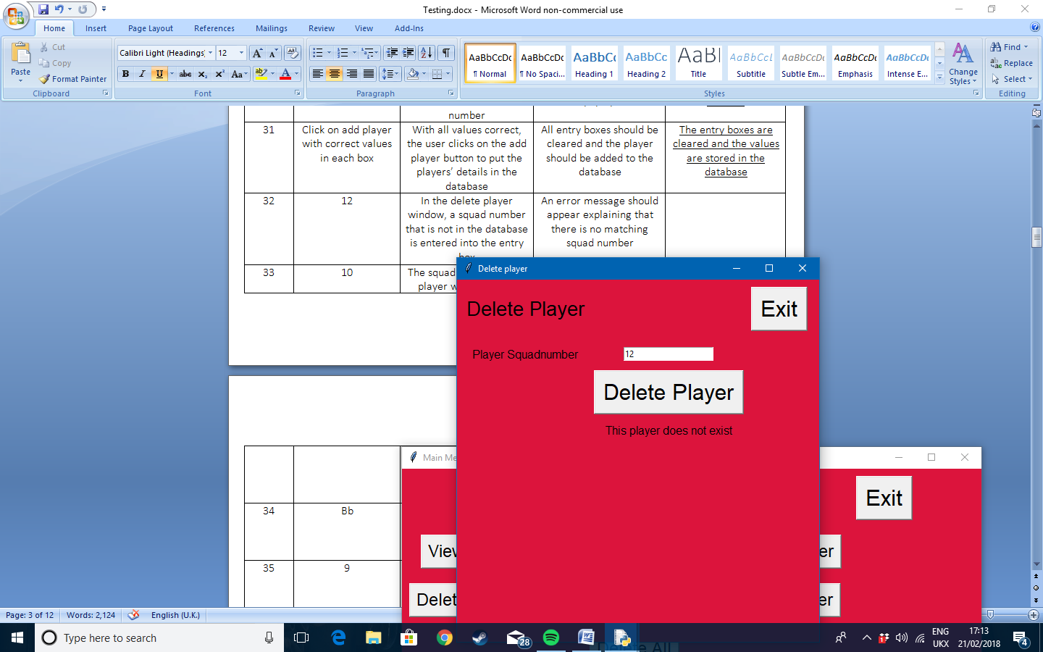

When there is no player with the matching squad number to the one entered in the database, then the message appears saying that there is no match

Test 33

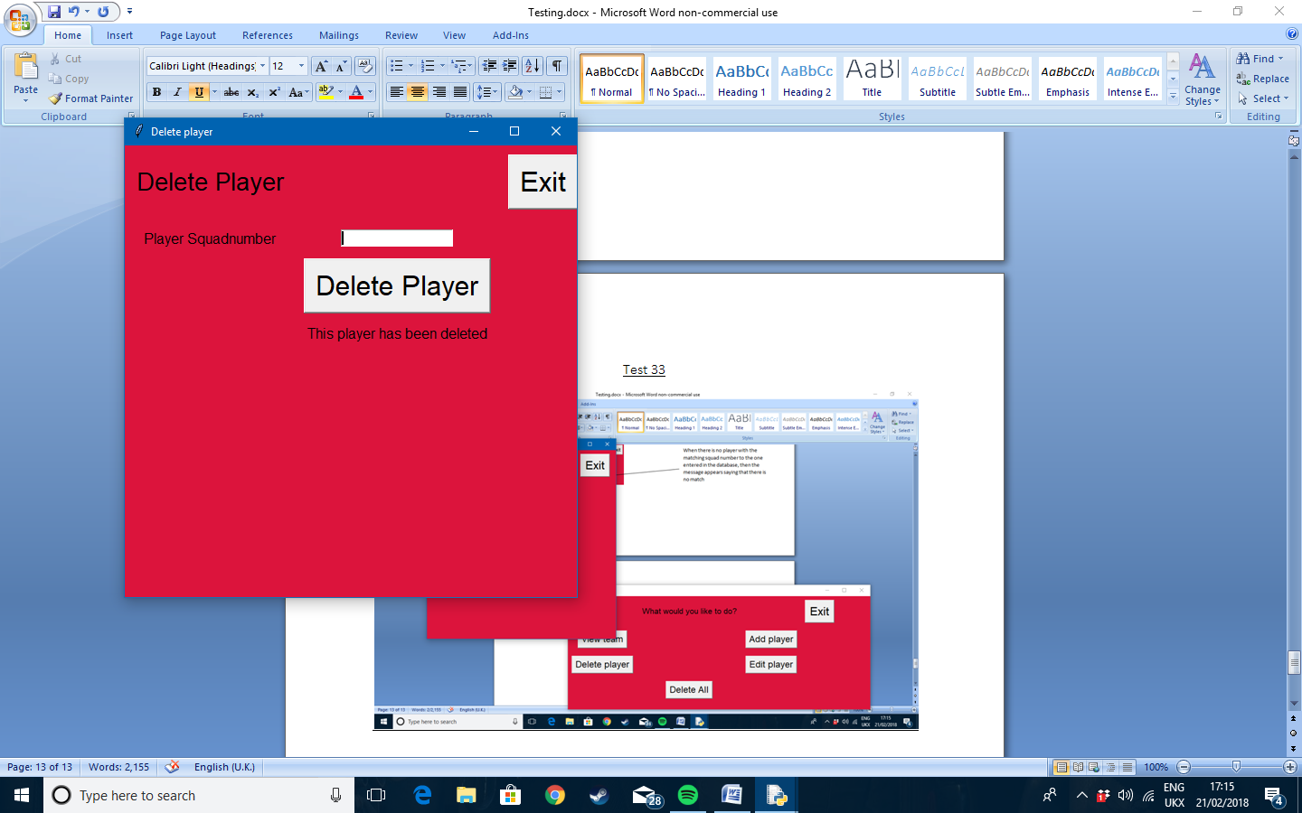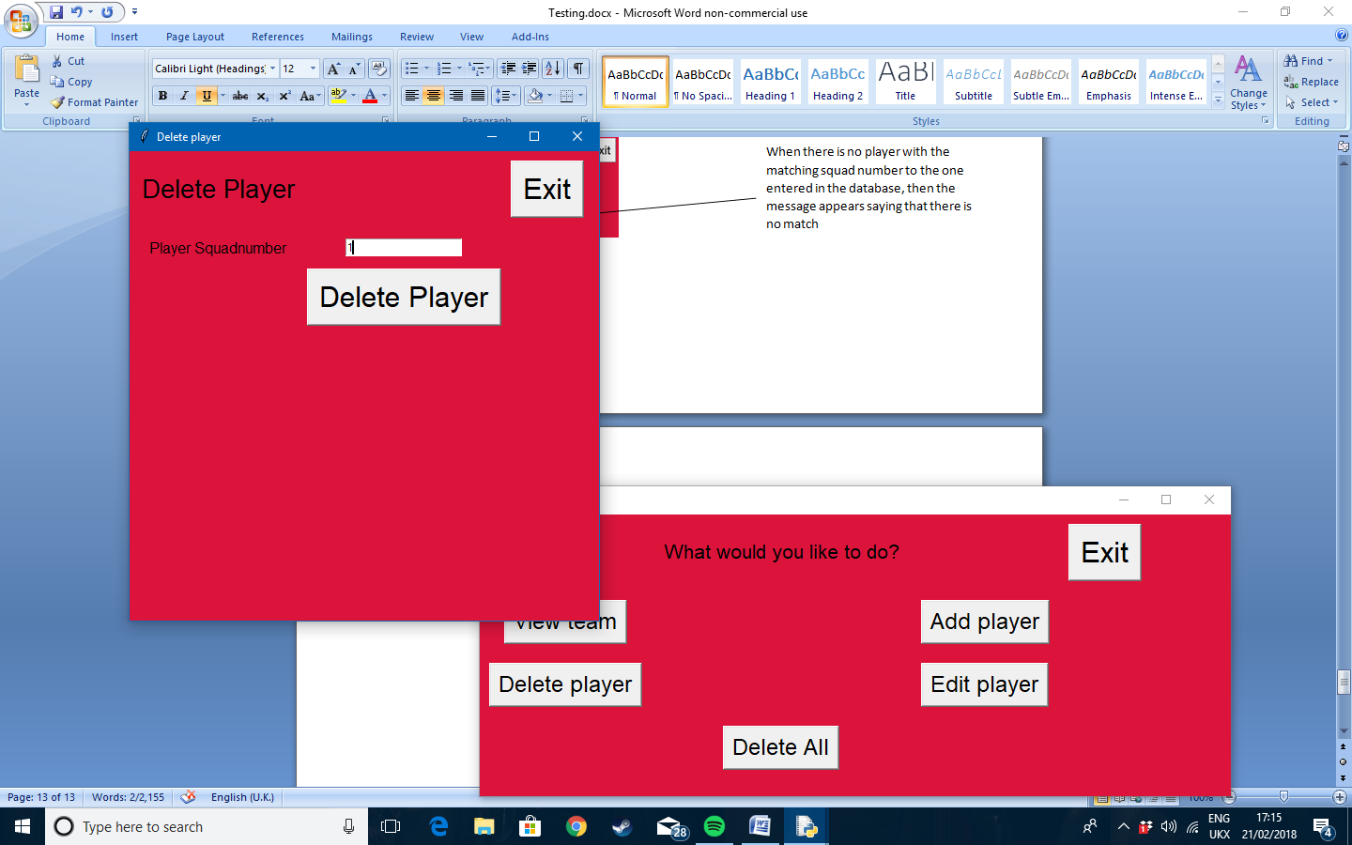

When a matching squad number is found in the database all of the data relating to it is deleted and cannot be seen by the user again

Test 34

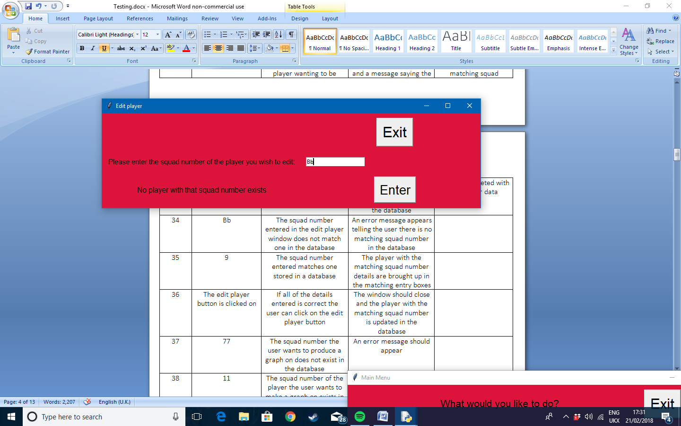

If there is no matching squad number then the error message will appear

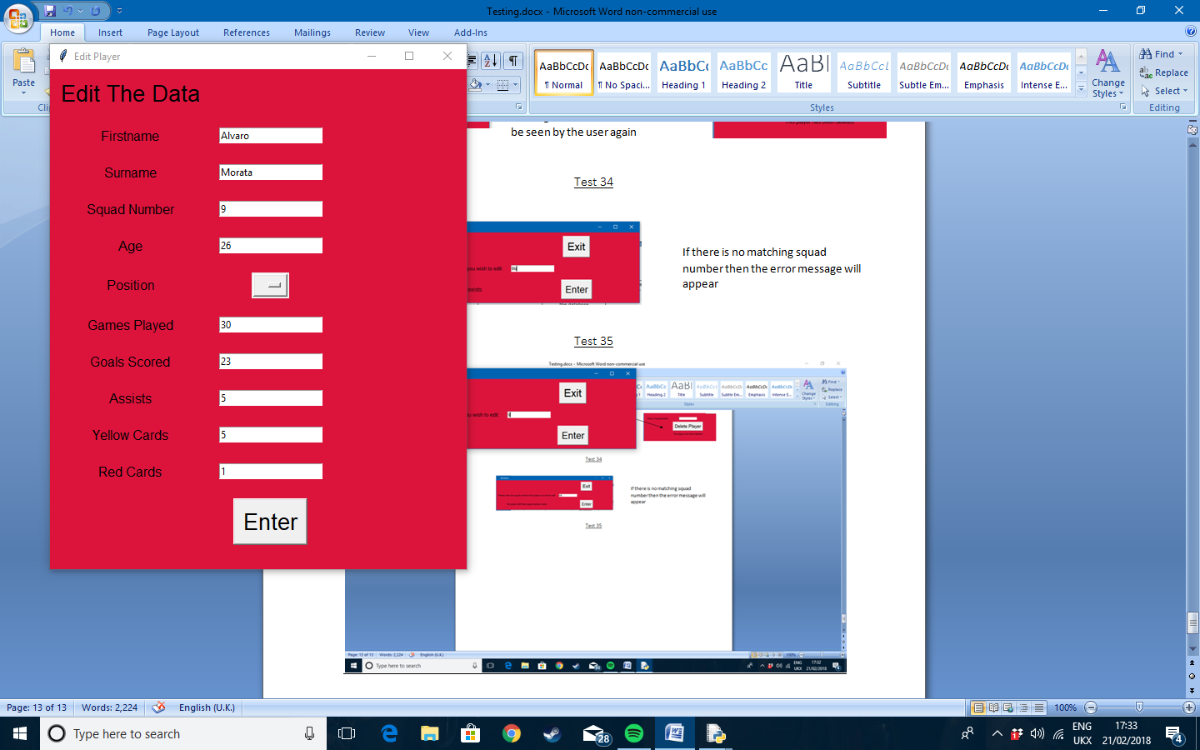Test 35

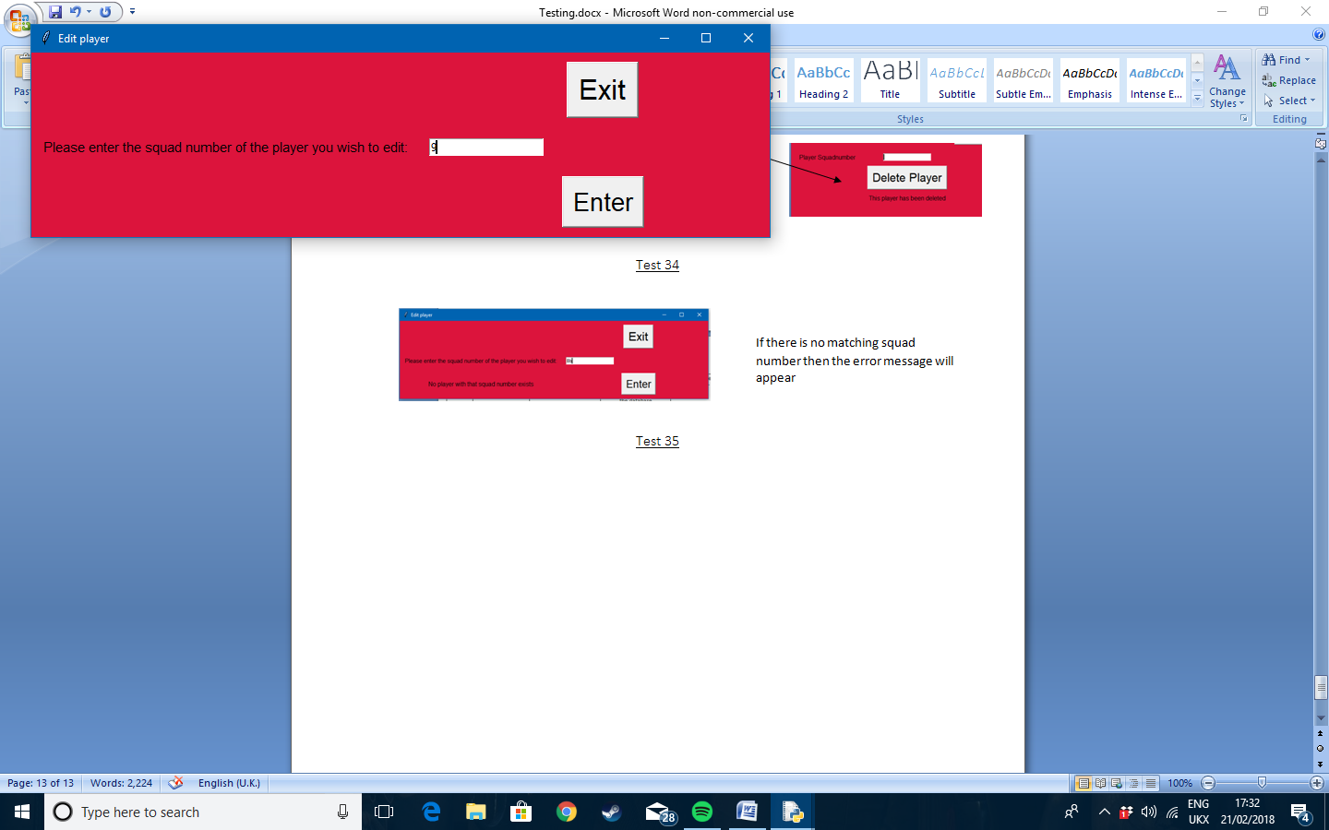

When a matching squad number is entered then the program brings up all of the data related and puts them in matching entry boxes to be edited

Test 36

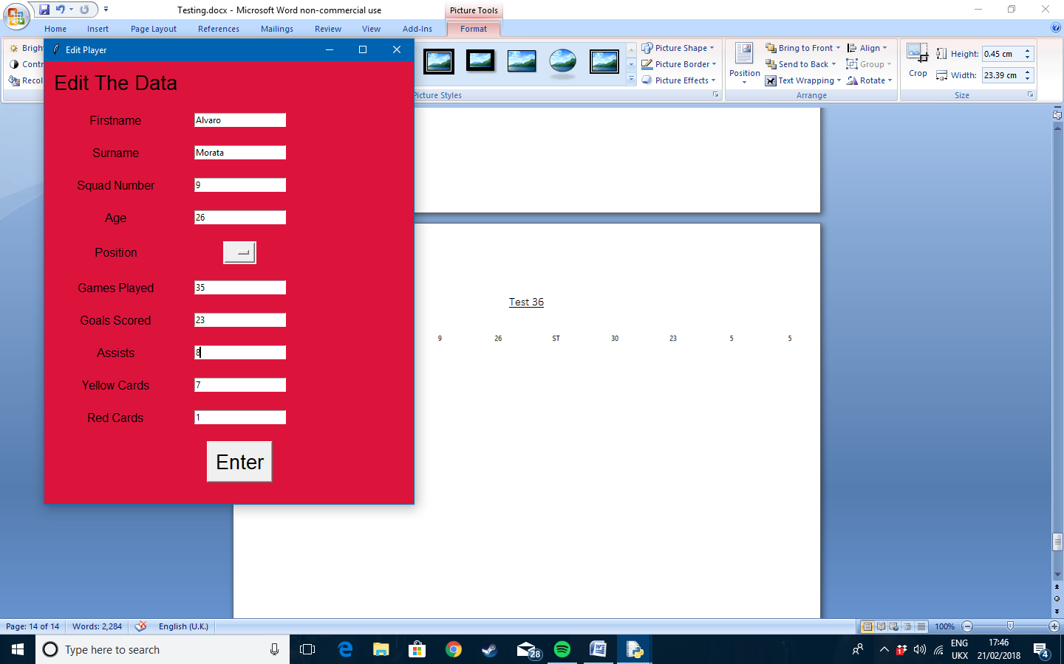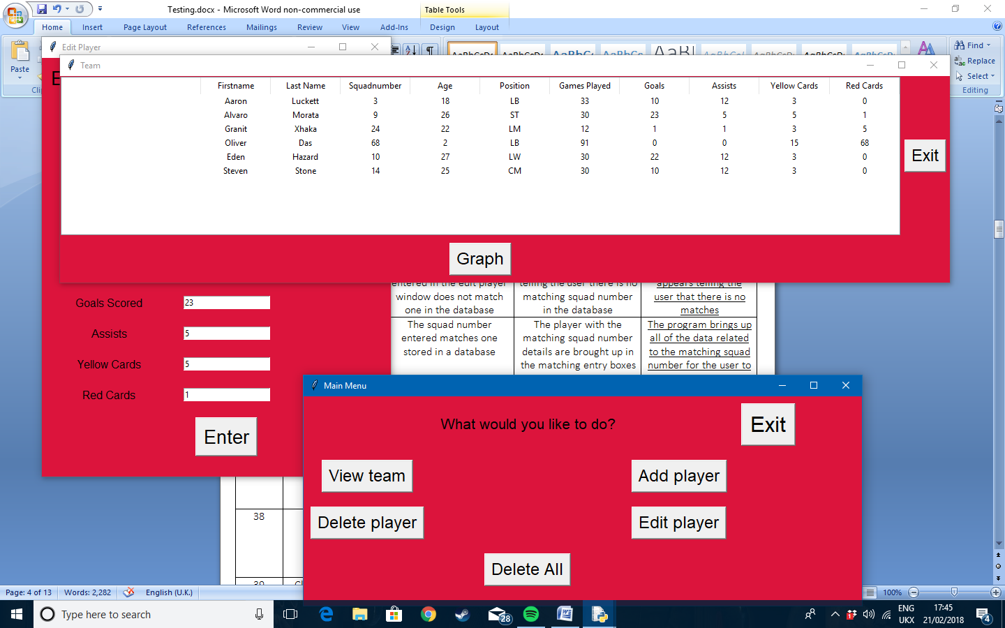

The first image if before the edit went through. The user changes and edits the numbers of the player and presses enter. The player stats will then be updated and changed as the image below shows. The entry boxes go through the same error checking as the add player menu, so the test results would be the same, so are unnecessary

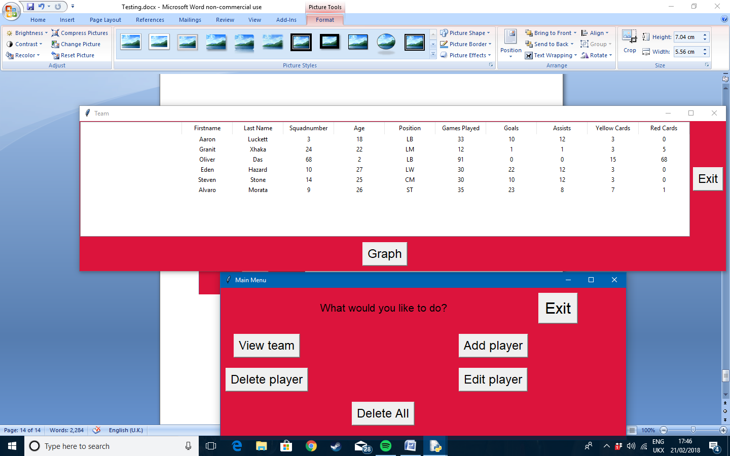

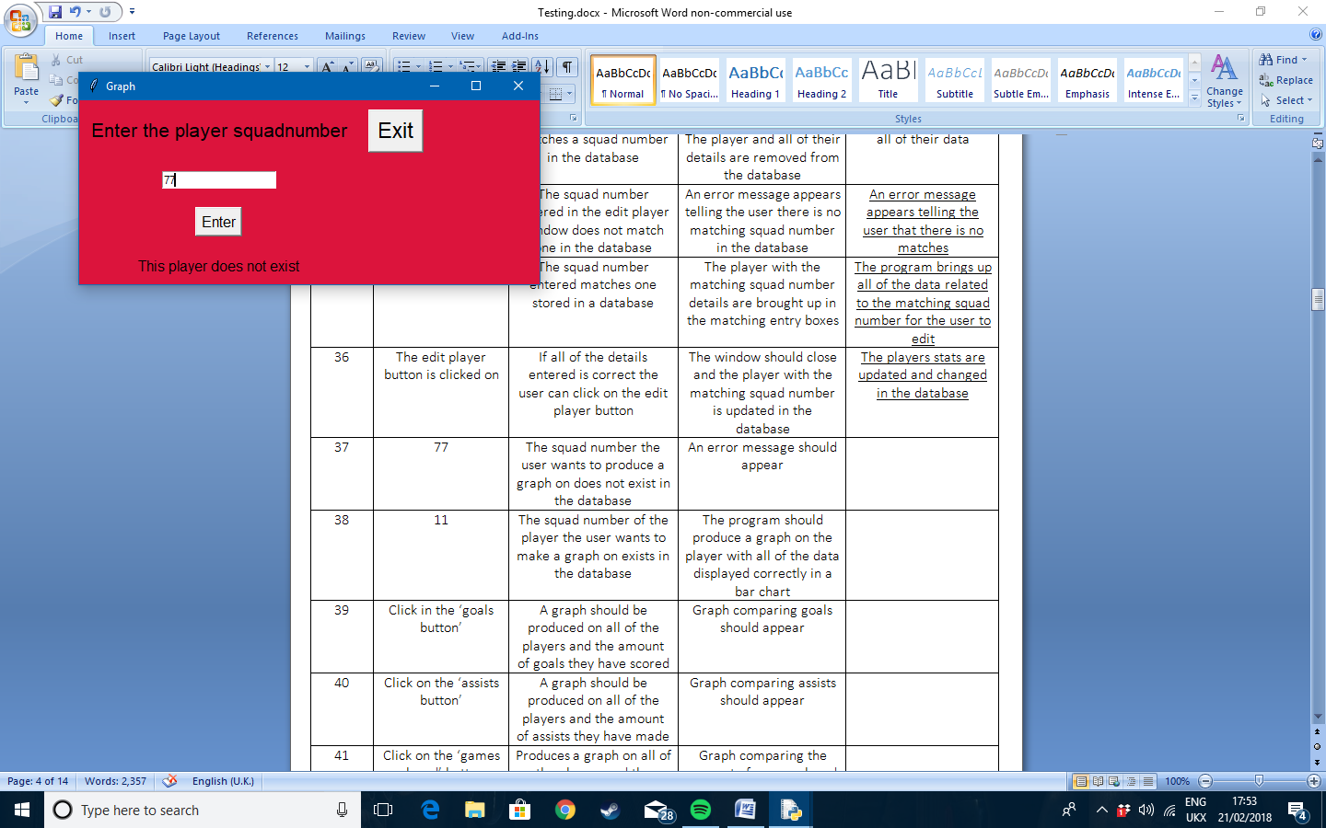Test 37

The error message appears telling the user there is no matching squad number

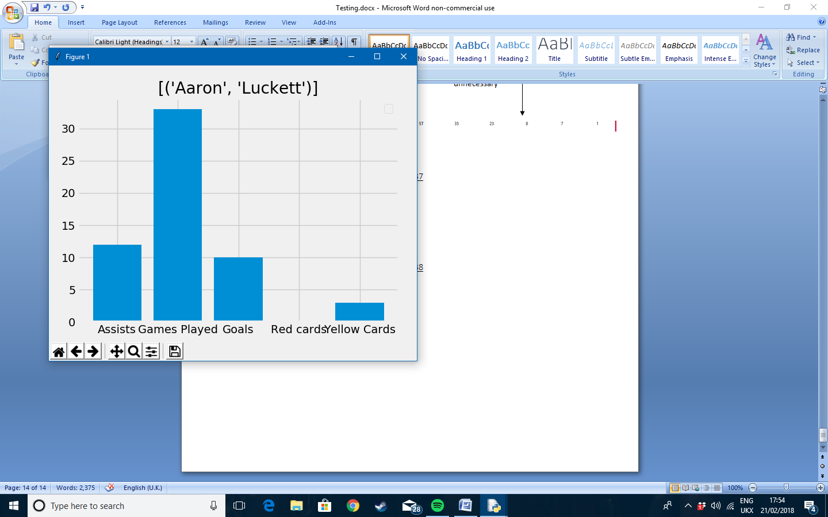

Test 38

The graph is produced on the player’s individual stats

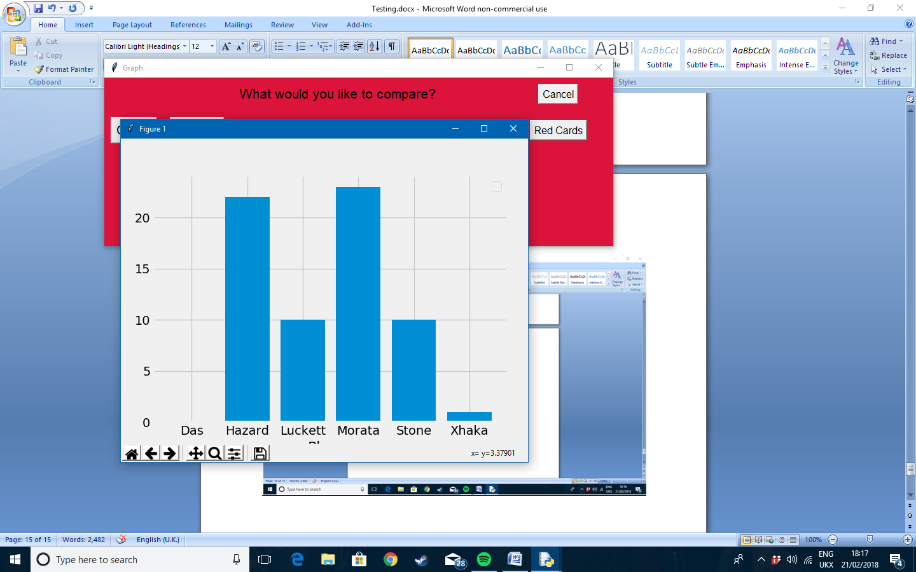Test 39

When the ‘goals’ button is clicked, this graph is produced where it shows all of the players and how many goals they have scored

Test 40

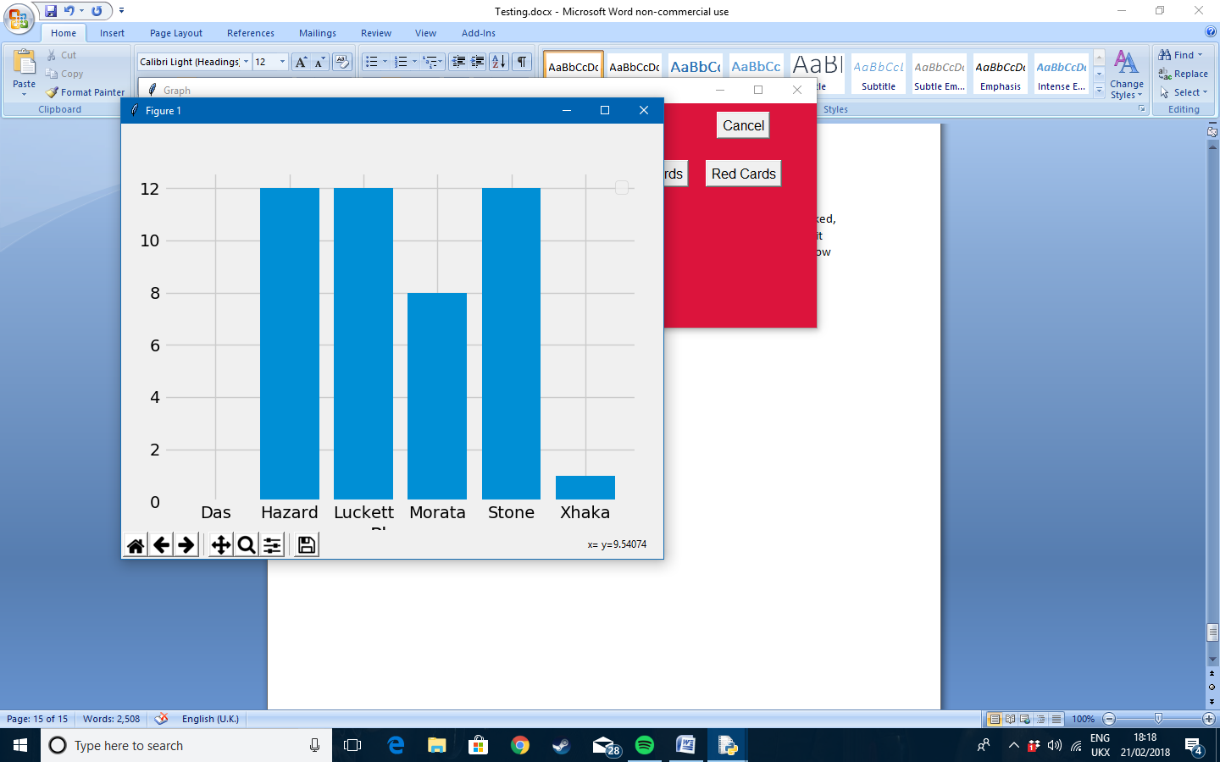

When the ‘assists’ button is clicked, a graph on all of the player’s assists is produced

Test 41

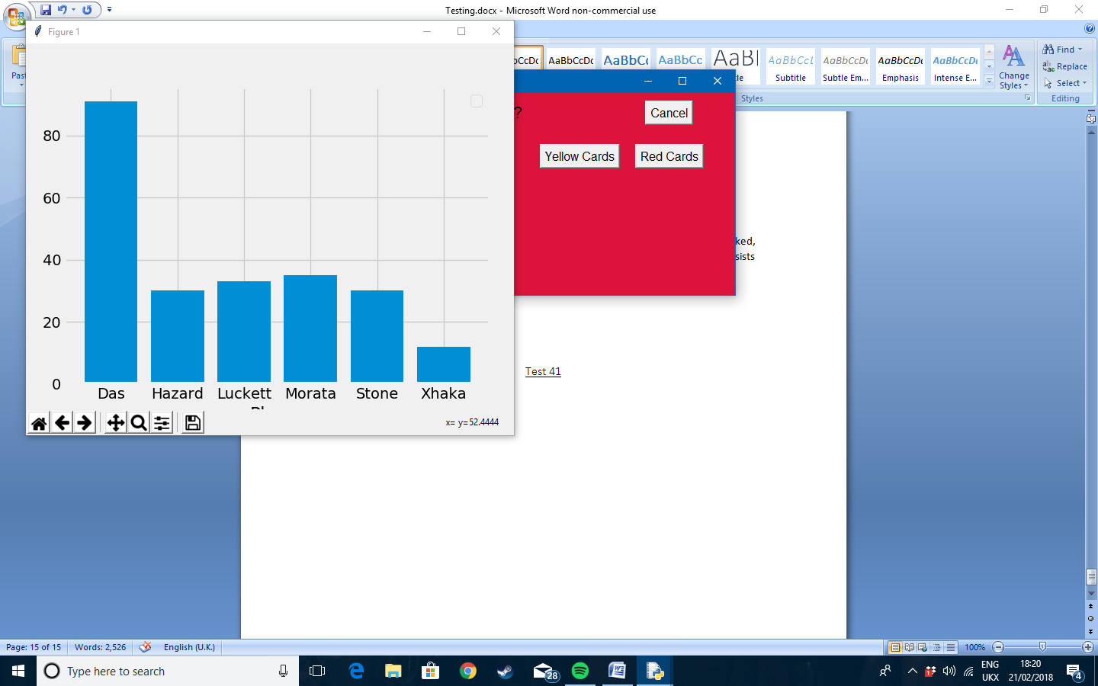

When the ‘games played’ button is clicked, a graph on the amount of games the players in the squad have played is produced

Test 42

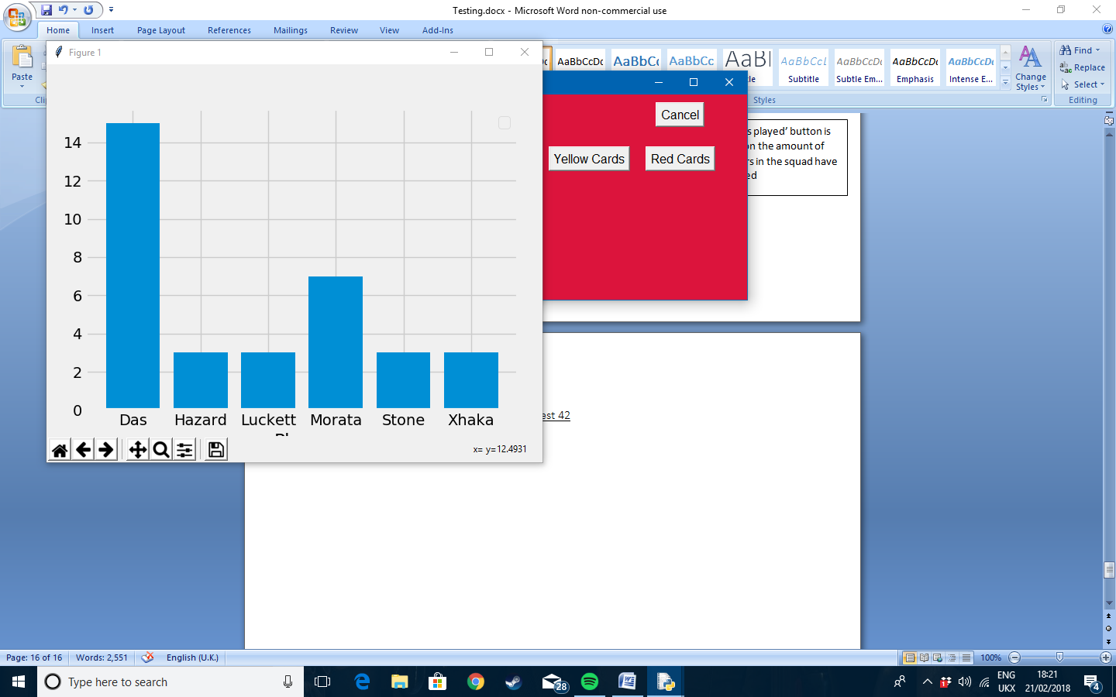

When the ‘yellow cards’ button is click the graph is produced showing all of the squad members and how many yellow cards they have

Test 43

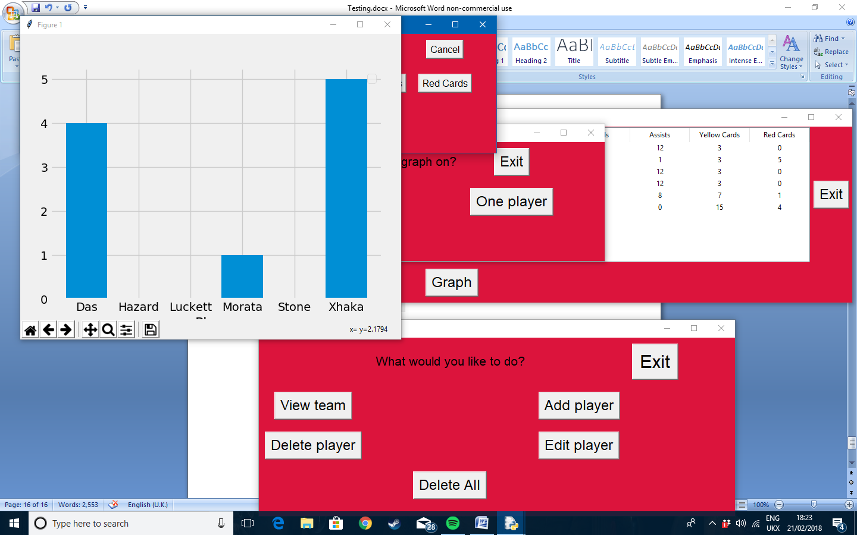

When the ‘red cards’ button is clicked, a graph showing all of the players and how many red cards they have each accumulated is produced

# Evaluation

Overall I feel that the project went well, with deadlines being met throughout the time period set and with any problems or issues being solved in a decent amount of time causing minimum interference with the production. The program itself works smoothly and I think that the client will be happy with it and will be able to use it effectively. However, I do feel that given a longer time period there would have been a few extra things that I would have been able to add to the program, to make it more advanced and easier for the client to use.

## Smart objectives

The smart objectives in my analysis section will be used to see if I had managed to meet all of my clients’ requirements. I will colour code them green for met, red for not met and orange if they are met but could be done or improved on if I had more time.

1. The program must store all of the statistics for each player in the squad.

2. The program must allow the user to delete, update and add specific pieces of data in the database.

1. The program must be able to create graphs on specific pieces of data in the database.
2. The program must have a login window that will only allow specific people with logins to change the data
3. The program must display a message saying “Incorrect login details” when the incorrect login is inputted, therefore only allowing certain people to access the data.
4. The program must display the data stored in the database in a GUI window that is quick to view and find specific data.
5. The program must get rid of any GUI windows that are not being used to make it as simple as possible for the user to use the program.
6. The system must be easy to navigate around and easy to view and read.
7. The program must save all changes to the data in the database if it is changed or deleted.
8. There should be an option to clear all of the data. This could be used if a new season has begun.
9. The system must allow the user to view the data both in a table format as well as in a graph.
10. The graphs produced must be able to be printed in colour.
11. The colours used must stick to the colour scheme of the club, red and black.

Personally, I think that each SMART objective has been met accordingly. Objective 1 has been met as the programme stores all of the correct data for each player in a database. Objective 2 has been met however I did come across one issue when updating the data. On one computer I was using the computing crashed when data was edited for a player. However on any other computer I used this feature worked just fine and on the computer my client used it worked fine to so there was no real issue. The programme could create graphs on specific pieces of data and statistics as well as a graph in general so objective 3 has been met.

At the start of the programme a login window appears and only certain credentials can be entered in order to access the programme, meaning objective 4 has been met. If the user enters incorrect details an error message appears so objective 5 has been met as well. Objective 6 has been met as the data is shown in a GUI window and from the email my client says that the programme is quick and simple to use. This also means that objectives 7 and 8 have been met as the client is happy with the simplicity of the programme.

Objective 9 has been met as the programme staves all of the changes made to the data in the database. Objective 10 has also been met as there is a delete all button that removes all the data from the database, which is convenient for when a new season starts. Objective 11 has been achieved as graphs can be produced on the data as well as it being able to be viewed in a table format. The graphs can be printed out in colour meaning objective 12 has been met. Finally objective 13 has been achieved as the colour scheme is black and red to match the colour scheme of the club.

## Email from client

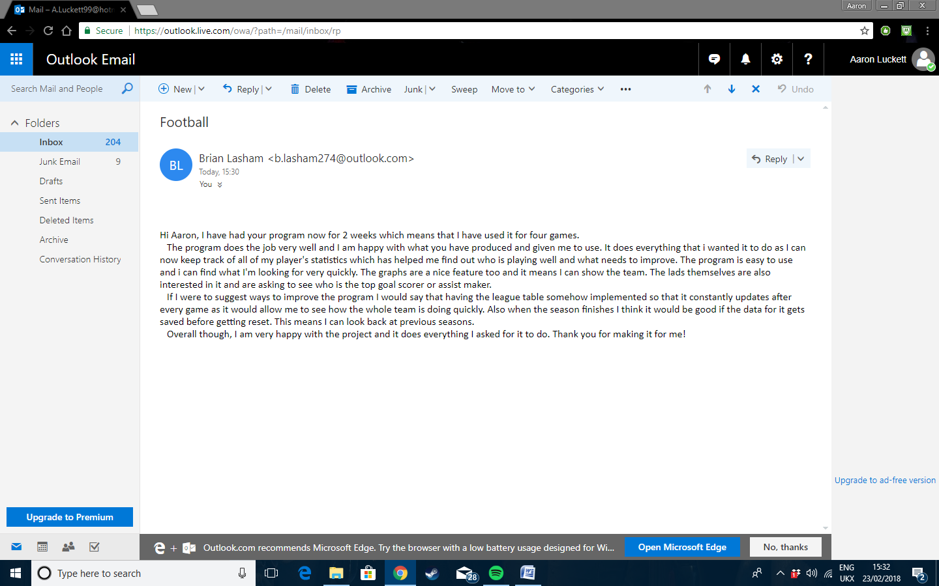Below is the email I have received from my client after they had used the program for just over two weeks, which in that time the team, played four matches. This meant the client got a good use out of the program. Here is what it says:

“Hi Aaron, I have had your program now for 2 weeks which means that I have used it for four games.

   The program does the job very well and I am happy with what you have produced and given me to use. It does everything that i wanted it to do as I can now keep track of all of my player's statistics which has helped me find out who is playing well and what needs to improve. The program is easy to use and i can find what I'm looking for very quickly. The graphs are a nice feature too and it means I can show the team. The lads themselves are also interested in it and are asking to see who the top goal scorer is or assist maker.

   If I were to suggest ways to improve the program I would say that having the league table somehow implemented so that it constantly updates after every game as it would allow me to see how the whole team is doing quickly. Also when the season finishes I think it would be good if the data for it gets saved before getting reset. This means I can look back at previous seasons.

   Overall though, I am very happy with the project and it does everything I asked for it to do. Thank you for making it for me!”

The email from my client has made me content with the project as it does what they want it to do and they are happy with it. With regard to the improvements suggested, I think that they would definitely help improve the program. However, given the time left these look unlikely to be implemented. This is because I need to get data from other teams, the teams in there league, and try to put them in the database. Therefore to improve the project next time, and if I had more time then I would have been able to add a league table as well as have an entire season be saved when a new one starts; however eventually this could have a storage issue. But overall with the project provided I am happy with the outcome as my client is happy and the program works very well.

## Conclusion

Overall, I am happy with how the overall project went. In terms of the main solution, everything is met and catered to the client’s needs.

The analysis part of the coursework gave me a good understanding of what I needed to do when creating my design. I think my questionnaire and interview helped me create a good set of SMART objectives that I needed to achieve in order to make the client happy. The thing I struggled most with in this section was the DFDs as it was hard to show and explain how to current and proposed system worked.

The design section was the hardest aspect for me, apart from creating the solution itself. This is because I had to try and plan many different things such as looks and data flow, as well as trying to work out how to the programme will work with the design I made. The pseudo code was the hardest part of this section though, as some of the code was extremely hard to put into pseudo code due to its complexity. However I think my design section looks acceptable and shows how I planned the programme to look clearly.

I have already covered my technical solution but I think it works very well and does everything required by the client. Although I can across many difficulty and errors when coding the programme, I managed to find solutions to them and produce a working, error free programme.

The testing section was the easiest section of the project. However it was very important as it helped me find errors in the code and programme that I may not have found without the tests. This section helped me carry out final tweaks to my programme to smooth out any hidden errors.

The evaluation section allowed me to bring all of the previous sections together in order to check that all objectives had been met and everything linked together. It also allowed me to see if the client was happy with the programme, which he was. Therefore I think the project on a whole went fairly well.